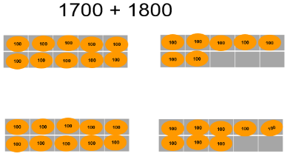
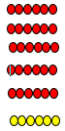
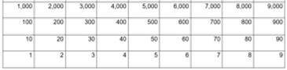
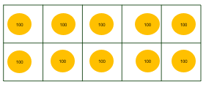
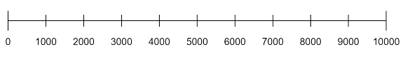
Place Value
Multiplication and Division
Recall multiplication and division facts for multiplication tables up to 12 × 12 (facts for 6,7,9,11,12 are new)
Recall multiplication and division facts up to 12 x12 , and recognise products in multiplication tables as multiples of the corresponding number.

Apply place-value knowledge to known additive and multiplicative number facts (scaling facts by 100)

Use place value, known and derived facts to multiply and divide mentally, including: multiplying by 0 and 1; dividing by 1; multiplying together three numbers

Recognise and use factor pairs and commutativity in mental calculations

Square
Squared

Addition and Subtraction
Mental

Find 1000 more or less than a given number

Apply place-value knowledge to known additive and multiplicative number facts (scaling facts by 100)

Add and subtract numbers with up to 4 digits using the formal written methods of columnar addition and subtraction where appropriate
Addition/Subtraction of multiples of 1000s and 100s
Mental strategies for up to 4 digits

Estimate and use inverse operations to check answers to a calculation

Solve addition and subtraction two-step problems in contexts, deciding which operations and methods to use and why.

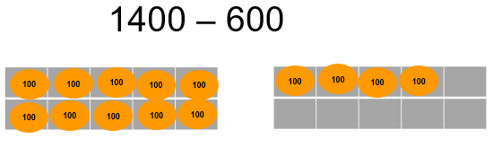

ten thousand
one thousand more
one thousand less

Area

Find the area of rectilinear shapes by counting squares

Area
Covers
Square centimetre (cm²)

Perimeter
Measure and calculate the perimeter of a rectilinear figure (including squares) in centimetres and metres

time

Identify, represent and estimate numbers using different representations

Order and compare numbers beyond 1000
Reason about the location of any four-digit number in the linear number system, including identifying the previous and next multiple of 1,000 and 100, and rounding to the nearest of each.

Divide 1,000 into 2, 4, 5 and 10 equal parts, and read scales/number lines marked in multiples of 1,000 with 2, 4, 5 and 10 equal parts.

Recognise the place value of each digit in a four-digit number (thousands, hundreds, tens, and ones)
Know that 10 hundreds are equivalent to 1 thousand, and that 1,000 is 10 times the size of 100; apply this to identify and work out how many 100s there are in other four-digit multiples of 100.

Recognise the place value of each digit in four-digit numbers, and compose and decompose four-digit numbers using standard and non-standard partitioning.

.

Make links to measurement across every number unit and statistics in place value and addition/subtraction
Include reasoning and problem solving in all units
Green statements are ready to progress, and red are additional information
Year 4 – Autumn Term

