Getting Year 3 ready

Recall and use multiplication and division facts for the 2, 5 and 10 multiplication tables, including recognising odd and even numbers
Recognise repeated addition contexts, representing them with multiplication equations and calculating the product, within the 2, 5 and 10 multiplication tables.
Show that multiplication of two numbers can be done in any order (commutative) and division of one number by another cannot

Week 9 and 10 – Multiplication and division of x 2, x 5 and x 10
(multiplication and division folders)

Getting Year 3 ready
Add and subtract numbers using concrete objects, pictorial representations, and mentally, including:
▪ two two-digit numbers
Cross 10 boundaries

Week 7 and 8 addition and subtraction of 2d across boundaries
(named in addition and subtraction folder and long projects in Build- my problem)

SATs -

Statistics
Interpret and construct simple pictograms, tally charts, block diagrams and simple tables

Ask and answer simple questions by counting the number of objects in each category and sorting the categories by quantity

Ask and answer questions about totalling and comparing categorical data.

Week 6 – Block graphs and pictograms
In statistics folder

graph, block graph, pictogram represent, tally time label, title most popular, most common least popular, least common

Position and Direction
order and arrange combinations of mathematical objects in patterns and sequences

Use mathematical vocabulary to describe position, direction and movement, including movement in a straight line and distinguishing between rotation as a turn and in terms of right angles for quarter, half and three-quarter turns (clockwise and anti-clockwise).

Week 5 – Turns
In geometry folder

Clockwise
Anti-clockwise
right angle straight line

Measure - Time
Compare and sequence intervals of time

Tell and write the time to five minutes, including quarter past/to the hour and draw the hands on a clock face to show these times

Know the number of minutes in an hour and the number of hours in a day.

Week 4 – Time quarter past and quarter to and leading to 5-minute intervals

In measure folder

quarter past, quarter to 5, 10, 15 … minutes past

Addition and Subtraction
Add and subtract numbers using concrete objects, pictorial representations, and mentally, including:
▪ two two-digit numbers
Cross 10 boundaries

Week 1 addition of 2d across boundaries
Week 2 and 3 subtractions of 2d across boundaries
(named in addition and subtraction folders)

.

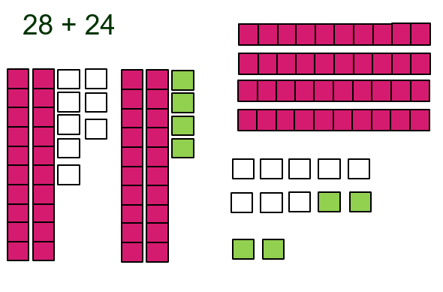

…

Make links to measurement across every number unit and statistics in place value and addition/subtraction
Include reasoning and problem solving in all units
Green statements are ready to progress, and red are additional information
Year 2 – Summer Term

