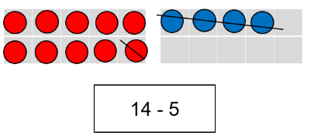
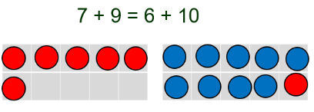
Multiplication and Division
Solve one-step problems involving multiplication and division, by calculating the answer using concrete objects, pictorial representations and arrays with the support of the teacher

No symbols as Year 2
Week 1 – Multiplication
Week 2 - Division
(Folders called multiplication and division in overall multiplication and division folder)

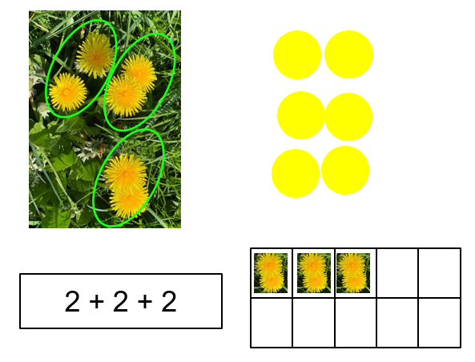
multiplication multiply multiplied by multiple division dividing grouping, array

Fractions
Recognise, find and name a half as one of two equal parts of an object, shape or quantity

Recognise, find, and name a quarter as one of four equal parts of an object, shape or quantity.

Week 3 – Half as a number and fractions of amount
Week 4 – quarter as a number and as fraction of amount

(Fractions folder)

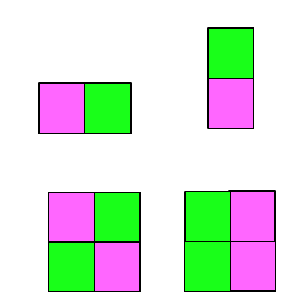
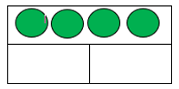
Fraction equal part equal grouping equal sharing parts of a whole half one of two equal parts quarter one of four equal parts

Measurement - mass
Compare, describe, and solve practical problems for:
mass/weight [for example, heavy/light, heavier than, lighter than]

Measure and begin to record the following:
mass/weight

Week 10 – Mass unit in measurement
(measure folder)

Kilogram
Half kilogram

Place Value
Count to and across 100, forwards and backwards, beginning with 0 or 1, or from any given number

Count, read and write numbers to 100 in numerals.

Week 9 – Represent numbers to 100
(Place value folder)

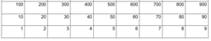
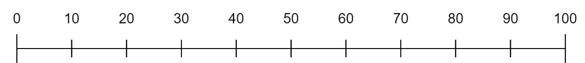

Fifty-one, fifty-two …

Addition and Subtraction
Add and subtract one-digit and two-digit numbers to 20, including zero.
Cross the boundary for example 7 + 8 or 14 – 6

Week 7 – addiytion across the boundary using two single digits
Week 8 – subtraction across the 10-boundary starting from 1 two-digit number less than 20

(addition and subtraction folder)

Across the ten

Position and Direction
Describe position, direction, and movement, including whole, half, quarter, and three-quarter turns.

Week 6 – Position and direction language as well as turns

(Geometry folder

time

Underneath
Centre

Time
Sequence events in chronological order using language [for example, before and after, next, first, today, yesterday, tomorrow, morning, afternoon, and evening]

Recognise and use language relating to dates, including days of the week, weeks, months and years

Tell the time to the hour and half past the hour and draw the hands on a clock face to show these times

Compare, describe and solve practical problems for:
- time [for example, quicker, slower, earlier, later]
Measure and begin to record the following:
- time (hours, minutes, seconds)

Week 5 – O clock and half past
(Time in measures folder)

seasons: spring, summer, autumn, winter
hour hand, minute hand hours, minutes
half past

Make links to measurement across every number unit and statistics in place value and addition/subtraction
Include reasoning and problem solving in all units
Green statements are ready to progress, and red are additional information
Year 1 – Summer Term

