www.grammarsaurus.co.uk

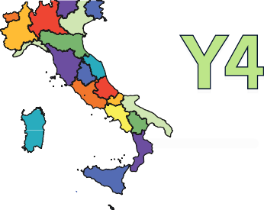
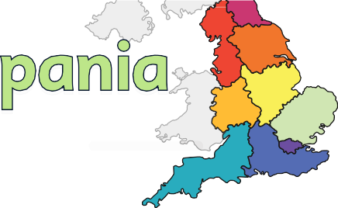

What are earthquakes and volcanoes? What are the similarities and differences between my region and Campania, Italy?

Children will learn about plate tectonics, earthquakes and volcanoes and will complete two Campania case studies. Children will then use their knowledge to compare their own region in England with Campania and establish similarities and differences between the two.
Overview of Learning
Year 1 - Children will learn about the geography of the world, including the seven continents and five oceans. Children will learn the countries, capital cities and seas of the United Kingdom.

Year 2 - Children will complete a study into their local area, including the human and physical features. Children will use this knowledge to complete a comparison study with Tulum, Mexico.

Year 3 - Children will learn about the key geographical characteristics of the United Kingdom including countries of the United Kingdom and the regions within England. Children will explore the types of settlements, key topographical features and how types of land use have changed over time. Children will use maps and atlases and learn features of maps.
Previous Learning

Pupils will learn physical geography, including volcanoes and earthquakes and human geography, including types of settlement and land use. Pupils will learn about the continent of Europe, concentrating on key physical and human characteristics, the countries and major cities. Pupils will understand geographical similarities and
differences through the study of human and physical geography of a region of England and a region in Europe.
Knowledge and Understanding Objectives

Year 5 - Children will discover the different countries and capital cities of North America and then focus on specifically the Western United States, including biomes, climate zones, vegetation belts, earthquakes and volcanoes. Children will learn about the physical processes of rivers, mountains and the water cycle.
Year 6 - Children will do an in-depth study into the economic activity of the United Kingdom. Children will learn about the three main economic sectors and how each of them impacts the economy of the UK. Using a range of case studies, children will find out how sustainable different economic activities in the UK are and the ramifications they have on the environment.
Future Learning


Aerial photograph, agriculture, Arctic Circle, atlas, beach, capital, characteristics, city, climate, coast, continent, country, earthquake, environment, equator, factory, farm, ﬁeldwork, forest, hemisphere, hill, house, landmark, land use, latitude, locality, location, longitude, map, mountains, observational skills, ocean, office, peninsula, region, river, rural, scale, shop, tropic of Capricorn, tropic of Cancer, urban, valley, village, volcano, weather

Key Vocabulary to Explain
Knowledge: Locational Knowledge, Place Knowledge, Human Geography, Physical Geography
Concepts: Place, Space, Scale, Physical Processes, Cultural Awareness, Cultural Diversity
Theme and Concepts


www.grammarsaurus.co.uk
Understanding that the equator, tropics etc. are not physical lines but imaginary lines around the world. Understanding the scale of types of settlements/areas of land e.g. continents - countries - regions - counties. Understanding that the size of types of settlements can be inconsistent e.g. towns being larger than cities. Understanding that there are significant differences between regions within England dependent on history/physical features.
Misconceptions

Unit Overview

How do earthquakes and volcanic eruptions happen? |  |  | What are the key physical and human features of Campania, Italy and how do they compare to my region?
Lesson 1 | Lesson 2 | Lesson 3 | Lesson 4 | Lesson 5 | Lesson 6 | Lesson 7
Key question: | Key question: | Key question: | Key question: | Key question: | Key question: | Key question:
What is plate tectonics? | What are earthquakes and how do they occur? | What are volcanoes and how do they occur? | What are the key physical features  of Campania, Italy and how do they compare to my region? | What are the key settlements in Campania, Italy and how do they compare to my region? | How is the land used in Campania, Italy, what are the economic activities and how do they compare to my region? | What are the similarities and  differences between my region and Campania, Italy?
Geographical Knowledge:  Physical Geography  Locational Knowledge |  |  | Geographical Knowledge:  Physical Geography | Geographical Knowledge:  Locational Knowledge  Place Knowledge  Human Geography |  | Geographical Knowledge:  Locational Knowledge  Place Knowledge Human Geography Physical Geography
Concept:  Physical Processes |  |  | Concept:  Place, Space, Scale | Concept:  Place, Space, Scale, Cultural Awareness and Cultural Diversity
Cumulative Quiz:  Q14-16 | Cumulative Quiz:  Q17-19 | Cumulative Quiz:  Q20-22 | Cumulative Quiz:  Q23-25 | Cumulative Quiz:  Q26-28 | Cumulative Quiz:  Q29-31 | Cumulative Quiz:  Q32-34
www.grammarsaurus.co.uk

- Research into other regions in England or in Italy.
- Research into other volcanoes or earthquakes to compare with Mount Vesuvius.
- Create a model of a volcano showing the different features.
- Create a fact file case study of an earthquake.
- Create an informative video outlining the similarities and differences between their region and Campania.
Stretch and Challenge Ideas Across the Unit
- The knowledge organiser can be used to support children. This could be on display, on the tables, sent home or used for pre-teaching key vocabulary or concepts.
- The post-unit test can be used to assess the knowledge and understanding objectives taught throughout the unit. This can be done independently or in small groups with a teacher.
- There is a cumulative quiz with questions that can be used to assess children throughout the topic. The quiz questions will link directly to each objective. They can also be used at the end of each lesson to give immediate feedback to inform future planning and give the opportunity to identify children who do not understand.
Assessment

