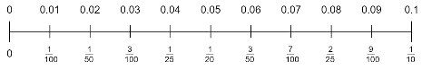
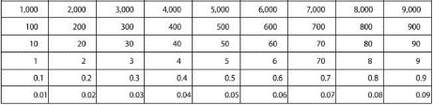
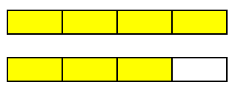
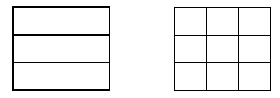
Fractions
Reason about the location of mixed numbers in the linear number system. 

Recognise and show, using diagrams, families of common equivalent fractions

Count up and down in hundredths; recognise that hundredths arise when dividing an object by one hundred and dividing tenths by ten
Solve problems involving increasingly harder fractions to calculate quantities, and fractions to divide quantities, including non-unit fractions where the answer is a whole number

Convert mixed numbers to improper fractions and vice versa

.

Area model
$\frac{1}{3}$ = $\frac{3}{9}$

Bar model for improper fractions
$\frac{7}{4}$ = $1\frac{3}{4}$

Improper fraction
Mixed number

Measurement

Convert between different units of measure [for example, kilometre to metre; hour to minute]

Estimate, compare and calculate different measures, including money in pounds and pence

unit, standard unit metric unit

Multiplication and Division

Multiply and divide two-digit and three-digit numbers by a one-digit number using formal written layout
Solve division problems, with two-digit dividends and one-digit divisors, that involve remainders, and interpret remainders appropriately according to the context.

Solve problems involving multiplying and adding, including using the distributive law to multiply two digit numbers by one digit, integer scaling problems and harder correspondence problems such as n objects are connected to m objects.
Manipulate multiplication and division equations, and understand and apply the commutative property of multiplication.

Understand and apply the distributive property of multiplication.

x | 300 | 20 | 7
6 | 1800 | 120 | 42

327 x 6 = 1800 + 120 + 42

Decimals
Recognise and write decimal equivalents of any number of tenths or hundredths

Recognise and write decimal equivalents to ¼, 2/4, ¾

Find the effect of dividing a one- or two-digit number by 10 and 100, identifying the value of the digits in the answer as ones, tenths and hundredths

Multiply and divide whole numbers by 10 and 100 (keeping to whole number quotients); understand this as equivalent to making a number 10 or 100 times the size.

Round decimals with one decimal place to the nearest whole number

Compare numbers with the same number of decimal places up to two decimal places

Solve simple measure and money problems involving fractions and decimals to two decimal places.

hundredths decimal, decimal fraction, decimal point, decimal place, decimal equivalent

Time
Read, write and convert time between analogue and digital 12- and 24-hour clocks

Solve problems involving converting from hours to minutes; minutes to seconds; years to months; weeks to days.

time

Make links to measurement across every number unit and statistics in place value and addition/subtraction
Include reasoning and problem solving in all units
Green statements are ready to progress, and red are additional information
Year 4 – Spring Term

