Project - Under the Sea

Learning Project WEEK Beginning 11.1.21– Space
Age Range: Year 1
Weekly Reading Tasks | Weekly Phonics Tasks
Monday- Start to practice reading this week’s keywords –  he, she, be, do  you could make some pink word cards and put them around the house to practice reading whenever you see them | Monday- Watch the two pre-recorded lessons introducing this week’s sound – ea  Using some green paper or a green pen on white paper make a set of green words with the ea sound in them- tea, sea, seat, dream, cream, scream, clean. How quickly can you read them?
Tuesday Read a book you love from home. Video yourself reading it and send me the video on Seesaw. | Tuesday- Read and write your green words with the ea sound in them  Complete a peak on Fast Phonics – use your Reading Eggs log in to play
Wednesday Read a book on Epic.  Year One Epic Class Code: tvb2960 | Wednesday- Watch the pre- recorded lesson and practice writing the green words containing the ea sound.  CHALLENGE: Can you write a sentence with an “ea” sound word in it?  EG. I had a dream in bed.
Thursday  Read “Aliens Love Underpants”- tell a grown up what you liked about it and why. | Thursday  Read some “alien words” – words with our sounds in that do not make sense  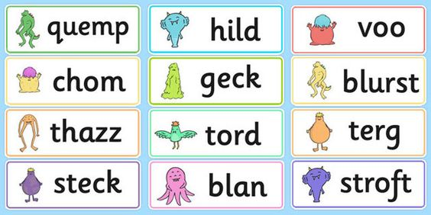
Friday- Complete a full lesson on Reading Eggs | Friday- Play “Odd and Bob” – select ea words with and decide if they are real words or pseudo words.
Weekly Writing Tasks | Weekly Maths Tasks – Subtraction
Monday- Our new topic is Space. What do you already know about space? Write some sentences to tell me. | Monday- Watch the video lesson on Seesaw assigned today and complete activites on video- Subtraction by crossing out . Complete True or False on Page 2.
Tuesday- What would you like to find out about space? Write some questions.  EG: How many planets are there? Can you walk on the moon? Etc.. | Tuesday- Complete task assigned today on Seesaw- subtraction by crossing out
Wednesday- Practice writing this week’s keywords. See above. You could write a sentence with them in. You could make some mini books for your toys. Write this week’s keywords inside them then you and your toys can have fun learning to read them.  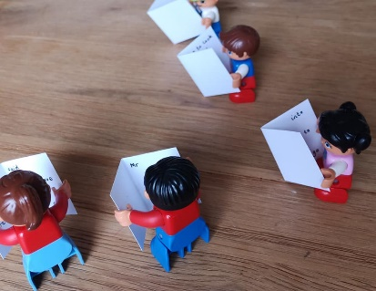 | Wednesday- Complete task assigned today on Seesaw – subtraction by crossing out
Thursday- Start to practice grown up “joined up writing.” Practice c try very hard to do the flick and practice some simple words such cat, can, cap, car, cup etc.. | Thursday- Live Lesson today 10 am – subtracting by using number bonds.  Then complete the work sheets to go with the lesson on Seesaw.
Friday- Quiz day  Get a grown up to test how many words you know from this week! If you get them wrong just practice them again.  tea, sea, seat, dream, cream, scream, clean.  here, once, brother, small, who | Friday Can you make up a subtraction story?  I had 6 sweets , my friend took 2 how many do I have left etc…  Can you draw what happened and record it using subtraction by crossing out or subtraction using number bonds.  Now go on Seesaw and complete some number stories

Learning Project - to be done throughout the week
This project this week aims to provide opportunities for your child to start to learn about Space. This week will act as an introduction and help the children learn what Space actually is and the names of the planets.

PE
Try Cosmic Yoga – Yoga Space Adventure

Forest School
When out in the forest (children in school) or your daily walk look up and notice the tree shapes. Winter is a perfect time to see them. Can you draw some of the shapes? Which is your favourite?

Watch the Live Lesson on Zoom
Tuesday 12th January 1:30pm – Topic Launch

What is Space?
Watch the video to learn about what Space actually is. What can we find in Space?

Name the planets
Watch the video to learn the planet names.

Learn features of planets
Watch the lesson about planets – Can you learn a rhyme to remember them? Can you learn the actions?

Create the planets
Create the 8 planets showing their features. You can use felt tip pens /finger prints/ papier mache/playdough

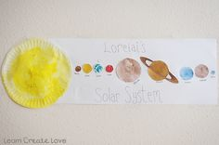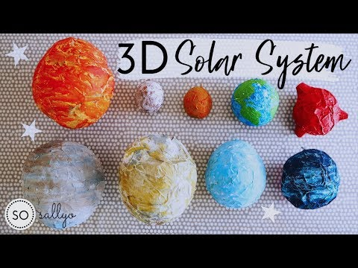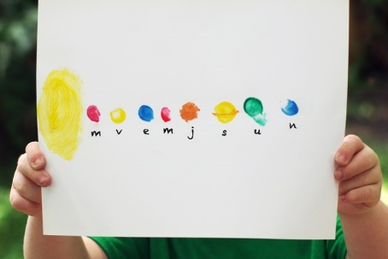

What is your favourite planet?
Complete the task assigned into Seesaw for Friday 15th January 6am

