Project - Under the Sea

Learning Project WEEK Beginning 4.1.21– Winter
Age Range: EYFS
Weekly Reading Tasks | Weekly Phonics Tasks
Monday- INSET | Monday- INSET
Tuesday Read your school book. Video yourself reading it and send me the video on Seesaw. | Tuesday- Practice all of your Set 1 Sounds  Recap all Set 2 Sounds and practice writing words with them in.  CHALLENGE: Get ready for this term and learn some Set 3 Sounds!
Wednesday Read a book about Winter on Epic.  Learn about Snowy Sports  Year One Epic Class Code: tvb2960 | Wednesday- There are live phonics lessons on Youtube daily. Click here to watch and keep on practicing at home.
Thursday    Practice reading our keywords. Place out a selection of coloured paper. You will also need to have the matching coloured pens. Write out the words or letters onto a white sheet alternating the coloured pen that you use. Cut out the words, fold and place in a tub or cup. Now your child takes a piece of paper. Reads the word identifies the colour it is written in and then writes it onto the matching coloured sheet of paper. So, for example, they take out the word ‘said’ that is written in green and then they write the word onto the green sheet. | Thursday Play “Splat the Letter” - Write out the letters for the sounds your child has been practising on pieces of paper and spread out on the floor. Take it in turns to shout out a sound and both players have to try and splat the sound with their hand.  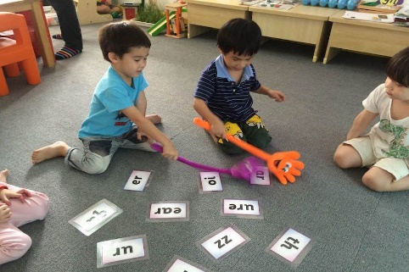
Friday- Complete a full lesson on Reading Eggs | Friday- Play “Pick a Picture” – practice reading words with digraphs (2 letters, one sound) in them
Weekly Writing Tasks | Weekly Maths Tasks – Subtraction
Monday- Inset | Monday- Inset
Tuesday- Did you have a good holiday? What did you do? What presents did you get from Santa? What was your favourite day? Tell me your news – remembering finger spaces, capital letters and full stops. | Tuesday- Watch the video lesson about time and the seasons.  https://classroom.thenational.academy/lessons/exploring-and-discussing-time-and-the-seasons-6mwp8c?activity=video&step=1
Wednesday-Start to practice grown up “joined up writing.” Practice a try very hard to do the flick and practice some simple words such at, an, and | Wednesday- Make a simple seasons spinner – label the four seasons and draw a picture in each quarter.  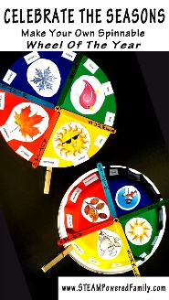
Thursday- Write an acrostic for winter  Woolly hats  Icy winds etc….  N  T  E  R | Thursday- Learn the Months of the Year song
Friday- Write a sentence using two adjectives about why you like winter.  EG  I like the cold, frosty winter because I like to wrap up in my warm, cosy jumper. | Friday Practice writing the months of the year. What special events take place each month? Find out which month your family member’s have a birthday.

Learning Project - to be done throughout the week
This project this week aims to provide opportunities for your child to learn more about the seasons and winter. You can explore this through art and science and do some writing about what you learn.

What can you see in winter?
Watch the lesson about what you see in winter.
Now go on a winter walk.
Can you write a list of things you can see in winter?

Create a winter scene
Watch the video about the changing seasons. Can you create a winter collage? You could use cotton wool or shaving foam mixed with pva glue to create a
snowy puffy paint scene.

Look at Gabriele Munter paintings
Look at images of paintings of winter done by the famous German expressionist painter Gabriele Münter.
What can you see?
What do you like/dislike about them?
What colours has she used?
Can you create a painting inspired by her work?

Learn about Hibernation
Watch the lesson on hibernation. Write a Hibernation Checklist- what would you need if you were a hedgehog about to hibernate?

STEM Learning Opportunities #sciencefromhome
Ice investigation
● Put a container of water outside overnight to see if you can make ice. How has it changed?
● Freeze a container of water with a lego toy inside it in your freezer.
● How can you set the toy free? Can you heat up the ice? Add salt? How can you melt your ice?

