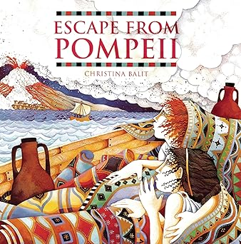
Communication, Language & Literacy
Literacy
Historical Narrative: We will use “Escape from Pompeii” by Christina Balit as a stimulus for writing. We will be writing our stories from a character’s point of view as well as writing diaries and explanatory letters.

French
Our work for this half term is ‘My/your family members.

Knowledge & Understanding of the World
History
During this topic we will be looking at why the Romans were so powerful, their impact on Britain and how Britain changed during their occupation.

Geography
During this topic, we will be looking at the topic – Where does our food come from? We will be exploring how our food choices have an impact on the environment, how to trade responsibly and are our school dinners ethically sourced?

RE
This half term we will be studying the beliefs and traditions of Sikhism.

Science
Our Science focus is electricity. We will be learning which appliances require electricity, creating complete circuits, finding out which materials conduct electricity and using switches in a circuit.
Personal, Social & Emotional Development
PSHE
Our PSHE topic this half term is “Safety and the Changing Body”
Problem Solving, Reasoning & Numeracy
Maths
This half term, we will be learning about odd and even patterns, square numbers and multiplicative structures. We will also learn how to use co-ordinates and reviewing and extending our understanding of fractions.
Creative Development
PE: GYM
This half term’s P.E. topics are gym and orienteering.

Computing
This half term we will be controlling an object to move along a route, seeing how an algorithm works, suing variables and repeating events in programs.

DT
We’ll be designing and creating our own sling shot car.

Art
We will be looking at texture and pattern in painting. We will be inspired by the work of Enid Marx.

Music
This half term we will be learning about instrument families, exploring tone and recognizing and responding to musical instructions.
Autumn 2 - Year 4

