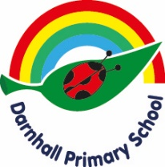

EYFS Early Adopter Revised Early Learning Goal Descriptors

Expressive Arts and Design

ELG: Creating with Materials

- Safely use and explore a variety of materials, tools, and techniques, experimenting with colour, design, texture, form and function.
- Share their creations, explaining the process they have used.
- Make use of props and materials when role playing characters in narratives and stories.

