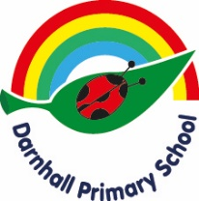

EYFS Useful Websites

https://www.bbc.co.uk/cbeebies
https://www.bbc.co.uk/bitesize
https://www.busythings.co.uk/
http://www.crickweb.co.uk/Early-Years.html
http://www.ictgames.com/
https://www.oxfordowl.co.uk/
https://www.phonicsplay.co.uk/resources
https://www.ruthmiskin.com/en/find-out-more/parents/
https://www.topmarks.co.uk/maths-games/3-5-years
https://www.phonicsbloom.com/
https://www.education.com/games/word-patterns/

