Glossary
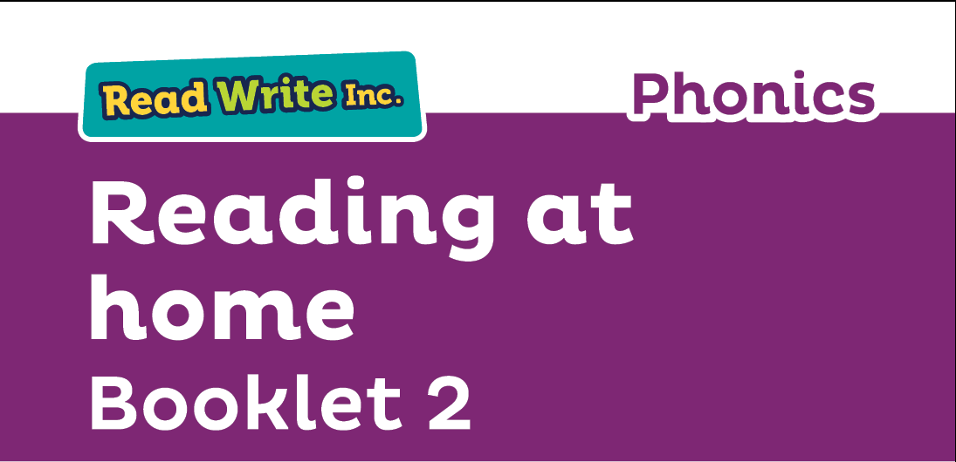
Fred Talk – sounding out the word before reading (blending)

sound-blending – putting sounds together to make a word,
e.g. c–a–t cat

special friends – sounds written with more than one letter,
  - sh, ng, qu, ch

Speed Sounds – the individual sounds that make up words

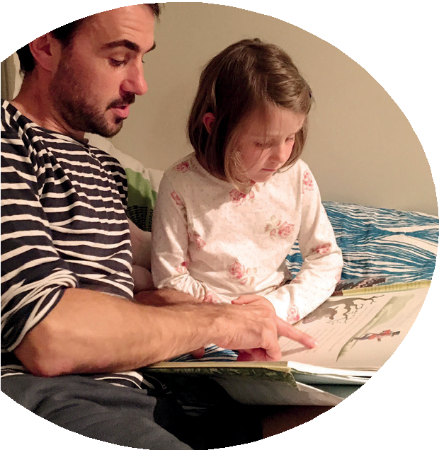
Read stories to your child with feeling! The more you love the story, the more your child will love reading.

Booklet 2 shows you how to help your child practise reading:
- Sets 2 and 3 Speed Sounds
- Pink, Orange, Yellow, Blue and Grey Storybooks.

Your child is learning to read with Read Write Inc. Phonics, This second booklet shows you how you can get your child off to a quick start.

Your child will learn to read in a very simple way. He or she will learn to:
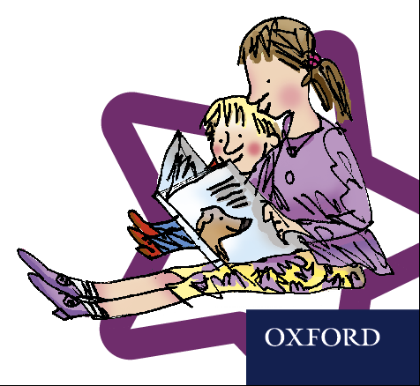
- Read letters by their ‘sounds’

Blend these sounds into words
- Read the words in a story.

www.ruthmiskin.com/parents has many videos to help you help your child.


For more information on Read Write Inc., please talk to the Read Write Inc. manager in your child’s school or visit www.readwriteinc.com.

8

How to listen to your child read
How will my child learn to read?

Your child will already have learnt to read:
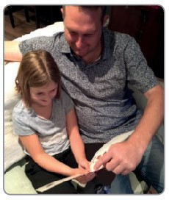

- Set 1 Speed Sounds: these are sounds written with one letter:
m a s d t i n p g o c k u b f e l h r j v
y w z x and sounds written with two letters • (your child will call these ‘special friends’): sh th ch
qu ng nk ck
- Words containing these sounds, by sound-blending,
e.g. m–a–t mat, c–a–t cat, g–o–t got, f–i–sh ﬁsh,
s–p–o–t spot, b–e–s–t best, s–p–l–a–sh splash
- Blending Books and Red, Green and Purple Storybooks.

- Do not read the book aloud before your child reads it to you.
- Ask your child to read the sounds and words before he or she reads the story.
- When your child reads the story, ask him or her to sound out the words that he or she can’t read automatically. Don’t allow your child to struggle too much. Praise your child when he or she succeeds.
- Read back each sentence or page to keep the plot moving. (Your child’s energy is going into reading the words not the story.)
- Do not ask your child to guess the word by using the pictures.
- Do it all with patience and love!
Now, he or she will learn to read:
- Set 2 Speed Sounds: ay ee igh ow oo oo ar or air ir ou oy
- Words containing these sounds
- Pink, Orange and Yellow Storybooks.

Next, he or she will learn to read:
- Set 3 Speed Sounds: ea oi a-e i-e o-e u-e aw are ur er ow ai oa ew ire ear ure
- Words containing these sounds
- Blue and Grey Storybooks.

We have a storytime every day at school so children develop
a love of stories. We hope that you will do the same by reading a bedtime story to your child every night. We have wonderful books in school for you to borrow.

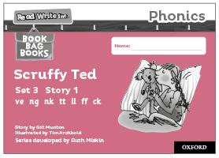
Black and White Storybooks Your child will continue to bring home a Read Write Inc. Phonics black and white Storybook. This is
a copy of the colour version he or she will have read at school.
Your child will have read this story three times with their reading teacher, so should be able to read the story conﬁdently.
A brief explanation of how to follow the activities is included in the books. These will be sent home and changed on a Monday and a Thursday.

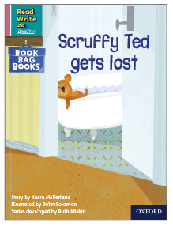
Book Bag Books
Your child may also bring home a Book Bag Book. This book builds upon the ideas and many of the words in the Storybook he or she has just read. Your child will need more support in reading this book.
Again, explanations of how to use the activities are included in the books.
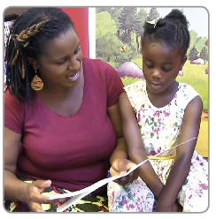

The book bag books will be sent home and changed a Monday.

1. Help your child read the Sets 2 and 3 Speed Sounds
Your child will bring home the Set 2 or Set 3 Speed Sounds cards or a My Sets 2 and 3 Speed Sounds Book.
Each sound has a picture and phrase to help your child remember the sound. For example:
- the sound ‘ay’ has the phrase ‘May I play?’ with a picture of children playing together
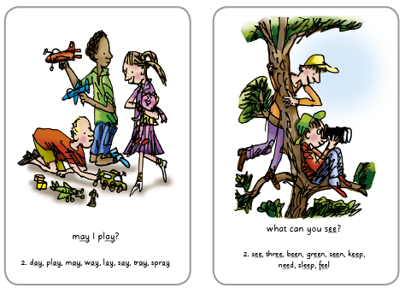
- the sound ‘ee’ has the phrase ‘What can you see?’ with a picture of two boys in a tree.

Using the Set 2 Speed Sounds cards
First, in the pack, ﬁnd the sounds: ay ee igh ow oo

- Picture side up, ask your child to say the phrase on each card, getting quicker each time.
- Help your child to say the sounds on the letter side, getting quicker each time. If he or she forgets, turn back to the picture side. When your child can say the sounds without turning over to check, increase the speed!
- Repeat with the sounds: oo ar or air ir ou oy and then mix these sound cards with the ones above. Keep practising until your child can read these 12 sounds quickly and conﬁdently.

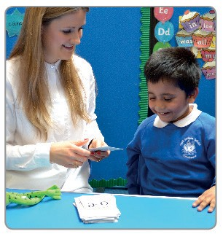

Learning the Speed Sounds in the classroom.
Using the Set 3 Speed Sounds cards
First, in the pack, ﬁnd the sounds: ea oi a-e i-e o-e u-e
  - Picture side up, ask your child to say the phrase on each card, getting quicker each time.
  - Help your child to say the sounds on the letter side, getting quicker each time. If he or she forgets, turn back to the picture side. When your child can say the sounds without turning over to check, increase the speed!
  - Repeat with the sounds: aw are ur er ow ai oa ew and then mix these sound cards with the ones above. Keep practising until your child can read these 14 sounds quickly and conﬁdently.
  - Repeat with the sounds: ire ear ure


