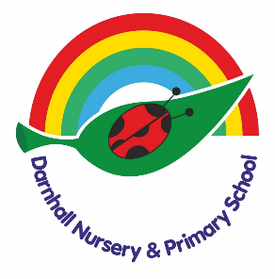
EYFS Curriculum

Intent

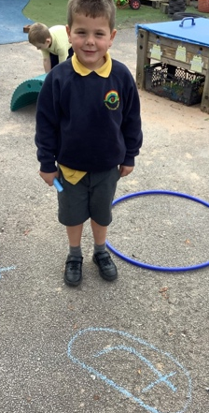
At Darnhall, we provide a high-quality EYFS education giving children a secure and confident start to their school life. We are committed to nurturing a lifelong love of learning alongside the aims of the EYFS statutory framework. We strive for high standards, consider the development of the whole child and seek to foster resilience and independence.

We aim to provide the children with the essential knowledge that they need to prepare them for their future success and to give children the best possible start to their early education.

We provide inviting classroom environments indoors and outdoors to stimulate learners and engage them in developing the three ‘Characteristics of Effective Learning’ as set out within the EYFS.

The EYFS curriculum encompasses our school motto…
Dream, Believe, Learn, Achieve

We carefully plan our EYFS curriculum to meet the following aims:
- Foster a love of learning which inspires curiosity.
- Ensure all children have access to high quality learning opportunities.
- Provide parents/carers with the opportunity to develop their child’s learning at home.
- Share a love of learning between our children, staff, parents, and the wider community.
- Develop knowledge and understanding of the community and wider world.

Implementation

- Quality first teaching across all areas of the curriculum.
- Stimulating learning environments indoors and outdoors.
- Well planned and organised continuous provision which allows the children to learn through play.
- A carefully planned balance of adult-led and child-initiated learning opportunities.
- Promoting a love of learning through real life experiences and opportunities to build on prior learning.
- Close links with local nurseries which support a smooth and settled transition into school.
- Strong parental partnerships which empower parents to support their child’s learning at home.
- Systematic approaches to teaching reading to ensure all children learn to read. High quality phonics teaching is started as soon as children begin reception.
- Opportunities for children and families to develop a love of reading.
- Planned opportunities for outdoor learning through ‘Forest Schools’ and in the outdoor classroom.


Impact

- High levels of engagement and motivation demonstrated from children which supports them to become lifelong learners.
- Confident and capable readers who demonstrate a love of reading.
- Evidence of strong links with parents.
- Children demonstrate the characteristics of effective learning and are well prepared for the next stage in their learning.
- Children feel happy and safe and enjoy coming to school.
- All children access a balanced and challenging curriculum regardless of their background, needs or abilities.
- Children make strong progress from their starting points and are offered a broad curriculum which meets each child’s unique needs.
- Children are supported by adults that are well trained and passionate about providing the best education for every child.
- The percentage of children achieving the GLD within the EYFSP is in line with or above the national average

In our classroom, you may see children playing alone or with their peers, deciding on resources and choosing how to spend their time. You may see a child playing and listening to an adult, who is modelling how to achieve something or teaching a new skill that interests the child.

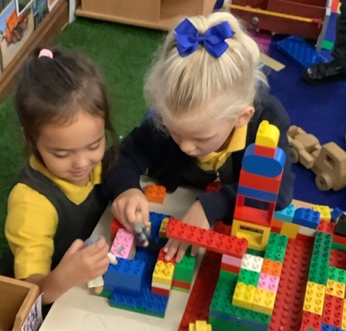
Adults may scaffold a child’s play. This involves taking their play to higher levels of learning, entering the play as a co-creator, and helping to provoke a framework for the children to go from ‘what they know’ to ‘what else they could know.’ Scaffolding enables a child to solve a problem, carry out a task or achieve a goal which is just beyond his or her abilities. During play, where foundational social and emotional skills are developed, scaffolding is a bridge to new skill levels using three key ingredients; modelling the skill, giving clues, and asking questions while the child is trying out a new skill, and then as the child approaches mastery, withdrawing the support.

The EYFS statutory framework does not prescribe a particular teaching approach.
Play is essential for children’s development, building their confidence as they learn to explore, relate to others, set their own goals and solve problems. Children learn by leading their own play, and by taking part in play which is guided by adults.
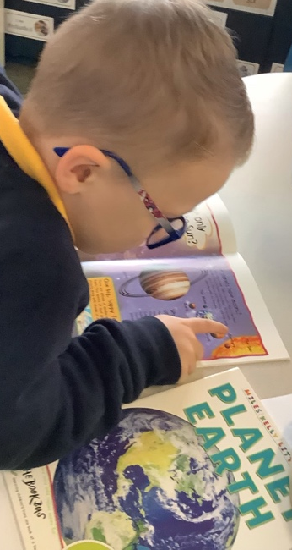
The EYFS curriculum lead carefully plans what the children learn in the classroom and through provision enables them to learn from their interests, alongside extending their knowledge and understanding through direct teaching.

Each day, we stimulate children’s interests, respond to each child’s emerging needs and guide their development through warm, positive interactions coupled with secure routines for play and learning.

As the children develop and their skills progress throughout the reception year, we use more direct teaching and modelling and plan specific sequences of lessons. These strategies help us to focus on teaching the essential skills and knowledge in the specific areas of learning so that the children can develop the skills and confidence required for the end of their reception year.

