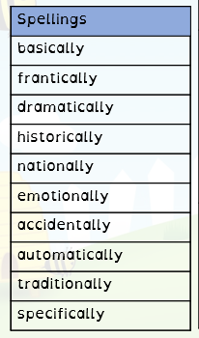
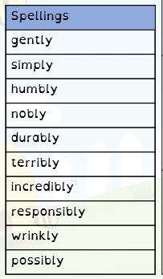
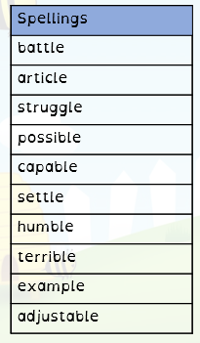
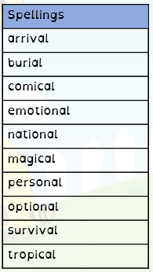
Date set: 16th March
Date of test: 23th March
No spellings set over easter holidays
Date set: 9th March
Date of test: 16th March
Date set: 2nd March
Date of test: 9th March
Date set: 23rd February
Date of test: 2nd March

