
St Vincent’s Catholic Primary School

Year 3 Curriculum Overview- Spring Term 2026

Welcome to the Spring term of Year 3. We hope you have all enjoyed some family time this Christmas and are ready for another busy term. Thank you for all your kind words, cards and Christmas gifts – they were much appreciated. As always, we will aim to keep you informed of any additional dates as the term progresses but please do not hesitate to get in contact if you have any queries or concerns. Our email addresses are as follows:

jjennings@stvincents.trafford.sch.uk
kjones@stvincents.cheshire.sch.uk
Important dates this term:
Stone Age Tatton trip – Thursday 8th January
Swimming lessons on Friday afternoons, from 16th January
Enrolment Mass for children making their First Holy Communion- Sunday 25th January,
11am at Church
Visit to St Nicholas High School for retreat- 10th February
World Book Day – 6th March
Parents’ Evening on Tuesday 24th March and Wednesday 25th March
Children will make their First Forgiveness in Church, at 7pm on Tuesday 31st March
Parent information morning for residential – Wednesday 4th March at 9am
Residential to Fox Howl (Delamere Forest outdoor education centre, Frodsham) – Thursday 7th May to 8th May.

During the Spring term your child will study the following curriculum areas:
Religious Education:
- Galilee to Jerusalem
- Desert to Garden

English:
The Rhythm of the Rain by Grahame Baker Smith -Setting Narrative
-Information Leaflet
The Visible Sounds by Yin Jianling -Return Narrative
-Letter
Maths:
- Multiplication and division.
  - Multiplying a 2-digit number by a 1-digit number without exchanges
  - Multiplying a 2-digit number by a 1-digit number with exchanges
  - Dividing a 2-digit number by a 1-digit number without exchanges
  - Dividing a 2-digit number by a 1-digit number with exchanges
  - Rapid recall of 2, 5, 10, 3, 4 and 8 times tables
- Length and perimeter.
  - Measure in centimetres, meters, millimetres
  - Calculate perimeter.
- Fractions.
  - Fractions on a number line.
  - Compare and order non-unit fractions.
  - Find equivalent fractions on a bar model and on a number line.
- Mass and capacity.
  - Measure mass in grams and kilograms.
  - Add and subtract masses and add and subtract capacities.
  - Measure capacity in millilitres and in litres.

Science:
- Rocks and soil.
- Plants.
Computing:
- Programming A – sequence in music.
- Data and information – Branching databases.
History:
- How did Britain change from the Stone age to the Iron age?
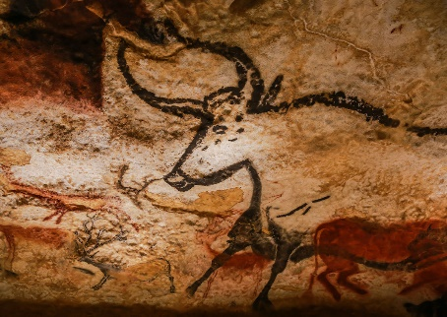
Art:
- Prehistoric art.
D.T.:
- Structures: Constructing a castle.
Music:
- Compose using your imagination
- More Musical Styles
RSHE:
- Friends, Family and Others
- When things feel bad
- Sharing online
- Chatting online
- Safe in my body
- First aid heroes

P.E.:
- Swimming – on Friday afternoons.
- Tag Rugby.
- Cricket (outside provider) – after half term.
- Tennis.
Children must have outdoor and indoor (pumps, t-shirt, shorts) PE kits every Thursday for Coach Dave.
Swimming kits are needed every Friday (first half-term only).

Spring term homework timetable:
 | Monday | Tuesday | Wednesday | Thursday | Friday
 | Spelling practise  Spelling Shed | Reading  Times tables practise | Reading comprehension or SPaG CGP | Reading  Times tables practise | Maths.co.uk
DUE | Tested on Mondays |  | The following Wednesday |  | The following Friday

In addition to reading regularly, we also encourage you to go on TT Rockstars as often as possible with your child.

Also, in order to help the children to become more organised and independent when they arrive at school, please could you check they have the following items every day:

- Homework diary
- Completed homework (if applicable)
- Reading book and reading diary

If you have anything that we could use for any of the topics mentioned, we would be very grateful if we could borrow them. Additionally, if you could help enrich our curriculum based on any of the topics above, please let us know!

Thank you for all your support.

Mrs Jennings and Mrs Jones

