For more information contact:

Your local School Health team can be contacted Monday to Friday from 9am to 5pm for advice and support.

We can arrange to see you at home, in a clinic or a venue of your choice if possible:

Contact details :
Formby School Health Team
Formby Clinic
Formby
L37 4AY
Tel 01704 395723

nwbh.seftonformby 0-19team@nhs.net

Useful Website
www.nwbh.nhs.uk/child-health-services
Follow us on Twitter: @NWBoroughsNHS
Like us on Facebook: www.facebook.com/nwboroughsnhs

. 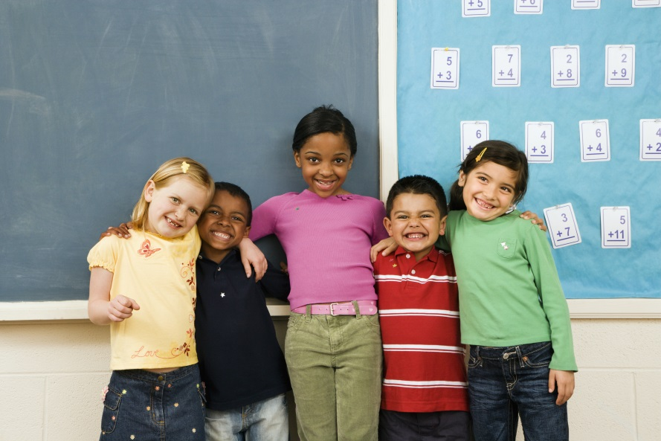
www.nwbh.nhs.uk

Confidentiality

All members of the School Health Team have a duty to protect your privacy and confidentiality. We would only share information with your consent. Information without consent could only be shared in situations where we have a concern that there was a risk of harm to your child or a member of your family.

If you have any worries about confidentiality please talk to a member of staff

Your School Nursing Service
• Text should be in Ariel
• Text should be no smaller than 12pt
• Text should be in black
• Sub-headings should be bold
• Make sure you have your flyer or poster approved by the communications team before issuing it.
- Image box (see sketch) – ‘Insert your image here. If you require an image from the Trust’s photo library please contact the communications department’
What are School Nurses?
- Specially trained nurses
- We work with school aged children from reception until they are age 19.
- Every school has a school nurse who is based in a clinic near your school.
Who are we?
- Part of a team who support the health & wellbeing of every child aged 5-19 yrs.
- We work within a multi skilled team so the most appropriate person can deal with your needs
- Our enhanced 5-19 team support children who attend Pupil Referral Units and children who are educated at home.
Public Health Role
We can provide support for:
- Resilience & wellbeing
- Healthy lifestyles
- Keeping safe
- Maximising learning & achievement
- Supporting complex & additional health & wellbeing needs
- Transition through services

Children with Special educational needs and disabilities (SEND)
We will work in partnership to create a support system for all children with SEND.
Working together with families to make sure all children have an opportunity to reach their full potential and live healthy, happy lives.

Safeguarding Children & Young People
- If you are worried about an adult or child’s safety including your own, at home or anywhere else you can speak to us
- We work closely with other services to keep you safe
- There may be occasions when we are asked to attend meetings with other agencies about you and your family, we may see you more frequently if this happens
- Whenever possible anything we do will be discussed and agreed with you

What we offer to everyone

- Prevention & early intervention
- Health screening & reviews
- Signposting to other services
- Key health priorities including healthy lifestyles such as healthy eating and weight, smoking, drugs and alcohol awareness
- Health promotion advice & activities
- Healthy relationship advice and support along with sexual health & contraception advice
- Routine Childhood Immunisation Programme
- National Child Measurement Programme
- Health drop-ins - regular sessions for children and parents/ carers are held within primary schools. Weekly sessions are held for young people in secondary schools
- Helping keep children and young people safe

