Areas of the curriculum to be taught separately  RE  Hinduism in Britain today  Maths  -Length and Perimeter  - Fractions and Decimals  English  English – writing linked to the discovery of the lost tomb.  Games/PE  Athletics and Egyptian Dance.  Music  Wider opportunities- Brass instrument  Computing – Data loggers  PSHE- Citizenship  Latin- Verbs and adverbs  Art -The Art of Display  Science – Sound  DT- Making pyramids | 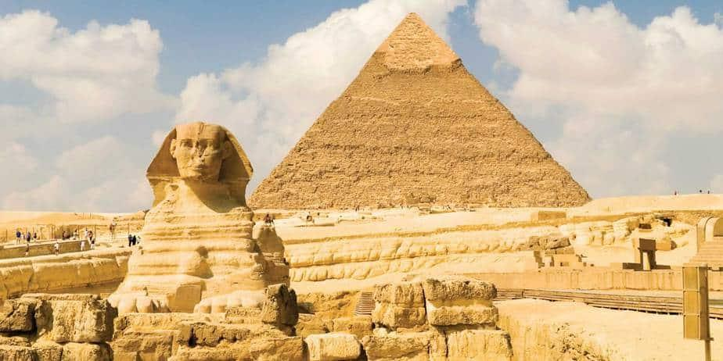 | Egyptian Civilisation
Main Curriculum Focus
As historians we will look at the lives of the Ancient Egyptians, their beliefs and practices. We will be visited by Mr Egypt (who lives in Luxor), to learn about the reality of Egyptian life.
As geographers, we will research the River Nile and its importance to the Egyptians. As writers, linking to our historical topic, we will follow in the footsteps of one of Britain’s most famous archaeologists, Howard Carter, as he hunts for the legendary tomb of Tutankhamun. We will write a diary set in that era, gathering evidence from different sources to bring our writing to life.

 | L.E.A.R.N.  This half term we continue to focus on all aspects of LEARN We will promote and celebrate each strand across the curriculum. |  | How you can help at home  Please help your child by:  - practicing times tables (these MUST be secured this year)  - practicing spellings  - reading at home  - telling the time  - practicing handwriting
Our Year 4 Christian value is ‘Hope’.

