Areas of the curriculum to be taught separately  RE  Exploring Easter as a story of betrayal and trust.  Year 4 leading the Easter church service  Maths  Multiplication and division  Length and perimeter  Fractions  English  English - grammar, punctuation and spelling linked to ‘Charlie and the Chocolate Factory.’  Games/PE  Handball  Yoga  Music  Wider opportunities- Brass instrument  Art  The drawing journey  PSHE  Health and Well being.  Latin  Subject and object nouns | 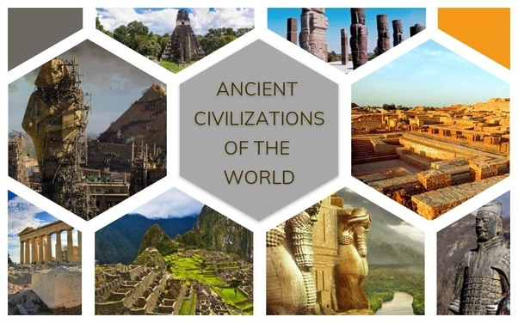 |  | Ancient Civilisations
Main Curriculum Focus
We will take a look into three of the four main ancient civilisations, Ancient Sumer, Indus Valley and The Shang Dynasty. In Science, we will look at electricity, making circuits that include switches and investigating which materials and metals conduct electricity. We will use our knowledge of switches in Design Technology and make a motorised vehicle.
There will be a strong focus on the Easter story and its importance to Christians. We will be using a dramatisation of the story as the basis for the Easter church service we will lead.
 | L.E.A.R.N.  This half term we continue to focus on all aspects of LEARN We will promote and celebrate each strand across the curriculum. | How you can help at home  Please help your child by:  - practice times tables (these MUST be secured this year)  - practice spellings (on Doodle)  - reading at home  - telling the time  - practice handwriting size and joins.
Our Year 4 Christian value is ‘Hope’.

