Areas of the curriculum to be taught separately  RE- Why do some people think life is a journey?  Maths  -Further multiplication and division  -Graphs  -Fractions  -Time  Geography- South America – Rainforests and Climate zones.  Games/PE  Outdoor-Basketball  Indoor- Gymnastics  Art – Exploring pattern- focusing on the artist Shaheen Ahmed  Music  Rainforest body and tuned percussion  PSHE  -Health and Wellbeing  -Safety  Computing  -Online safety | 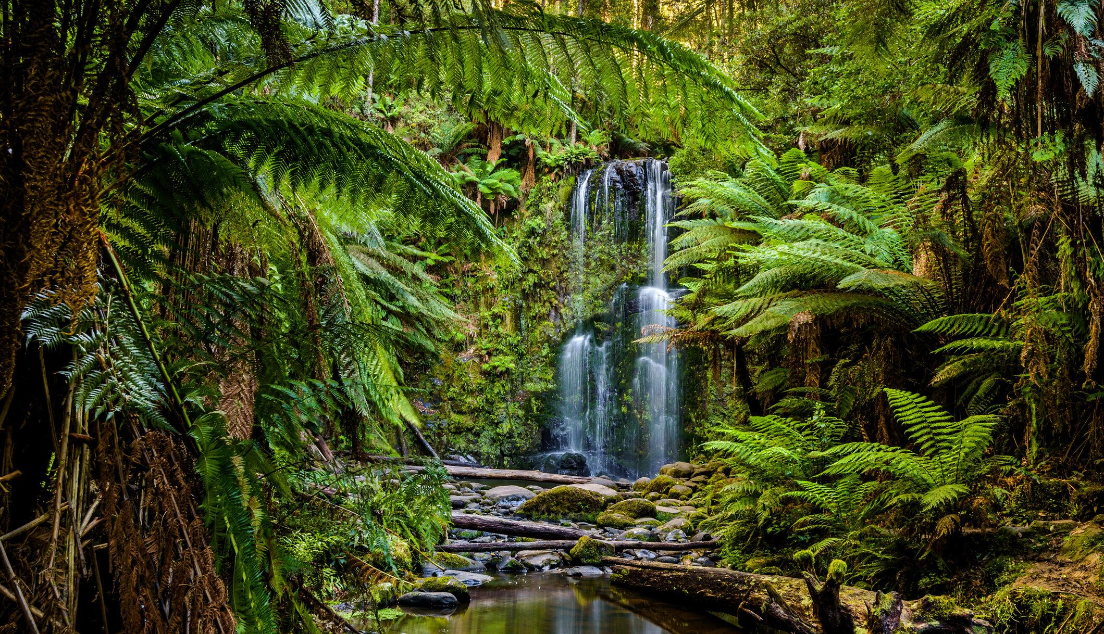 |  | Rainforests
Main Curriculum Focus

Our English will focus on the ‘The Great Kapok Tree’ by Lynne Cherry. We will discuss the characters’ thoughts and feeling. The children will change elements of the story, to write their own persuasive narrative. In science, we will look at how we can group animals in different ways. We will use a variety of classification keys to help us group, identify and name living things from our local and wider environments. We will construct and interpret food-chains, focusing on producers, consumers, predators and prey. We will also think about how environments can change and how this can sometimes pose danger to living things.

 | L.E.A.R.N.  This half term we continue to focus on all aspects of LEARN We will promote and celebrate each strand across the curriculum. | How you can help at home.  - learning times tables  - Encourage the children to regularly use Doodle Learning- Maths,Tables, Spelling and English  - reading at home  - telling the time
Our Year 4 Christian value is ‘Hope’.

