Areas of the curriculum to be taught separately  RE  Exploring the symbolism of light.  -Christingle  Maths  – Addition/ subtraction  -Area  English  Writing a narrative.  PE  Indoor - Gymnastics 4M/swimming 4C  Outdoor – Hockey  Music  The Romans  PSHE  -Celebrating ourselves and our roles.  -Our changing emotions.  -Friendships  Latin  Verbs and adverbs. | 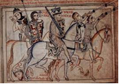  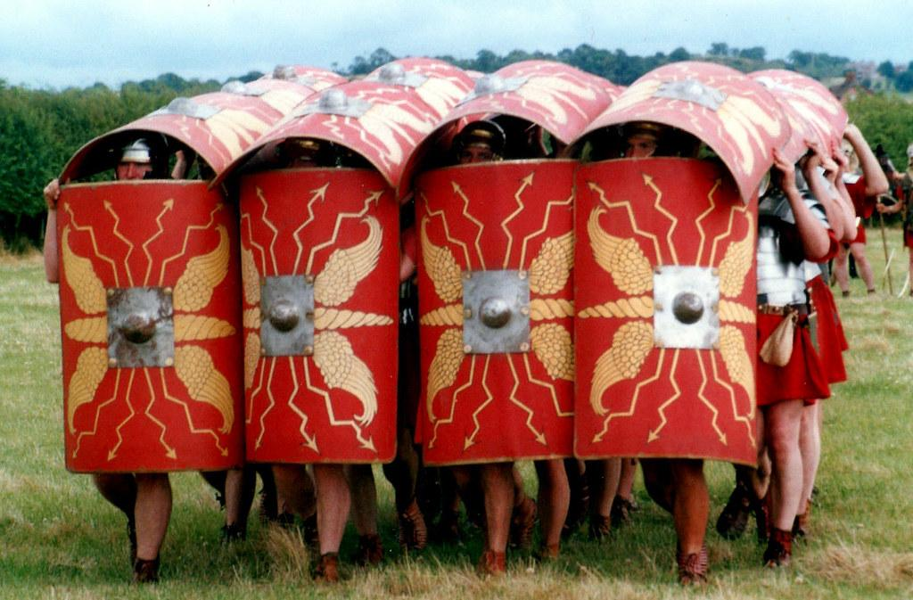 |  | After the Romans
Main Curriculum Focus
As Historians we will consider whether the settlement of the Anglo-Saxons made England a better or worse place to live?
We will look at how Saxon England began. We will explore events that happened during the Anglo-Saxon period. We will also be comparing daily life in Saxon England with the Romans.
As writers, we will be using the text, The Boy, the Mole, the Fox and the horse. The children will create their own sentences based on Year 4 writing criteria. They will develop their own ideas and plots to write their own story.
As Designers, we will look at a selection of biscuits. We will adapt a recipe and design our own packaging.
 | L.E.A.R.N.  This half term we continue to focus on all aspects of LEARN We will promote and celebrate each strand across the curriculum. | How you can help at home  Please help your child by:  - learning times tables and division facts  - learning spellings (found in Doodle learning spelling)  - reading at home  - telling the time
Our Year 4 Christian value is ‘Hope’.

