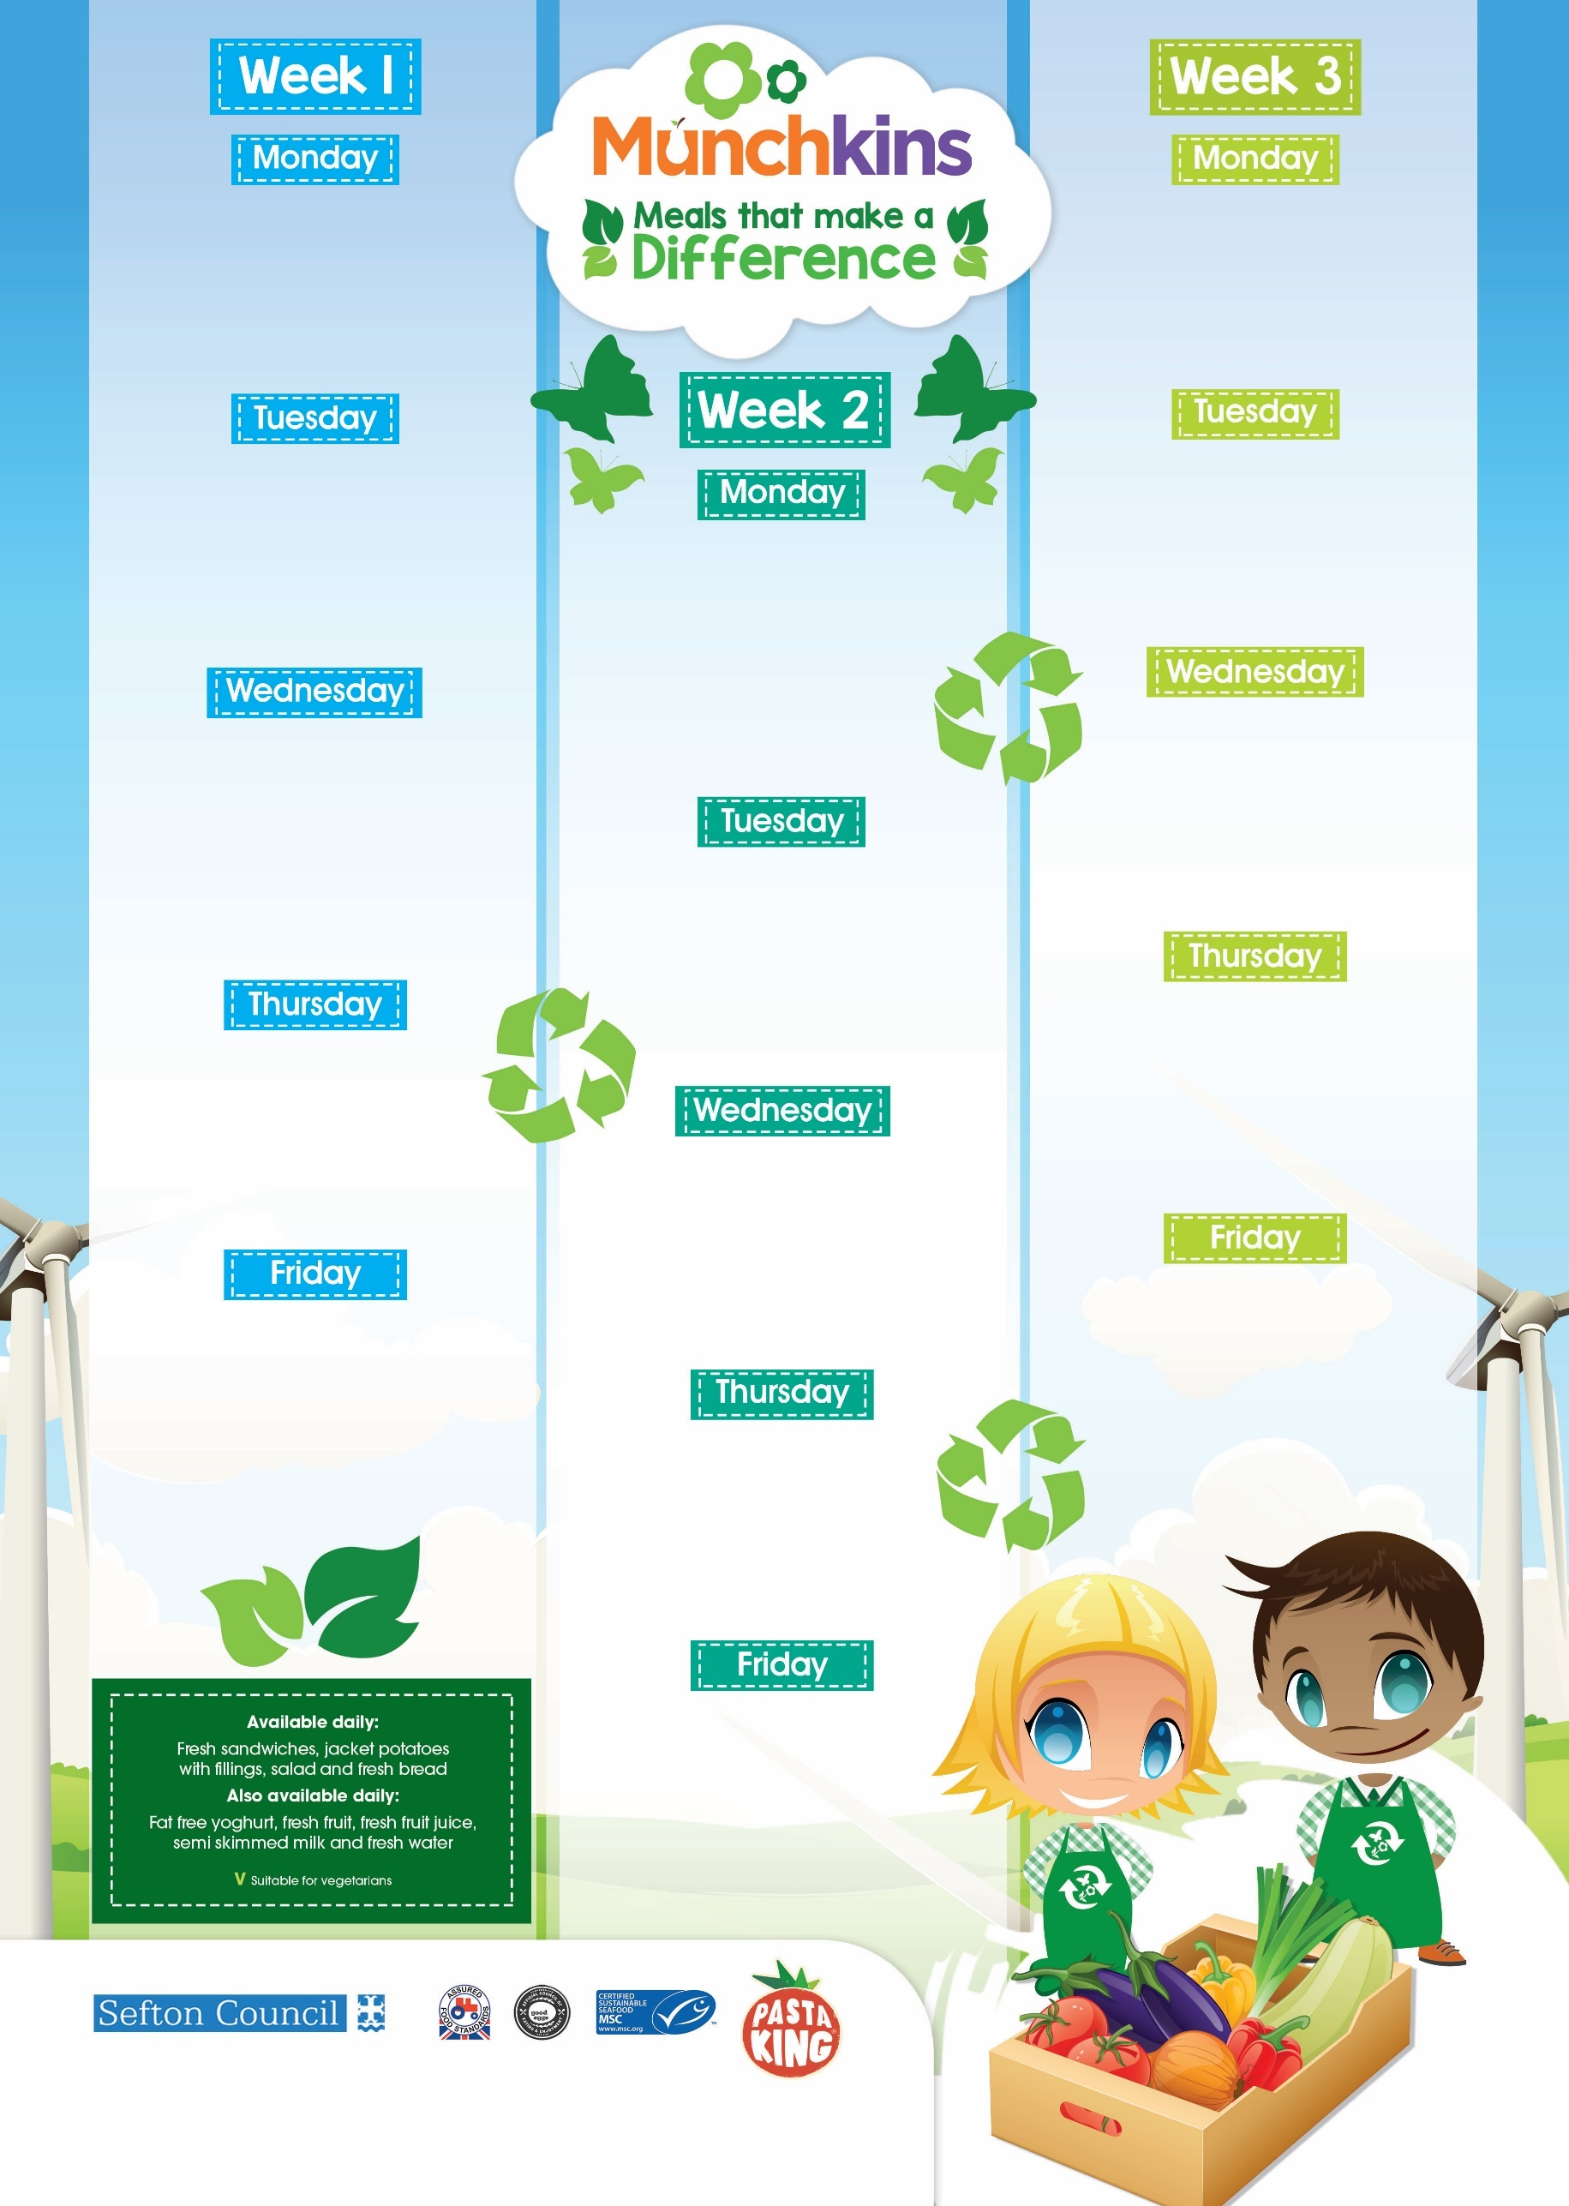
Oven Baked Sausages, Mashed Potatoes, Garden Peas

V Veg Curry & Rice, Naan Bread

Homemade Mini Biscuit
& Fruit Slice
Fishy Friday, Garden Peas & Sweetcorn , Chips

V Tuna Pasta

Chocolate & Banana Brownie
Big Breakfast

Tuna Pasta Bake & Crispy Salad

Oat, Apple & Honey Slice
BBQ Chicken with Sunshine
Vegetable Rice

V Mac & Cheese with Mixed Salad

Shortbread Biscuit

Fruity Flap Jack
Cook’s Choice Pizza, Coleslaw, Salad, ½ Jacket Potato

V Tomato & Basil Pasta, Roasted Veg, Crispy Salad

Peach & Pineapple Flapjack
Sausage & Tomato Pasta,
Mixed Salad

V Veggie Cottage Pie & Greens

Fruity Oat Cookie
Chicken Tikka Curry, Boiled Rice, Naan

V Pizza Pockets, Salad Sticks, Potato Wedges

Vanilla Cupcake
Roast Chicken & Gravy, Sweetcorn,
Green Beans, Paprika Potatoes

V Quorn Bolognaise with Pasta & Onion Bread

Jam Sponge & Custard
Meatball Pasta

V Cheese & Onion Sausage Roll & Wedges

Frozen Yoghurt Pot
Fishy Friday, Garden Peas, Chips Potatoes

V Tuna Pasta

Cookie
Fishy Friday, Mushy Peas, Chipped Potatoes

V Tuna Pasta

Fairy Cake
Chicken Korma with 50/50 Rice,
Naan Bread

V Cheese & Potato Puff,
Baked Beans

Ice Cream Pot
Honey Glazed Gammon, Vegetables, Paprika Roast Potatoes & Gravy

V Quorn sweet & sour & rice

Jam Sponge & Custard
Beef Lasagne & Garlic Bread, Side Salad

V Chunky Veg Curry with 50/50 Rice, Naan Bread

Fruit Sponge & Custard
Roast Turkey, Carrots & Peas,
Roast Potatoes

V Quorn & Bean Chilli with Boiled Rice

Fruit Jelly & Cream

