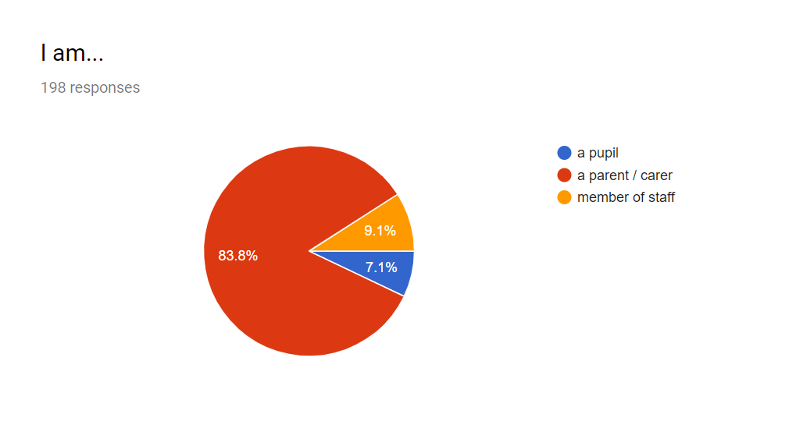
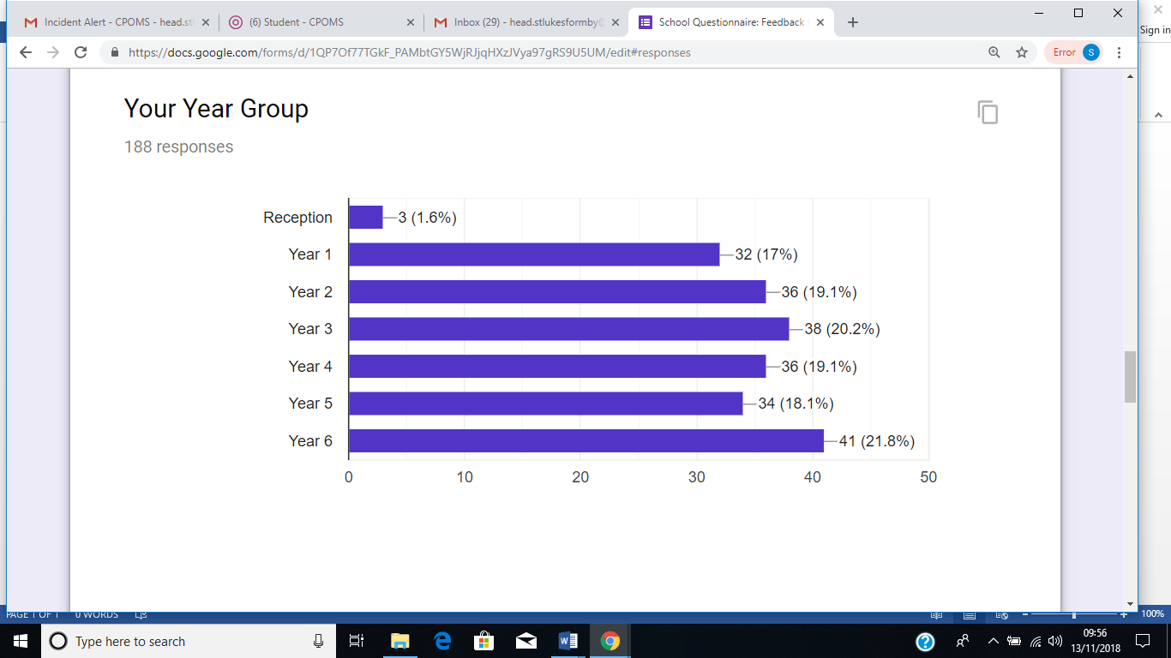
NB reception children did not receive home learning in this format, so we assume the 3 respondents also have older children in school.

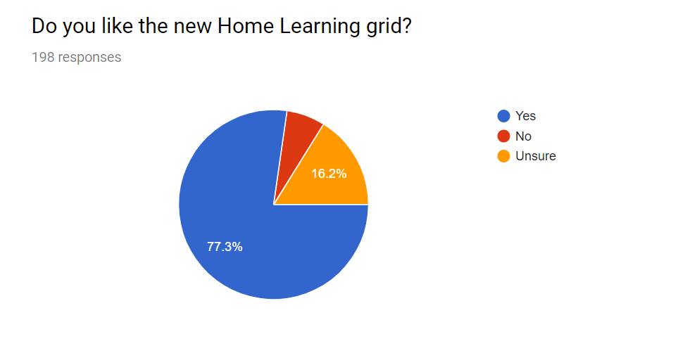
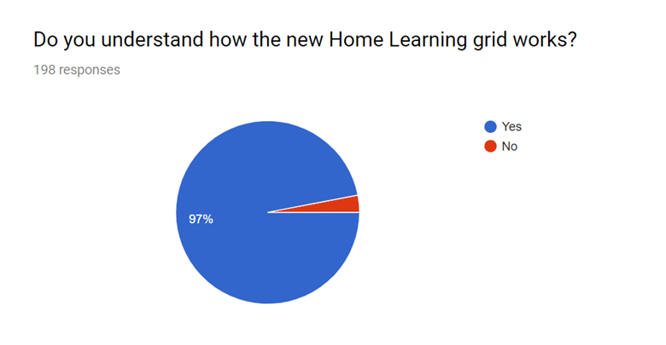

NB these comments are taken directly from the questionnaire, so any spelling and grammar errors are not ours!
POSITIVE COMMENTS
it's very good
Much easier to see whats needed for the next term an also allows you to prepare especially for working parents. Much better system
Brilliant idea - not like homework for the kids in my opinion..... so less aggro to get them to do it!
It offers a choice of homework which helps with busy weekends which is good. It feels less like being at school for the kids. The new home learning (early days as it is!) will incorporate family time.
Varied and interesting activities
It's great! Love the flexibility of it
Straight forward learning. We like how they have choice which home learning they want to do per week
More enjoyable for the children to pick which homework they would like to do each week. Lots of opportunities to share activities with their families.
My daughter is excited to do homework. It's good that we can get ahead and know what is coming up if we have busy weekends.
I find it easier to pick my own topic each week to do with Xxxxxx, which enables me to plan Home learning around our family life, as opposed to a topic being given to us and then having 2 weeks to complete it.
Good fun for learning
I like the gird and the fact it allows flexibility on what homework tasks can be done when outside of the core subjects
More relaxed approach - excellent idea
Brilliant idea, makes it more flexible and personally I fee like a full day at school is enough some days without homework.
Good idea and the children enjoy it more as it is no longer called homework.
Great. Love the fact it’s more interactive and incorporates life skills
my child does these things anyway, its not what they need, I feel that it works for some but for my child needs more structured to meet their needs as in maths & English, I would prefer If you had that option too
I think it’s really good being able to give the child the choice of what they want to do for their homework. My child has never enjoyed doing it in the past and it has been a battle of stress and tears but now they look forward to doing a piece that they have selected from the grid, it also means that it can be done to their level of understanding as opposed to one sheet of generic english (for example) that was too high a level for them to complete without struggling, upsetting, stressing them and lowering their confidence in that subject
I feel it’s more relevant to an individual (in that there’s choice) and like that it encourages simple family activities that sometimes get squeezed out but are, nevertheless, valuable. Also, having emphasis on home learning, not work, means that we can mention and use the extra things our children do that aren’t part of the given activities.
Better motivation as there's an element of choice. Stops our family time being spoilt by homework pressures as we can choose a quicker activity for a busy weekend!
Much more interesting than traditional home work. I think the children work hard enough in school, especially Y6, so no homework at all would be ideal; however, this doesn't seem too onerous and I like the family things as sometimes you don't get a chance to do that sort of thing.
Love the fact it frees up a lot of time and can do all at once or over time so for those busy wkds etc as children nowadays have lots of outside hobbies from school!! Time is precious so if your away for the wkd your not in a panic to get homework done !! Although at the moment I don’t think it is very challenging although that may change as the grids go forward??
Lovely activities and clearly explained
A good balance of basic skills and interesting, fun activities that promote a love for learning. This sums up what we love about St Luke's!
Only week two but both our children like the concept, being able to see what homework there is for the half term seems a great idea.
much better. the homework before was dreadful. too many worksheets and rather dull for children and parents. my children did them because they had to and not because they wanted to. they need to find homework interest I g and engaging to prepare them for high school.
Seems to give children more of a choice and to enjoy doing something that they like.
More enjoyable way of doing homework. How homework should be. Loving the free choice.
A lovely variety of activities when you look at all the grids. A bit of time to populate it, but we had fun thinking if the activities. Think it will encourage children to be independent learners.
Wish homework had been like this when I was at school! Children at primary school should be keen to learn and traditional homework can just be a bind.
We were cynical at first but our daughter is actually choosing to do MORE homework just so she can highlight the sheet! Nice activities for the family to do together. How about tie laces for life skills?
My friend from Woodlands is jealous. You're still learning but it is more fun, not like work.
Makes the homework more accessible can plan when to do the bigger making activities .On busy weekends plan an easy one of the tasks.More fun my kids did more than 1 last week as they wanted to. Freedom to do a activity an involve whole family.Shows them different ways to learn in different settings.
It’s still a little early, but so far so good. Would be good to give feedback again at the end of the trial 🙂
I find that it gives more time to prepare for more special homework’s (hoping to do a museum trip (yr1) and gallery in London for Kandinsky (yr3) and also gives easier options for more busy weekends - we can link some of the yr 3 and yr 1 hmwrks as they are similar.
I like being able to choose a creative/ research task each week and the flexibility around that. The topics are all great learning opportunities within a family. However, the top section is too vague. This is with regards to the maths especially. I feel this is the case especially for the year 6 child and the need for a significant amount of practice for his stats. There is also no grammar practice opportunities. This concerns me. Both my children respond better to a written page of questions to complete ' for school'. The vagueness lengthens the time taken to do the homework. It's also a problem not knowing the correct resource in relation to what they have been learning that week in terms of maths and English and being able to find questions that we can practice. The new homework is positive in different ways of learning, but not good for my children in terms of needing to practice in a structured way what will be tested in stats.
I love the flexibility/choice!
Great , I love the choice element and my son loves picking the activity .
Activities are appropriate and fun .
It’s more interesting and my children are more eager to do their homework as they can choose what they want to do.
Like it as it gives you time to share out the homework in a half term
I like it a lot. Homework was boring before and I use to get showted at for taking to long to get started. This is more fun and lets me doe some things with my mum wich I like.
We are suppose to learn for life at St Luke's and this helps with that - much better than a work sheet. I hope we can keep it. Me and my friends are already saying what might be on the next one and we never even talked about homework before.
Some of my daughter's friends say they should have more challenging homework to get ready for high school, but our older child is in Y8 and she got more homework in Y6! This is more fun and is good for the learn for life ethos of St Luke's. Please keep it! Also we are loving Latin. Wish I had done it before learning another modern foreign language - a good grounding.
Every good idea. As still do home work and have family fun
Really impressed with new home learning
so far so good. Ask me again later in the year in case the novelty wears off.
much better than previous "mandatory" homework each week which eats into a weekend. gives time to do properly and at an appropriate time for the family. my child is much more engaged
Fab idea, the children seem to like choosing what they can do .
Its great, it allows us to do the larger more difficult tasks on the weekends we have nothing on. Great for working parents, we can plan much better. I have only so far received it for Yr.3 not for reception class.
I think its great, I like how its split up and that some of the homeworks can be completed as a family. (We played monopoly at the weekend which did both kid's homework and there was loads of learning going on.) I'm not sure all parents get the ongoing stuff at the top. (based on mutterings off the whats app gp) but I like it. It feels manageable and doesn't always require something written, even my keen child often does not want to write...
It’s a bit early to tell if the grid works, but just knowing the homework in advance is very helpful. Homework set on Friday to be in the next Wednesday can be tricky if a busy weekend is planned (visitors/parties/birthdays).
Great idea, it's nice to see more family oriented tasks being suggested. They are more fun and more likely to get the child engaged and to participate. We also like the flexibility of when home learning can be submitted which takes the pressure off when there are times we are particularly busy.
I think it is very good. The children enjoy the flexibility.
Much preferred. Children like the choice and I like that I can plan ahead and schedule the homework around our home life more I.e doing double homework one week if we have a busy weekend ahead.
I think it’s an excellent way of bringing learning to life at home.
Giving the children a choice is making homework more fun for them
Much more family centred and far more beneficial to life than some of the inappropriate homework that has been previously sent. Other than times tables reading and a bit of homework if the child wants to, homework is pointless. It cause friction in the family and has a negative impact on learning. Family time and extracurricular activities are all they should be doing at home. Preparing a meal or a healthy snack are great tasks for homework. Lifeskills. St Lukes send more homework home than Formby High do.
Varied, meeting pupil needs and taking our vision and values forward.
I think it is very good. It gives the children practical tasks to get them used to helping out around the house as well as learning times tables, spelling etc!
I love it. I think it reinforces with parents that key skills of reading etc are still extremely important in UKS2 and also gives opportunity for engaging family homework’s. For me, I would rather children complete an activity every week rather than 2 one week and 0 the next as it is very hard to track when many aren’t highlighting the sheet. I can see why it is great from a parent’s point of view though.
Clearly organised, gives varied responses. Will need to monitor overall engagement.
It gives the children more choice in what they can do.
It is great to have a choice of which homework to complete and when. There is a nice range of activities which vary in time so if you have a particularly busy week there are some simpler options.
Nice to have choice, so children can choose something they are strong in or enjoy most.
No brainer - getting homework done, learning, and no arguments.
It allows us to plan ahead and gives a good mix of tasks/activities.
It's brilliant
Much preferred to the previous style homework. Like that can choose an activity to suit the time available in a particular week.
I find this a refreshing change. Xxxxxxx believes she is selecting the homework she wants to do and is a lot more eager and keen to complete it each week.
something diffrent every week is interesting
its fun
Much more interesting to mark, getting different things each week.
My children used to hate homework. I should think this would be better. wait and see if the novelty wears off!
Early days, but have enjoyed this as a family.

CONSTRUCTIVE CRITICISM
Love the idea but need more regular maths
Doesn’t seem as complusary as standard homework that used to be sent home? Is it marked and discussed in school ?
more maths - weekly - would be better
would prefer more structure to the maths, but love the other activities.
Makes home life easier but think some of the activities could be more challenging
Like the practical tasks and encouragement of family tasks, unsure yet if Y6 require more expectation related tasks.
Have enjoyed thinking of different activities. Might be better for families if at least one of the family activities was the same for every year group, so they have the option of choosing one for the whole family if they like.
I like the variety of activities and giving the children a choice is fantastic. However, Maths is lacking if it is only practising the same skills for the half term. It would be good to have a weekly task, like the weekly spelling list in addition to the half term list.
like the idea but needs more structured maths tasks
I like the top row which informs you of what you should be practicing each week including the idea to get the children to be more independent. The fact that the amount has been reduced to 4 tasks per half term is great as sometimes I have felt there has been too much homework each week. However, I feel that the range of tasks is limited as they are mainly research based. I think there needs to be a structured based maths task in each section in addition to the times tables weekly practice. A task linked to a web based system for maths such as 'MyMaths' which our elder child found really helpful would be good.
I appreciate it gives flexibility to homework as well as a fun element when home life is busy. However, for a year 6 pupil it doesn’t reflect the amount of homework or structure for moving into year 7. In particular consolidation of maths at home for both my year 6 and year 3 child give them an opportunity to practice and receive help with areas they are finding difficult.
I was not able to attend the parent evening due to a work commitment and I had to ask other parents how it worked as there was no other communication about how to use it. An instruction sheet would be helpful for next time for new parents.
I like that it allows flexibility and the ability to plan homework activities in advance. The instructions could be clearer as I know some people have been confused regarding requirements.
I don’t have a printer at home so I find the spellings online a pain as I have to then print them somewhere but so far I’ve been able to do this in work.
In theory the idea is fine but would prefer maths and English sheets were still provided on a weekly basis even if they were non compulsory
In principle this could be a good idea however time is often spent wasted looking for activities on line or shees to download and print instead of that time spent going through an activity given by the teacher. Additionally, I spent half an hour finding a set sheet on the website, going to Tesco to buy print and paper to print off one sheet. I would have preferred to have spent this time working on the task itself.
I especially like the element of choice for the child and the focus on encouraging family time. I wonder whether for some of the activities, it might be useful to have a bank of resources available to borrow (mindful that not all families would necessarily have ready access to resources that would be useful for some of the activities).
I would like all of the separate years exception words on the website so I can print out (so can keep a copy) and own record of where up to with spellings.
After I checked the year page as well (I can’t find where I saw this now) I did feel a little overwhelmed especially for Xxxxx as it also said practice spelling yr1&2 exception words that can’t do - (but I don’t think I had been told what ones he can/cant do so have had to go through them all again with him). Would also help if all new downloads could start with the year - most do but yr 3 spellings this time just have the date; or be put on separate year pages. Overall is much better thank you
I like the fexibility, but more numeracy and science on it needed!
Like the variety but unsure I would like a more defined weekly maths homework activity tooif pushing yr 6 to where they need to be
Easier for parents as nicer for children and can do more some weeks and less others. More flexible if away for w/e for example can do an easier one. However, would like more structured homework( e.g. test/practice papers) in summer term for year 6 before SATS.
Like the choice element so child takes ownership but needs to be written to encourage children to do more than one choice to push them selves to do more than bare minimum
We are enjoying the greater degree of flexibility and choice with the new format. It does require a little more thought and planning as a parent as to what will be appropriate to do each week. However, I feel core maths and English worksheets every week allow me to assess how my children are coping with new areas of work which are introduced in the classroom and if further work is needed to help them grasp challenging topics. I am unable to make this judgement with the new homework format.
To mich other class info that's messy to read
I felt initially it was a little patronising as we do those things anyway like an autumn walk and dont really need telling to do them..... but maybe not all parents are the same. And we have actually quite enjoyed doing them since and recording what we have done. I do wonder if it’s more relevant to do things that support their current learning like maths sheets on coordinates when they have done coordinates in school that week as they get higher up the school as I am not sure I would have liked the home learning in years 5 and 6 when the emphasis is on SATS.

I also feel that if parents have bothered to take photos and gone to the effort of recording what we did in the homework book it should at least be stamped so we know it has been looked at and we have not just wasted our time I think if we have gone to the effort to do it the teachers should go to the effort to Mark it and give a little feedback.otherwise parents could simply just tick and date one each week and just say it has been done with no evidence!!!
I have to say I was disappointed after the book cam Home on the second week with no acknowledgement.
But I also think that the teachers should have to provide a little communication in the yellow reading diaries like they do in reception as if we can be bothered to write in the diary as requested I think teachers should reply.
Finally on the homework front I understand that there are to be cost savings but having to print out on a computer makes things more difficult for parents who are trying to support everything and not everybody has a printer to be able to do this.
regular maths in addition to the grid, like the weekly spellings, would be perfect
A lot of the tasks seem like irrelevant ‘time fillers’ which obviously aren’t bespoke to the child or differentiated in any way. It appears this is going through the motions of ‘setting homework’ as a tick box exercise, which I don’t agree with at all. Reading/ spellings is more than enough for a Y1 child. Also the expectation of parents printing out photos of their child’s work and or worksheets is totally unrealistic, and assumes all families have access to both a computer and a printer. As a working parent with no access to a printer this is proving impossible and so the task becomes homework for be parent. Not the child. Reduce staff workload/marking by reducing homework- not by setting pointless tasks eg make a slice of toast 🙄

NEGATIVE COMMENTS
I would be prefer a more structured piece of homework and I feel that the choices made by my son are the easier ones in the grid
I think it is far to basic and patronising towards parent that already do most of the skills with there children. It looks like very little thought was out into planning and is a bit of a ‘cop out’ for Homework
It wasn’t explained and I only found out how it works through other parents. Some of the tasks are futile (“play a board game”) and she can’t do about a third of them yet because they haven’t covered it in school. Not a fan at all, I’d give it 3/10. Explain it better and have more productive tasks straight across the board.
A bit complicated would prefer just a straightforward task brought home on paper it’s difficult to find the time to do all of the tasks ontop of all the reading, maths, spelling etc. Its difficult to get photographs printed all the time also. I dont have access to a printer
I think it’s a complete waste of time, to put something like this together in year 6 with Sats coming up is ridiculous - the majority of the learning exercises are a waste of time, and why year 6 are being used as a trial for teaching Latin is a joke. They shld be set specific & relevant homework & it says there are weekly maths activities on the website which have yet to be seen. It’s so patronising - if children can’t pack their own bag, know about the seasons, or understand what healthy eating is or exercise then that’s worrying for 10/11 year olds. To spend time taking pictures of family meals & designing dance routines to the Jackson 5 is not going to help them with their transition into high school. We will not be partaking in this ‘learning grid’ & I request appropriate homework is sent out as opposed to this.

Seems to be a lot of responsibility on parents to do several learning tasks daily, difficult to fit in when children are tired after school and our work schedules. Usually try to do work at the weekends. Think the grid is easy to lose given we need to use it for the full term. Liked the old system of homework sheets in book bags on a Friday knew where we were with that as didn’t need to run around accessing the internet and printing sheets out.
I would like a more challenging version
No one seems to understand it. There are lots of WhatsApp between parents because no-one can understand it.
It's easier to just have one piece of paper with instructions for the homework that week. I can see it's a good idea as it gives the children options but as a full time working parent it's just easier to have a task set and not have to negotiate which one to do.
States weekly activity sheet for maths. 2nd week running no maths online??
It is far too easy for year 1 - the tasks are what we’d do with a toddler and we’ve pretty much covered them all in week 1, it’s very concerning that it has been pitched so low, raising concerns that expected standards have lowered. For year 4 the grid isn’t online and the homework book didn’t come home so no comment - haven’t seen it yet.
Too much to expect from a 5 year old! Why does he need to know how to make toast I’m sure there’s another way they could do texture etc! And tying shoe laces at this age is a big ask
Making a meal seems a bit too much to ask! They can learn that later on in life
I don't feel it appropriate for Year 6 given the work needed to support SATS.
What we are really struggling with though is this is in addition to weekly spelling tests, a continuation of trying to learn year 2 exception words, daily reading and maths etc. The pressure is too much for a 6 year old. My child is struggling as it is and I am very concerned how much is expected of him and the impact this will have on his wellbeing. He is starting to become more aware that he struggles and is getting frustrated with himself.
Homework can cause interference with precious family time. Only essential homework should be given which enhances key elements of learning. Whilst I appreciate the grid was an effort to make homework more manageable I would argue that other than reading, spellings and tables homework is an unneccessary pressure on family life.
Great for lower years but not suitable for year 6
Open to interpretation.....meaning some parents may do too much, some too less...
AND FINALLY, SOME COMMENTS THAT DON’T QUITE FIT ANY CATEGORY (BUT MADE US SMILE!):
Me and mum like it a lot but dad wud prefair a sheet
We actually do not agree with homework, but if we have to have it this is ok!
Its good. I like the broader mix of activities and greater flexibility. Hopefully next term one of the activities will be regrouting the bathroom ;-)

