Converting measurements:
Length
1cm = 10 mm 1mm = 0.1 cm
1m = 100cm 1cm= 0.01m
1m = 1000mm
1Km = 1000m 1m= 0.001 Km
Mass
1Kg = 1000g 1g=0.001 Kg
Capacity
1L = 1000ml 1ml = 0.0001L
Time
1 day = 24 hour
1 hour =60 mins
1min = 60 sec
Fractions, Decimals and Percentages
$\frac{1}{10}$ =0.1 =10%
$\frac{1}{100}$ =0.01 =1%
$\frac{1}{1000}$ =0.001 = 0.1%
$\frac{1}{2}$ = 0.5 = 50%
$\frac{1}{4}$ = 0.25 = 25%
$\frac{3}{4}$ = 0.75 = 75%
$\frac{1}{5}$ = 0.2 = 20%
$\frac{1}{8}$ = 0.125 = 12.5%
$\frac{1}{20}$= 0.05 = 5%

Maths Key Facts Sheet
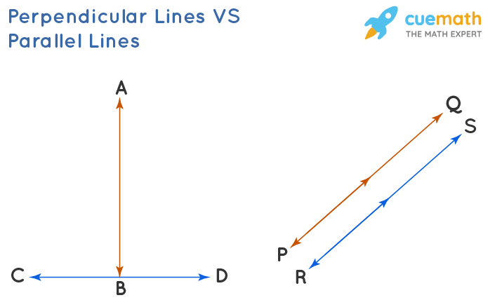

Perpendicular Parallel

