Areas of the curriculum to be taught separately  RE  What would Jesus do in 2024  Maths  Roman Numerals, Place Value (6 digit), addition, subtraction and multiplication.  English  English – spellings, punctuation and grammar. Guided Reading  Games/PE  Rugby  Dance – British Values  Music  Wider Opportunities Brass instrument lessons.  Geography  We will be studying the counties of the UK.  Latin  Maximum Classics – Creating simple sentences in Latin.  Buddies  We will each have our Reception buddy who is now Year 1 and will enjoy spending time together teaching them traditional playground games and walking to church for harvest.  Science  Investigating mechanisms including leavers, pulleys, gears and cams.  PSHE  Families and relationships.  We will develop an understanding of families, including marriage and what to do if someone feels unsafe in their family; learning that dealing issues can strengthen a friendship; exploring the impact of bullying and what influences a bully’s behaviour; learning to appreciate our individual positive attributes.  Computing  We will develop an understanding of computer systems and how information is transferred between systems and devices considering small-scale systems as well as large-scale systems. We will discover how information is found on the World Wide Web, through learning how search engines work (including how they select and rank results) and what influences searching, and through comparing different search engines | 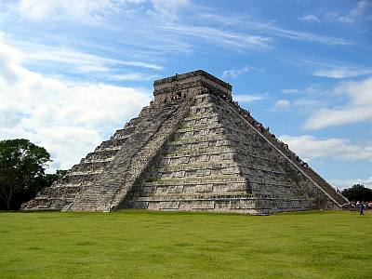 | Maya Civilisation
Main Curriculum Focus
Our English will focus on poetry and instructions on how to play the Maya ball game Pok-a-Tok.
In History, we will learn about the Maya Civilisation: where and when they lived, their culture, beliefs and way of life and will look at what they have given us today as a society. We will also complete a line of enquiry comparing what was happening in Maya times with what was happening in Britain. We will also have a Maya day, where an ancient Maya warrior visits us to bring the culture to life, with games, stories, drama and an opportunity to examine and handle Maya artifacts, becoming archeologists lokking for clues to work out what the objects are.
In Geography, we will learn all about the countries in Central America making links with the Maya Civilization, including its landscape.
In Art and Design, we will be creating maps using typography thinking about how archaeologists today are finding links between ancient Maya temples like Chichen Itza and astronomy.

 | L.E.A.R.N.  This half term we will focus on the L element of LEARN – Learn new things. We will learn all about the Mayans – a civilization we knew nothing about when asked. |  | How you can help at home  Please help your child by:  - learning times tables  - learning spellings brought home through look cover write check and dictation  - reading at home  - completing maths home learning and doodle english  - Helping with Homework
Our Year 5 Christian value is Faithfulness.

