ST.BEDE’S CATHOLIC JUNIOR SCHOOL
celebrates life and learning

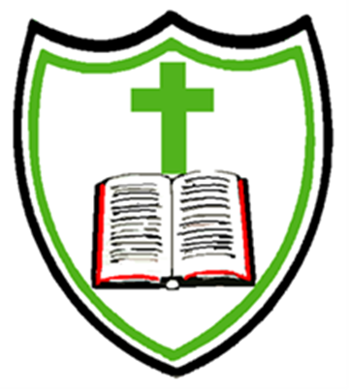
Safeguarding Policy

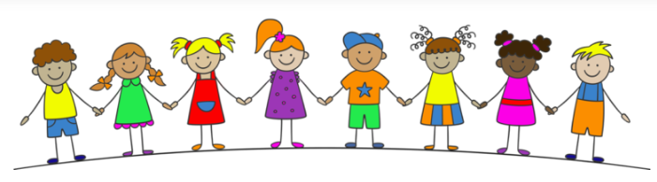
Child Friendly Version
2026-2027

We want St. Bede’s Catholic Junior School to be a safe place. The adults in school will do everything they can to make sure you are protected and happy. To help them do this they have lots of rules to follow. This policy is to help you understand what Safeguarding means to you and to help you decide what could be a ‘problem’ and whom you should talk to.
The adults in school understand that Safeguarding means that they should:
- Protect you from harm;
- Make sure nothing stops you being healthy or developing properly;
- Make sure you are safely looked after;
- Make sure you have the best life chances and can grow up happy and successful.

They agree that, to make sure they look after you, they will:
- Make the school a friendly, welcoming and supportive place to spend time in – somewhere you want to be;
- Be there for you to talk to;
- Make sure you know who to ask for help;
- Give you safe messages in your lessons to help you learn how to look after yourself both online and in the real world;
- Have all the right rules in place to help look after you. They will follow these rules all of the time (these rules are sometimes called policies).

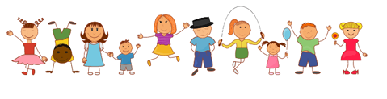

Abuse
When someone hurts you it can be called abuse. This is when someone, an adult or another child, does something to you that is harmful, unpleasant or painful like:
- If someone deliberately hits you, hurts you, injures you or humiliates you in different ways.
- If someone says or does something that makes you feel bad about yourself or hurts your feelings, which makes you feel scared, sad, upset or frightened.
- If someone shouts, threatens, hits or hurts someone you love whilst you are around which makes you scared, unhappy or worried
- If someone doesn’t take care of you so you feel lonely or neglected. You might not be able to eat or wash regularly, or you might not be able to come to school every day or on time.
- If someone touches you in a way that you don’t like (like touching your private body parts) or makes you look at things which make you feel embarrassed, uncomfortable or even guilty. They may ask you to keep it a secret or give you presents.

Abuse is never ok and if you are being or have been abused you must remember – it is not your fault. You must always tell someone and they will help it to stop.

In and Out of School
All of the staff at St. Bede’s Catholic Junior School will do their best to make sure the building is safe for you to learn in and spend time in. We will make sure that we know who everyone is in the school by asking visitors to sign in at reception. You will always know who a visitor to the school is because they will have signed in at reception and will be wearing a green cord around their neck with a visitor badge in the plastic wallet. People that we do not know will never be allowed to spend time with you on your own and will not be allowed to walk around the school without a member of staff. The building, outside areas and field will be as safe as they can be for you so that you don’t hurt yourself, although accidents can happen if you are not careful! Staff will look after you if the fire alarm goes off and you should know what to do and where to go. When you leave school to go on a trip somewhere, the staff will make sure they can keep you safe wherever you are going.
What we will do
At St. Bede’s Catholic Junior School we will help you in the following ways:
- We will do our best to spot if there is a problem. All of the adults in school have had training on this
- We will work with other people (including those at home) to help protect you and solve any problems you may have
- We will listen to you if you want to talk to us and need our help. We will always take you seriously
- We will support and encourage you and will respect your wishes and views

In St. Bede’s Catholic Junior School you can talk to any member of staff, but you should know that there are a number of staff who are responsible for making sure you are safe and well cared for:
- Mrs Hopkins – Headteacher
- Mrs Geoghegan – Designated Safeguarding Lead
- Mrs Harrington – Deputy Designated Safeguarding Lead
It is important that you know…
- It is never your fault someone is hurting or abusing you
- There is always someone who can help
- If someone is hurting you, they might also be hurting someone else so it is important that you tell someone to make it stop
- Every child should enjoy their right to a happy and safe childhood

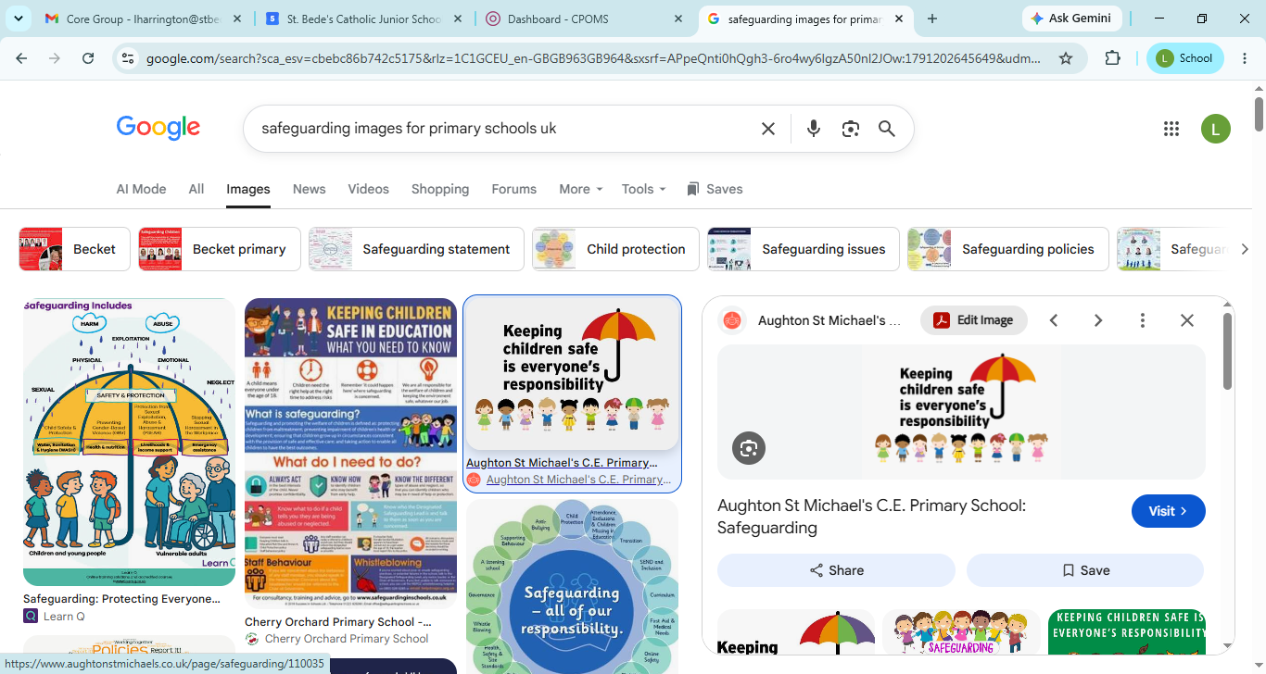

Tips for keeping yourself safe
Bullying - is a type of abuse that takes place when someone tries to hurt another person on purpose for a prolonged period of time. People can be bullied in many different ways:
- Emotional bullying includes hurting someone’s feelings, by leaving them out or bossing them about. People can sometimes use emotional bullying to take advantage of you to get their own way by making threats or making you feel like you have to do something for them.
- Physical bullying can include hitting, kicking, shaking, biting, hair pulling or purposely hurting someone.
- Verbal bullying can include insulting someone because of how they look or because of their personality, and can often go beyond that. People can also use verbal bullying to be racist, sexist or homophobic. Racist bullying is bullying someone because of their race, skin colour, the country they are from or the religion they believe in.
- Homophobic bullying means bullying someone because of their sexuality; calling someone gay or lesbian to hurt their feelings would be homophobic.
- Sexist bullying is bullying someone because of their gender; bullying someone because they are a boy or a girl would be sexist.
- Cyberbullying includes any kind of bullying which takes place online; cyberbullies send insulting messages over the internet and sometimes share secret information online to hurt someone’s feelings.
Bullying is not always done by one person and can often involve a group of people ‘ganging up’ on someone – if you ever see someone being bullied, never join in and always tell a teacher. The bully could be one of your peers, an older or younger child or an adult. It’s important that you tell someone if you think you are being bullied.
Online Safety - is an important part of keeping children safe at our school. We have lots of safety measures in place which we keep an eye on both in and outside of school, to help safeguard children. Computers and mobile phones help us all to share things and talk to friends or family, but they can also make it easier for bullies and other people to hurt you or to get close to you. It is important to know how to keep yourself safe on your computer, your phone and on websites. The school will help if you are sent unkind messages or if someone on the internet has asked you to do anything that has made you feel uncomfortable. If you are unhappy with any comments or photographs you've seen on your computer or mobile, you can tell a staff member in school. We have an Online Safety Policy which is there to protect you. Remember:
- Never share personal information online.
- Never share passwords with friends.
- Be careful when chatting with people you do not know.
- Tell an adult if someone asks for photographs, videos or personal information.
- Not everything online is true.
- Tell an adult if something online makes you feel worried, scared or uncomfortable.

Relationships - Any relationship you have should be positive and make you feel safe, happy and comfortable. A negative relationship might make someone feel scared, confused, worried and even unsafe. It is really important that you know the difference between a positive relationship and a negative relationship.

Positive relationships:
- You are comfortable around that person.
- You can be honest with that person.
- You can say how you feel and what you are thinking, and you listen to each other.
- You support each other and treat each other well.
- You feel safe.
- You trust that person.
- You do helpful things for each other.
- You are never pressured to do anything that makes you feel uncomfortable.
- You feel looked after.

Negative relationships:
- The person might push you, hit you or break your things.
- The person might tell you what to do, what to wear or who you can see.
- You might feel scared – they might say they will hurt you if you don’t do something.
- The person might make threats or do harmful things if you do something they did not want you to do.
- The person calls you names, makes you feel bad in front of other people and makes you feel bad about yourself.
- The person gets angry easily and you don’t know what will make them angry – it might make you feel nervous.
- The person might pressure you to do things you don’t want to do or are not ready for.
- The person might not take no for answer when you say you don’t want to do something.
Useful number and Websites:
Childline – 0800 11 11
www.childline.org.uk
www.nspcc.org.uk
www.thinkuknow.co.uk
www.iwf.org.uk
https://anti-bullyingalliance.org.uk
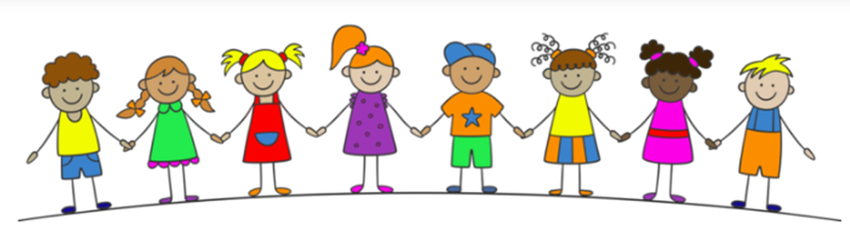
We are children of God
Who
Respect, Love and Achieve

