St. Bede’s Catholic Junior School
celebrates life and learning

Accessibility Plan 2025-2028
VISION STATEMENT
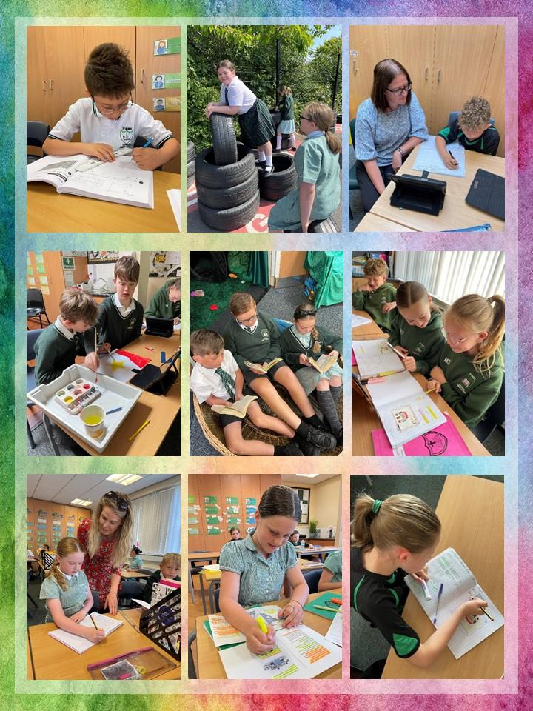
St. Bede’s Catholic Junior School aims to treat all stakeholders, including pupils, prospective pupils, staff, governors and other members of the school community favourably and, wherever possible, takes reasonable steps to avoid placing anyone at a substantial disadvantage. The school aims to work closely with disabled pupils, their families and any relevant outside agencies in order to remove or minimise any potential barriers to learning, which puts them at a disadvantage, but allows them to learn, achieve and participate fully in school life. The school is active in promoting positive attitudes to disabled people in the school and in planning to increase access to education for all disabled pupils.
As part of the school’s continued communication with parents/carers and other stakeholders we continually look at ways to improve accessibility through data collection, questionnaires and parental discussions.
Under the Equality Act 2010 schools should have an Accessibility Plan. The Equality Act 2010 replaced all existing equality legislation, including the Disability Discrimination Act. The effect of the law is the same as in the past, meaning that “schools cannot unlawfully discriminate against pupils because of sex, race, disability, religion or belief and sexual orientation”.
According to the Equality Act 2010 a person has a disability if:
(a) He or she has a physical or mental impairment, and
(b) The impairment has a substantial and long-term adverse effect on his or her ability to carry out normal day-to-day activities.
The Accessibility Plan is listed as a statutory document of the Department for Education’s guidance on statutory policies for schools.
The Plan will be reviewed every 3 years or where operational needs dictate and approved by the Governing Body. The review process can be delegated to a committee of the Governing Body, an individual or the Head.
At St. Bede’s Catholic Junior School, the Plan will be monitored by the Headteacher and evaluated by Governing Body. The current Plan will be appended to this document.
We are committed to working together to provide an inspirational and exciting learning environment where all children can develop an enthusiasm for life-long learning so they achieve their full potential. We believe that children should feel happy, safe and valued so that they gain a respectful, caring attitude towards each other and the environment both locally and globally.

LEGAL BACKGROUND
From September 2002, the Disability Discrimination Act 1995 outlawed discrimination by schools and LA’s against either current or prospective disabled pupils in their access to education. It is a requirement that the school’s accessibility plan is resourced, implemented and reviewed and revised as necessary.
This plan sets out the proposals of the Governing Body of the school to increase access to education for disabled pupils in the three areas required by the planning duties in the DDA.

AIMS
St. Bede’s Catholic Junior School aims to:
• increase the extent to which disabled pupils can participate in the school curriculum, which includes teaching and learning and the wider curriculum of the school, such as participation in extra-curricular clubs, leisure and cultural activities and educational and residential visits;
• improve the environment of the school to increase the extent to which disabled pupils can take advantage of education and associated services, which includes improvements to the physical environment of the school and physical aids to access education.
•improve the delivery to disabled pupils of information, which is provided in writing for pupils who are not disabled, for example: handouts, timetables, textbooks and information about school events. The information should take account of the pupils` disabilities and the preferred format of pupils and parents and be made available within a reasonable timeframe.

1) The Accessibility Plan has been developed and drawn up based upon information supplied by the Local Authority, and consultations with pupils, parents/carers, staff and governors of the school. The document will be used to advise other school planning documents and policies and will be reported upon annually in respect of progress and outcomes. The Accessibility Plan is structured to complement and support the school’s Equality Objectives, and will similarly be published on the school website.
The Accessibility Plan will be monitored through the Governing Body. The school will work in partnership with the Local Authority and Archdiocese of Liverpool in developing and implementing this Accessibility Plan. The Accessibility Plan may be monitored by Ofsted during inspection processes in relation to Schedule 10 of the Equality Act 2010.
2) St. Bede’s Catholic Junior School is committed to providing an environment that enables full curriculum access; that values and includes all pupils, staff, parents/carers and visitors regardless of their education, physical, sensory, social, spiritual, emotional and cultural needs.
We are committed to adhering to the principles of the Equality Act 2010 with regard to disability and to developing a culture of inclusion, support and awareness within the school.
3) St. Bede’s Catholic Junior School’s Accessibility Plan shows how access is to be improved for disabled pupils, staff and visitors to the school within a given timeframe and anticipates the need to make reasonable adjustments to accommodate their needs where practicable.
It also relates to the key aspects of physical environment, curriculum and written information:
• Increase access to the curriculum for pupils with a disability, adapting the curriculum as necessary. This includes teaching and learning and the wider curriculum of the school such as participation in extra-curricular clubs, enrichment and cultural activities or educational and residential visits – it also covers the provision of specialist or auxiliary aids and equipment, which may assist these pupils in accessing the curriculum within a reasonable timeframe.
• Improve and maintain access to the physical environment of the school, adding specialist facilities as necessary – this covers improvements to the physical environment of the school and physical aids to access education within a reasonable timeframe;
• Where needed, adapt the delivery of written information to pupils, staff, parents/carers and visitors with disabilities; examples might include adaptations to hand-outs, timetables, textbooks and information about the school and school events; the information should be made available in various preferred formats within a reasonable timeframe.
4) Whole school training will recognise the need to continue raising awareness for staff and governors on equality issues with reference to the Equality Act 2010.
5) This Accessibility Plan should be read in conjunction with the following school policies, strategies and documents:
• Health & Safety Policy
• Special Educational Needs and Disability Policy
• Supporting Children with Medical Conditions and Administration of Medicines Policy
• Educational and Residential Visits Policy
6) The Accessibility Plan for physical accessibility relates to the Access Audit of the School, which remains the responsibility of the governing body. It may not be feasible to undertake all of the works during the life of this Accessibility Plan and therefore some items will roll forward into subsequent plans. An accessibility audit will be completed by the school prior to the end of each period covering this plan in order to inform the development of a new Accessibility Plan for the ongoing period.
7) Equality Impact Assessments will be undertaken as and when school policies are reviewed.
8) The terms of reference for all Governing Body Committees will include the need to consider Equality issues as required by the Equality Act 2010.

CURRENT GOOD PRACTICE
We gather information about any disability or health condition in early communications with parents/carers of children who are new to school. For parents/carers of children already at the school, we ask them to keep the school informed of any changes to the information they have provided.
Physical Environment
There are no areas of the school to which disabled pupils have limited or no access at the moment. The only part of the building that requires use of the accessibility lift are the four classrooms downstairs (as their access is via a short staircase. All communal areas: hall, library, resource area are all on one level, along with nine of the thirteen classrooms. Disabled pupils participate in extra-curricular activities. Some aspects of extracurricular activities present particular challenges, for example lunch and break times for pupils with social/interaction impairments, extra-curricular clubs for pupils with physical impairments and school trips for pupils with medical needs; however all reasonable adjustments are made to support as full an involvement as possible.
Curriculum
Through planning for individual need, we aim to provide as inclusive an approach as practically possible. Some areas of the curriculum present particular challenges, for example: PE for pupils with a physical impairment; however all reasonable adjustments are made to support as full an involvement as possible, including providing additional adult support. We seek advice and support from the relevant professionals in order to ensure that we have made adequate and reasonable adjustments.
Information
Different forms of communication are made available as needs are identified to enable all disabled pupils to express their views and to hear the views of others. Access to information is provided in a range of different formats available for disabled pupils, parents/carers and staff as needed.

Access Audit
All entrances to the school are either flat or ramped and all have wide doors fitted. The main entrance features a secure lobby and is fully accessible to wheelchair users. The school does not have any dedicated visitor parking. Visitors to the school use the Local Council (free) Car Park or on-street parking; however suitable arrangements for disabled visitors are made when appropriate. There are disabled toilet facilities available in school. The school has internal emergency signage and escape routes are clearly marked. Personalised Evacuation Plans are put in place as required.

MANAGEMENT, COORDINATION AND IMPLEMENTATION AND REVIEW
• We consult with other professionals and services when new situations regarding pupils with disabilities are experienced.
• The Governors and Senior Leadership Team work closely with the Local Authority and Archdiocese of Liverpool.
• We work closely with parents/carers to consider their children’s needs.
• The Accessibility Plan is reviewed annually and/or as needs change.
• The annual review is then shared with staff.
• We make links with other schools to share best practice through regular SENDCo network meetings, IQM Flagship meetings and other communications as needed.

CURRENT RANGE OF DISABILITIES WITHIN ST. BEDE’S CATHOLIC JUNIOR SCHOOL
The school has children with a varied range of disabilities and neurodiversity’s, including those with a comorbidity of conditions. These disabilities include Autistic Spectrum Disorder, ADHD, Demand Avoidance Behaviours, Sensory Processing Differences, learning disabilities such as Dyslexia/ Dyscalculia/Developmental Coordination Disorder (DCD), communication differences such as Developmental Language Disorder (DLD) and other medical conditions, such as Visual Impairment, Hearing Impairment, Type 1 diabetes and epilepsy. When children enter school with specific disabilities, the school contacts the LA professionals for assessments, support and guidance for the school and parents/ carers.
All medical information is collated and available to staff, on the staff noticeboard, the head teachers’ office board and in the School Office. We have experienced First Aiders who hold current First Aid certificates.
All medication is kept in a central safe and secure place which has easy access for First Aiders and staff members. Administration of Medicines consent forms are filled in by parents/carers outlining the illness and amount and time of medication. All medication that is given is recorded using ‘First Aid Forms’ app.

ST. BEDE’S CATHOLIC JUNIOR SCHOOL
ACCESSIBILITY PLAN 2025-2028
Our key objective is to reduce and eliminate barriers to access to the curriculum and school environment, ensuring full participation in the school community for pupils and/or parents/carers with a disability, medical condition or other access need.
Through these aims, we can ensure all members of the school community can live out our mission:
We journey together so that we “Might have life - life in all its fullness”. John 10:10
Provision may include: Liaison with specialists, CPD for staff, a differentiated and/or personalised curriculum, specialist resources to support learning and access to the curriculum, a range of support staff including trained teaching assistants and access arrangements in place for statutory testing.
Aim 1: To increase the extent to which disabled pupils can participate in the school curriculum.
TARGETS | STRATEGIES | TIMESCALE | RESPONSIBILITY | REVIEW
To liaise with the Infant School to prepare for the intake of Y3 pupils | Identify pupils who may need adapted or additional provision through observation, networking, SENDCo meetings | Summer (prior to entry) and academic year | HT  SENDCo  Pastoral Leader  Year 3 Teachers | SENDCo visited Infant School and observed pupils
To review policies to ensure that they reflect inclusive practice and procedure | Review and revise to ensure compliance with Equality Act 2010  Ensure that all staff have a secure understanding of the Equality Act 2010 | Academic Year | HT  SLT  Governing Body | Staff training.
To establish and maintain close liaison with parents/carers | Collaborate and information sharing between school and families. | Summer (prior to entry)  Autumn Term | HT  SENDCo  Pastoral Leader | New intake meetings in June before admission.  Curriculum Meetings in September  3 x Parent/Carer Conferences  2 x SEND meetings
To establish and maintain close liaison with outside agencies for pupils with additional needs | Collaborate and information sharing between local and national schools | Academic Year | HT/DHT  SENDCo  IQM Flagship Network | IQM Flagship collaboration  School Improvement Strategy  PLN and Catholic Cluster  Meeting with LA SEND lead  EHCP review meetings
To include pupils with a disability, medical condition or other access needs as fully as possible in the wider curriculum including trips and residential visits as well as extracurricular provision | Personalised risk assessments and access plans for individual children. Liaise with external agencies, identifying training needs and implementing training where needed. Ensure that actions, including emergency evacuation procedures, are clear and that staff are capable of carrying them out. | Ongoing (as required) | HT  SENDCo | See Individual Inclusion Plans (IIPs) and Individual Health Care Plans (IHCPs)
To continue to train staff to enable them to meet the needs of children with a range of SEND. | SENDCo to review the needs of children and provide training for staff as needed. | Academic Year | HT  SENDCo  All staff | 23.02.26 PINS training (whole staff)  PINS webinars shared with ALL staff  Sept 25 ECM Adaptive Teaching  12/01/26 PINS S, L & C Needs in Schools (whole staff)  27/04/26 Maths SL and SENDCO – Dyscalculia Training  28/04/26 Thrive – When Neurodiversity, Trauma, Attachment and SEND Overlap
Aim 2: To improve the physical environment of the school to increase the extent to which pupils with a disability, medical condition or other access needs can access education and associated services.
TARGETS | STRATEGIES | TIMESCALE | RESPONSIBILITY | REVIEW
Improve the physical school environment | The school will take account the needs of pupils with physical difficulties and sensory impairments when planning and undertaking future improvements and refurbishments of the site and premises, such as improved access, lighting and colour schemes, clear signage and more accessible facilities and fittings. | Ongoing | SLT  Premises Manager  Governors | School displays constantly monitored to avoid sensory overload.  Calm/ sensory break spots available.
Ensure that reasonable adjustments are made for pupils with a disability, medical condition or other access needs | Create personalised risk assessments and access plans for individual pupils. Liaise with external agencies, identifying training needs and implementing training where needed. Ensure that actions, including emergency evacuation procedures, are clear and that staff are capable of carrying them out. | As required | HT  SENDCo  Class Teachers  Visit Leaders  Health Professional | RA completed for pupils at risk of exclusion; Intimate Care Policy in place; Fire Evacuation procedures in place including Personal Evacuation Plan for staff member with reduced mobility.
Aim 3: Improve the delivery of information to pupils, staff, parents/carers and other members of the school community
TARGETS | STRATEGIES | TIMESCALE | RESPONSIBILITY | REVIEW
Enable improved access to written information for pupils, parents and visitors. | Create and offer information in alternative formats.  Access arrangements are considered and put into place for statutory testing | Ongoing  Review termly | SBM/Admin  HT/AHTs | Access Arrangements correctly administered: additional time, scribe, reader, rest breaks etc.  Information for parents shared via texts, emails, paper and verbally, such as meetings and videos.  Key information translated as required. Translation service used to support a discussion with parents.  All documentation is available in adapted form.  Communication Strategy -improved communication with parents carers.
Ensure that reasonable adjustments are made for parents with a disability, medical condition or other access needs so as they can fully support their child’s education | Adopt a proactive approach to identifying the access requirements of parents and make reasonable adjustments where possible | Ongoing  Review termly | SBM/Admin  HT/AHTs  Teaching Staff | Positive relationships ensure that the needs of parents/carers are met: physical, psychological etc.  SEND Parent/Carer meetings enable discussion about adaptation needs.  Low threat workshops to support parents/carers in learning and in supporting their child(ren).  Pastoral Team supports accessibility for parents/carers with additional needs, accessibility etc.

Review 1: Summer 2026

