St. Bede’s Catholic Junior School
celebrates life and learning
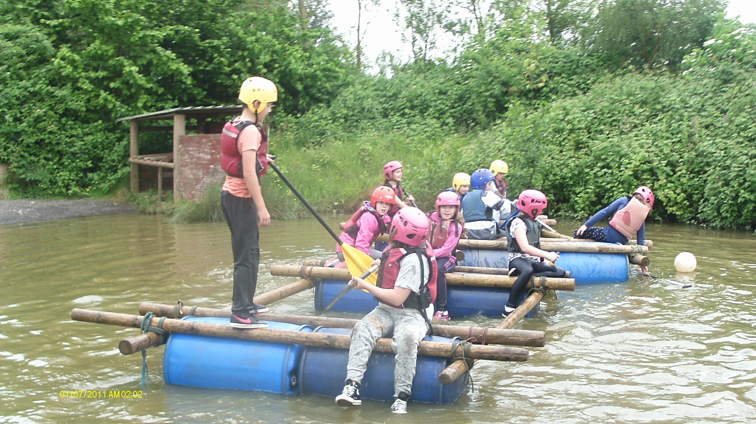

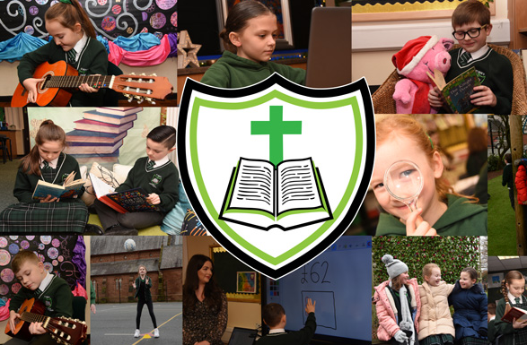

Prospectus 2025

ST. BEDE’S CATHOLIC JUNIOR SCHOOL
celebrates life and learning

CONTENTS


 | Page(s)
School and LA Contact Details | 3
Governors and Staff | 3 - 4
Mission Statement | 5
Education | 6
Curriculum | 6 - 7
Religious Education | 7 - 8
Prayer & Worship | 8
Sacramental Preparation | 8
Special Educational Needs and Disability | 8 - 12
Equity, Diversity and Inclusion | 12 - 13
Pupil Premium | 13 - 14
Relationship, Sex and Health Education | 14 - 15
Sport and Personal Development  Outdoor Play and Learning (OPAL) | 15 - 18  18 - 19
Healthy School Standard | 18
Arts and Humanities | 19 - 21
Information Technology & Computing | 21
National Curriculum Tests | 22
Complaints About Curriculum | 22
Admission Policy and Arrangements | 22 - 25
School Organisation | 25
Homework | 25 - 26
Pastoral Care | 26
Behaviour for Learning | 27 - 29
Prevention of Bullying | 29
Child Protection/ Safeguarding | 30 -31
Extra-Curricular Activities | 31
Children’s University | 31
Arrangements for Visiting the School | 31
Uniform | 32 - 33
Working Day | 33
Village Care Club Ltd | 34
Attendance | 34
Parents/Carers in Partnership | 34
Archdiocesan Schools Building Fund | 35
Charging and Remissions  Children’s Prospectus | 35  35

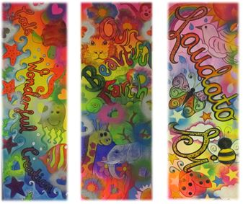
ST. BEDE’S CATHOLIC JUNIOR SCHOOL
celebrates life and learning

GENERAL

The information contained in this booklet relates to the academic year 2026/27 and, although it is correct in relation to that year on 1st September, 2025, it should not be assumed that there will be no change affecting the relevant arrangements or some other matter particularised:
- before the start of, or during the academic year in question,
or
- in relation to subsequent academic years.

SCHOOL St. Bede’s Catholic Junior School, Widnes

ADDRESS OF SCHOOL Appleton Village,
Widnes,
Cheshire,
WA8 6EL.

Telephone No: 0151 - 424 - 3386
Fax No: 0151 - 495 - 1886
E.Mail: head.stbedesjunior@haltonlearning.net
Website: www.stbedesjuniorschool.co.uk

EDUCATION OFFICE Children and Enterprise Directorate,
Halton Borough Council,
Grosvenor House,
Halton Lea,
Runcorn,
Cheshire,
WA7 2WD.

Telephone No: 0303 – 333 - 4300

GOVERNING BODY
The present Governors of the school are:

Chairperson Mr. P. Owen - Foundation Governor (Chair)
Vice Chairperson Mrs. J. Rourke - Foundation Governor (Vice Chair)
Mr. S. Holland - Foundation Governor
Mr. A. Hurst - Foundation Governor
Mrs. D. Parker - Foundation Governor
Vacancy - Foundation Governor
Mr. M. Baker - Parent Governor
Mrs. C. Handley - Parent Governor
Mrs. S. Baker - LA Governor
Mrs. L. Harrington - Staff Governor
Mrs. F. Tiernan - Headteacher

Teaching staff: Ms. F. Housley - Headteacher
Mrs. G. Geoghegan - Assistant Headteacher
Mrs. S. Lloyd-Green - Assistant Headteacher
Mrs. L. Harrington - Pastoral Lead
Mrs. D. Barron - Part-time
Mrs. V. Faulkner
Mr. M. Greaves
Mrs. A. Halliday - Part-time
Miss. M. Hayes
Mrs. A. Horton
Mrs. M. Hulme
Miss J. Joynson
Miss J. Massey
Mr. S. Stalker
Mrs. C. Smith - Part-time
Mrs. J. Wainwright

Teaching support: Miss B. Allen - Teaching Assistant
Miss S. Bate - Teaching Assistant
Miss K. Campbell - Teaching Assistant
Mrs. B. Kelly - Teaching Assistant
Mrs. S. Laverty - Higher Level Teaching Assistant
Miss D. Price - Teaching Assistant
Miss E. Rowley - Teaching Assistant

Administrative staff: Mrs. L. Williams
Mrs. M. Lawton

Premises Manager: Mr. N. Ortiz

Mid-day Assistants: Mrs. M. Lawton
Miss J. Todd

Cleaners: Mrs. M. Farmer
Mrs. J. Farrell
Mrs. G. Luter

Catering Supervisor: Mrs. C. Smith

The staff are committed to continuous learning, training and development to enable the needs of children and parents / carers and the requirements of the LA and DfE to be met, now, and in the future.

CLASSIFICATION OF THE SCHOOL

The school is a voluntary aided Junior School for children in the 7 - 11 age range.


MISSION STATEMENT, AIMS AND OBJECTIVES

St. Bede, patron of our school, wrote:
“It was always my delight to learn and to teach”.
We are a celebrating community, living the Gospel Values,
committed to educating children in the light of the Catholic Faith.
We journey together so that we
“Might have life - life in all its fullness”. John 10:10
AIMS
We aim:
- to be a celebrating community, living the Gospel Values;
- to provide an enriching, inclusive learning experience which strives for excellence;
- to journey together in partnership.

OBJECTIVES
To be a celebrating community, living the Gospel Values
To achieve this aim we:
- put Christ at the centre and integrate Gospel Values and the teachings of the Catholic Church into every aspect of our
school life and work;
- have a shared vision and common values;
- uphold the dignity and value of each person and celebrate them as a unique individual, made in the image of Christ;
- respect difference and value diversity;
- promote and model conduct, relationships and behaviour rooted in the teaching of Christ;
- deliver the ‘Come and See’ Religious Education Programme;
- ensure that acts of Collective Worship, prayer and liturgical celebrations are an integral part of the teaching and
learning;
- devise and implement policies and procedures that reflect and express the Catholic faith, which demonstrate personal
responsibility, justice, healing and reconciliation;
- display symbols and religious icons to enable everyone to experience the uniqueness and sacredness of the learning
environment;
- offer opportunities for each person to experience life in all its fullness.

To provide an enriching, inclusive learning experience which strives for excellence
To achieve this aim we:
- provide a Christian, broad, balanced, inclusive curriculum, including extra-curricular, educational and residential
visits to empower all members of the school community to reach their full potential;
- promote a positive, affirmative ethos;
- nurture the well-being of every individual and enable them to positively serve society;
- consider Religious Education to be the core subject and integrate it into all other curriculum areas;
- ensure that Religious Education is well-resourced and allocated 10% of curriculum time;
- integrate the knowledge, understanding, skills and values of Religious Education into all aspects of learning and
school life;
- sustain a learning environment that is unique, accessible, safe, stimulating and well maintained;
- develop understanding and respect for different faiths and cultures;
- teach respect and care for God’s creation;
- engage positively and collaboratively with individuals, schools, services, agencies and with changes and
developments in education.

To journey together in partnership
To achieve this aim we:
- form part of the spiritual, pastoral and community life of the Parish, Pastoral Area and Church;
- support the local Parish and the Church’s universal mission to make God known to all peoples;
- evolve with the Parish communities through developments in the Pastoral Area of St. Charles Borromeo;
- assist parents/carers in the education and religious formation of their children;
- maintain and build upon the affirmative and supportive relationships in the school community;
- collaborate with other schools, professionals, services and agencies to meet the needs of the children and their
families;
- encourage citizenship, communal responsibility and commitment to social justice;
- promote community cohesion by understanding and respecting difference;
- care for and maintain the environment as stewards of creation;
- endorse fundraising projects locally, nationally and internationally;
- serve the common good
EDUCATION
The Catholic Church acknowledges parents as the first teachers of their child(ren) and strives to support them in their privileged responsibility of educating their child(ren) in the Faith. In the words of the Religious Education Curriculum Directory, the outcome of Catholic religious education:
“is religiously literate young people who have the knowledge, understanding and skills - appropriate to their age and capacity - to think spiritually, ethically and theologically, and who are aware of the demands of religious commitment in everyday life.”
The Church’s mission is seen to be a religious one and, by that very fact, an eminently human one. St. Bede’s provides an experience of a living and worshipping community in which there is a commitment to service and, in this way, contributes to the entry of its members into the full life of the Church.
At St. Bede’s Catholic Junior School, and in accordance with the DfE, education is believed to be the route to:
- “spiritual, moral, social, cultural, physical and mental development, and thus the well-being, of the individual…..
- equality of opportunity for all, a healthy and just democracy, a productive economy, and sustainable development.”
It reaffirms our commitment to:
- “valuing ourselves, our families and other relationships, the wider groups to which we belong, the diversity in our society and the environment in which we live…
- the virtues of truth, justice, honesty, trust and a sense of duty…
- respond positively to the opportunities and challenges of the rapidly changing world in which we live and work…
- engage with economic, social and cultural change, including the continued globalisation of the economy and society, with new work and leisure patterns and with rapid expansion of communication technologies.”
(The National Curriculum Handbook for Primary Teachers in England.)

CURRICULUM

Christ is the foundation of the whole education enterprise in a Catholic school and it is our aim to assist every individual in the school community on his / her journey of faith - to grow in their personal relationship with God and experience

“life in all its fullness”.

The goal is the creation of a safe, happy, orderly, inclusive, caring Christian environment which provides opportunities for nurturing personal growth and fostering enquiring minds and in which children can receive their entitlement - a high quality education. This involves the provision of a broad, balanced, exciting, enjoyable curriculum, the presentation of suitably challenging work and relevant, memorable life experiences, along with the development of positive attitudes and values.

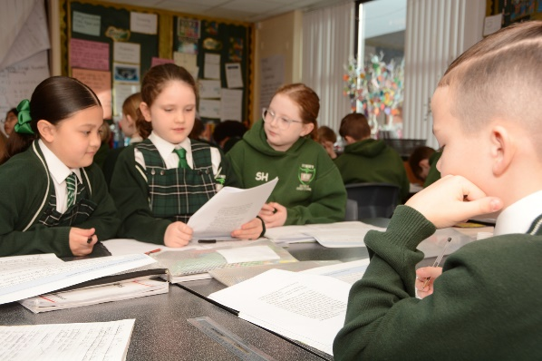
There is a strong emphasis on personal development, including the advancement of learning and thinking skills, and personal, social and emotional skills. These enable young people to become successful learners, healthy, confident, independent persons and active, responsible members of society. The school’s aspirations for them to develop as courteous, generous, tolerant, well-rounded and well-educated citizens, who can contribute to a fairer and better Britain now and in the future, are as high as ever.

National Curriculum
The school conforms with the requirements of the National Curriculum 2014 which details a clear, full and statutory entitlement to learning for all pupils. It determines and sets attainment targets for learning.
The Government believes that the content of the National Curriculum compares favourably with the most successful international curricula in the highest performing jurisdictions, reflecting the best collective wisdom we have about how children learn and what they should know.

Curriculum at St. Bede’s

It is acknowledged that the curriculum is at the heart of the school’s strategies to raise achievement and improve outcomes for all children.
The aim is for children to become:
- successful learners who enjoy learning and achieve;
- confident individuals who are able to live safe, healthy and fulfilling lives;
- responsible citizens who make a contribution to society.
Curriculum design is a dynamic process and the curriculum is constantly evolving and a vital part of the drive for ongoing school improvement. The design of the curriculum is fundamental in promoting and raising standards, securing the essentials for learning and life and making learning the best it can be for every child.

RELIGIOUS EDUCATION

Religious Education and all rites and ceremonies are according to the teaching and practice of the Catholic Church. Guidance and directives are received from (the agencies of) the Catholic Bishops’ Conference of England and Wales and the Catholic Archdiocese of Liverpool.
The Religious Education provided through the ‘Come and See’ programme (Years 5 and 6) and the new Religious Education Directory (Years 3 and 4) (“To Know You More Clearly”) is in conformity with the doctrines of the Catholic Church. The aspiration is the interpretation of knowledge in the light of the Gospel.
“The specific mission of the school, then, is a critical, systematic transmission of culture in the light of faith and the bringing of the power of Christian virtue by the integration of culture with faith and of faith with living”.

PRAYER AND WORSHIP
Every child has an opportunity to participate in a daily act of Prayer or Celebration of the Word.
Prayer and Worship aims:
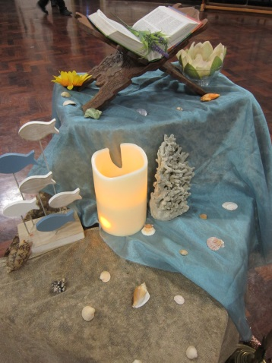
- to provide the opportunity for pupils to worship God and reflect upon Gospel values;
- to listen to, and respond to, the Word of the Lord;
- to encourage participation and response, whether through active involvement, listening to and reflecting upon the worship, or through stillness and thoughtful silence;
- to develop community spirit;
- to promote a common ethos and shared values;
- to reinforce positive attitudes;
- to respect the diversity of belief and commitment;
- to reflect the tradition of the Church and have Christ at its heart.
Parents / carers have the right to request that their child be wholly or partly excused from attending any Religious Education and/or religious worship at the school.

SACRAMENTAL PREPARATON
The school is in the Parish of St. Wilfrid. All of the children in the Parish are prepared to receive the Sacrament of the Eucharist in Year 4. The preparation is undertaken in the churches and with the support of the catechists. Parents/carers have a full and practical involvement in the sessions. The Sacramental preparation is supported in school and through the Religious Education Programme.

SPECIAL EDUCATIONAL NEEDS AND DISABILITY (SEND)
At St. Bede’s Catholic Junior School, it is the belief that all children have an equal right to a full and rounded education which enables them to achieve their potential. Best endeavours are employed to secure special educational provision for pupils for whom this is required, that is ‘additional to and different from’ that provided within the differentiated curriculum to better respond to the four areas of need identified in the Code of Practice (2014):
- Communication and interaction
- Cognition and learning
- Social, mental and emotional health
- Sensory and physical.
Definition
A pupil is considered to have SEND if he or she has a defined learning difficulty or disability over and above those generally experienced by the majority of his or her peer group. These difficulties may be sensory, cognitive, physical, social and/or emotional, and some children may have complex needs, which cover a range of difficulties.
“Special educational provision means educational or training provision that is additional to, or different from, that made generally for others of the same age in a mainstream setting in England… Health care provision or social care provision which educates or trains a child or young person is to be treated as special educational needs provision” (SEN Code of Practice, 2014).
Although there are acknowledged links, in some instances, with pupils who have English as Additional Language (EAL) needs, this is a separate area of provision. Children with EAL are not regarded as having SEND, although pupils with EAL may also have SEND.
St. Bede’s Catholic Junior School also recognises that the needs of high-achieving children should also be catered for and recognised as a ‘special educational need’, however, this does not mean that they will be included on the SEND list. It is recognised that some pupils have talents or gifts which are exceptional, and should be fostered and celebrated. Provision for the more able and/or inspired child is regarded as an integral part of the life of the school. The Able and Inspired Minds Policy (available in school) details identification, provision, assessment and the involvement of outside agencies or providers in the education of children. Mrs. A. Halliday is responsible for coordinating ‘above and beyond’ provision for pupils who are able and inspired.

Provision for children with SEND
Children with SEND are fully integrated in all aspects of the school. All lessons, with the exception of English and mathematics, are taught in mixed-ability classes with work and learning experiences differentiated, where necessary, to meet the needs of individual children. Throughout the school, children are given additional support by a Teaching Assistant and/or other additional adults to help to meet their Individual Inclusion Plan (IIP) targets. This can either be within the main classroom or in small groups, withdrawn from the whole class setting.
Teachers work collaboratively within the year groups, with the SENCO and Teaching Assistants to plan, deliver the curriculum and monitor the progress of children with special needs. This is recorded in the weekly, termly, and yearly planning of staff and on the children’s IIPs.
The school has no specialist provision for children with SEND, although there is access, and toilet facilities for wheelchair users and a loop system in the hall.

Identification and assessment
The school follows the guidance laid out in the 2014 Code of Practice. It is the responsibility of the SENDCo (Special Educational Needs and Disabilities Coordinator) to maintain individual records of all the children identified as having SEND who are in receipt of any extra provision from external agencies. These records are held centrally in the main office and on the administration computer system. IIPs are written and stored by the relevant staff.
Children are identified as having SEND using the school’s assessment procedures and through observation and the professional judgement of staff or parent/carer concerns. Many children have already been identified in Key Stage One and transfer with detailed records of intervention and support. Some of these children, however, may be removed from the SENS (Special Educational Needs Support) category in Key Stage Two due to their achievement, attainment and expected progress. Where necessary, the SENDCo refers children to the Educational Psychologist or to other Local Authority (LA) specialists for further assessment.

Implementation, Monitoring and Review Procedures
Once identified as needing additional support, in discussion with the child and their parent(s)/carer(s), he/she is placed at the SENS category of the 2014 Code of Practice. An IIP is drawn up and a profile of the child’s strengths and needs is established. The IIP is written in collaboration with the class/group teacher, the SENDCo and the child and is discussed with the parent/carer. It establishes what interventions are to be provided which are ‘additional to, or different from,’ those provided as part of the school’s usual differentiated curriculum. The class teacher remains responsible for working with the child on a daily basis and for planning and delivering the programme. The SENDCo is available for support and advice. The IIPs are reviewed termly and a decision is made whether support needs to be maintained, increased or removed, depending on individual progress.
If it is felt that a child is not making sufficient progress at the first level of the SENS stage, then an outside agency may become involved. The school has close links with the Halton SEN Service and the Educational Psychology Service. The SENDCo liaises with both services to establish an agreed programme of intervention which may involve the child being supported by the Child and Adolescent Mental Health Service (CAMHS), Occupational Therapy, Speech and Language Therapy Service (SALT) or other voluntary agencies. IIPs are written with the advice given from these outside agencies and more complex interventions are planned.
In a small number of cases, a child may need further support beyond the resources of the school. The Local Authority (LA) can be requested by either the school staff or a parent/carer to carry out a formal assessment of the child to determine if he/she meets the criteria for SENS Top-Up (previously known as Enhanced Provision) or for an EHC (Education and Health Care) Plan. If granted, it becomes the responsibility of the Local Authority (LA) to maintain and monitor this provision, as set out in the guidelines of the Code of Practice. The school will provide the resources specified in the SENS Top-Up Plan or EHC Plan and carry out an Annual Review with the child, parent/ carer and representative of the Local Authority (LA) to monitor the progress of the child.
All children identified as having SEND are monitored as part of the school’s normal procedures. IIPs are monitored termly and SMART targets (Specific, Measurable, Achievable, Realistic and Timed) are set in discussion with the child. The SENDCo monitors progress of individuals on an informal basis through discussions with teaching staff, teaching assistants, children and parents/carers.

A Nurturing School: ‘The Den’
In 2016/17, we established a nurture classroom in school to support children with barriers to their learning such as: speech, language and communication difficulties; social, emotional and behavioural difficulties; developmental delays; issues with friendships and/ or other relationships, amongst others.
The Nurture Group Network describes nurture groups as:
‘founded on evidence-based practices and offer a short-term, inclusive, focused intervention that works in the long term. Nurture groups are classes of between six and twelve children or young people in early years, primary or secondary settings supported by the whole staff group and parents. Each group is run by two members of staff. Children attend nurture groups but remain an active part of their main class group, spend appropriate times within the nurture group according to their need and typically return full time to their own class within two to four terms. Nurture groups assess learning and social and emotional needs and give whatever help is needed to remove the barriers to learning. There is great emphasis on language development and communication. Nothing is taken for granted and everything is explained, supported by role modelling, demonstration and the use of gesture as appropriate. The relationship between the two staff, always nurturing and supportive, provides a role model that children observe and begin to copy. Food is shared at ‘breakfast’ or ‘snack time’ with much opportunity for social learning, helping children to attend to the needs of others, with time to listen and be listened to. As the children learn academically and socially, they develop confidence, become responsive to others, learn self-respect and take pride in behaving well and in achieving. Nurture groups have been working successfully for more than 40 years in the UK and now in other countries including Canada, New Zealand and Romania, and have been praised, supported and recommended by organisations such as Ofsted and HMI.’
At St. Bede’s the children may spend part of each week in the nurture group or may access the group for 1:1 or small group interventions but still remain part of their mainstream class. They will work on core and foundation curriculum areas via a more creative approach, which is language heavy and encourages communication, along with PSHE (Personal, Social, Health Education) activities. They may also take part in guided reading and phonics work. All of the children participate in break and lunch times as usual.
The group is led Mrs. Lloyd-Green (SENDCo) and Miss Bate (Teaching Assistant) who have undertaken the Nurture Group Network accredited training.
The group adheres to the six Principles of Nurture:
1. Children's learning is understood developmentally.
2. The classroom offers a safe base.
3. The importance of nurture for the development of wellbeing.
4. Language is a vital means of communication.
5. All behaviour is communication.
6. The importance of transition in children's lives nurture.

Parents/Carers
The school maintains close links with all the parents/carers of children with SEND. Parents/carers are welcome to discuss any concerns with either the class teacher or the SENDCo, as and when required. Parents/carers are also invited to meet with the representatives of the SEN Service and the Psychological Service if they are involved with individual children.
At St Bede’s Catholic Junior School, it is recognised that parents/carers play a critical role in the education of their child. If any parent/carer has concerns or complaints regarding the education of their child, then the school staff investigates them promptly. If the matter cannot be resolved, then parents/carers have a right to make representation to the Headteacher and then to the Governing Body. Parents/carers also have access to the local independent Parent Partnership Scheme which can offer advice and information on all aspects of SEND.
If you are not helped by the staff (including the Headteacher), tell the Chair of Governors, Paul Owen, about your problem. Contact details: p.owen@stbedesjuniorschool.co.uk

Responsibilities
It is the Governing Body’s duty to determine the school’s general policy and approach to provision for children with SEND and to establish appropriate staffing and funding. The Headteacher’s Report to Governors contains an updated review of the current provision and this allows the Governing Body to monitor the effectiveness of it.
The Headteacher has responsibility for the day-to-day management of all aspects of the school, including provision for children with special needs. She is supported in this by the Special Educational Needs Co-ordinator (SENDCo), Mrs. Stephenie Lloyd-Green, who has completed the Government SENDCo Accreditation, and has day-to-day responsibility for the implementation of the policy and for co-ordinating the provision of education for these children. Mrs. Faith Tiernan is the Assessment Co-ordinator and is responsible for tracking the progress of all pupils, including those experiencing SEND. Together they ensure that the St. Bede’s Catholic Junior School Special Educational Needs and Disability Policy works within the guidelines and inclusion policies of the Code of Practice (2014).
The philosophy of the school is that the needs of children will be met by adopting a whole school approach, where all children’s needs are the responsibility of the whole school staff. The Revised Code of Practice focuses on meeting these needs in the classroom, and staff accept that the responsibility for meeting the educational needs of all children in their classroom lies with them, ‘All teachers are teachers of children with special educational needs’ (SEN Code of Practice p. 44). This responsibility remains, with or without a formal assessment of the children’s needs.
Enquiries about an individual child’s progress should be addressed at first to the class teacher since he or she is the person who knows the child best. Other enquiries can be addressed to Mrs. Lloyd-Green (SENDCo).

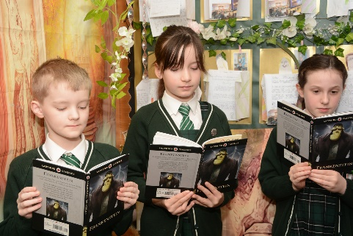
EQUITY, DIVERSITY & INCLUSION
At St. Bede’s we are committed to securing equality of education, opportunity and treatment for all employees, pupils and any others involved in the school community regardless of race, faith, gender or capability in all aspects of school life. Self and mutual respect is promoted along with a caring and non-judgemental attitude throughout the school.
The Equity, Diversity and Inclusion Policy enables the staff of St. Bede’s Catholic Junior School to deliver the best possible education programme to all our pupils and to support them and their families.
Staff ensure that people with disabilities are not treated less favourably in any procedures, practices and service delivery, while also developing a culture of inclusion and diversity in which people feel free to disclose their disability and to participate fully in school life. The achievement of disabled pupils is monitored and the data used to raise standards and ensure inclusive teaching. Reasonable adjustments are made so that the school environment is as accessible as possible. We believe that diversity is a strength, which is respected and celebrated by all those who learn, teach and visit this school.
This statement sits alongside the school’s and Halton Borough Council’s Inclusion Policy which aims to promote inclusive education by identifying and removing barriers to the “presence, participation and achievement” of all children, young people and adults.

Inclusion Quality Mark
The Inclusion Quality Mark provides UK schools with a nationally recognised validation of their inclusive practice and ongoing commitment to developing educational inclusion. There are three award levels, beginning with the IQM Inclusive School Award. Two higher award levels are available to schools that continue to grow and develop their practice in conjunction with other like-minded schools – IQM Centre of Excellence Award and IQM Flagship School Award.
The school has held the Inclusion Quality Mark (IQM) since 2015 and is currently graded at Flagship Status, which is the highest level awarded.
The summing-up of the school’s inclusive practice said, “It is clear that St Bede’s Catholic Junior School not only meets the standard required but is a beacon of best practice. The reflective approach to school development ensures that the children all receive an excellent, holistic education.”

PUPIL PREMIUM
The Pupil Premium is additional funding allocated to schools to raise the attainment of disadvantaged pupils and to close the gap between them and their peers. The funding is allocated according to the number of pupils who have been:
- registered as eligible for free school meals at any point in the last six years;
- been in care for six months or longer.

In 2025/26 the school was been assigned £143,925 for Pupil Premium.
A wide variety of strategies are employed to tackle ‘the opportunity gap’ in education and to raise attainment for the children from disadvantaged backgrounds. For example:
- utilising staff, including teaching assistants, and resources effectively;
- employing a Pastoral Leader to support vulnerable pupils and their families;
- deploying intervention programmes;
- raising pupil aspirations using engagement/aspiration programmes;
- engaging parents/carers;
- providing family learning;
- developing social and emotional competencies;
- supporting school transitions;
- using approaches which give peer support/assistance;
- one to one / small group tutoring;
- accessing high quality out of school learning experiences;

Undoubtedly, the quality of teaching delivers the greatest improvements in learning outcomes for all pupils, including those from deprived backgrounds. The most powerful approaches are well-specified, well-supported and well-implemented programmes of work, incorporating extensive continuous professional development that is often delivered within the school context. Early intervention is effective in the lower school (Year 3) as is specific tutoring of individuals/groups by teaching assistants and/or teachers.

The school adopts a variety of synchronised approaches: long-term, planned and co-ordinated provision to enable all children to experience success and achieve their potential. Undoubtedly, strategies are successful when confident, well-trained adults use programmes that meet the needs of individual pupils and circumstances of the school.

RELATIONSHIP, SEX & HEALTH EDUCATION
The Governing Body of St. Bede’s Catholic Junior School has considered the Education Act and the Bishops’ Statements and the Policy Guidance for delivering quality Relationship, Sex & Health Education (RSHE) and has decided upon a Policy for the provision of Relationship, Sex & Health Education. This Policy embraces issues of sexuality and relationships within the curriculum and the pastoral life of the school.
There is a planned programme of RSHE, ‘Journey in Love’, throughout the school. The teaching offered is complementary and supportive to the role of parents / carers who are recognised as being primarily responsible for raising their children, and teaching them about relationships, sex and growing up. They do this by:
- teaching their children about relationships and sex;
- maintaining the culture and ethos of the family;
- helping their children cope with the emotional and physical aspects of growing up;
- preparing them for the challenges and responsibilities that sex and maturity brings.
Parents / carers have been consulted and are kept informed of the content of the programme. It provides opportunities:
- to appreciate that life is a gift from God;
- to explore the meaning and value of life, and give some appreciation of the values of a family life;
- to understand what is meant by relationships within families, friends and communities;
- to help the children understand that there are different types of relationships and develop skills to be effective in relationships;
- to enable the children to have some understanding that love is central and the basis of meaningful relationships;
- to encourage pupils to be aware of their attitudes and values and have a sense of responsibility for themselves;
- to help the children to understand that their actions affect themselves and others, to care about other people’s feelings and to try and see things from their point of view;
- to enable children to talk and write about their opinions and explain their views on issues that affect themselves and society;
- to research, discuss and debate topical issues, problems and events;
- to reflect on moral, spiritual, social and cultural issues, using imagination to understand other people’s experiences;
- to enable pupils to understand the impact of external factors, such as the media, the Internet, social networking, peer groups and in so doing remain independent decision makers;
- to enable pupils to recognise the importance of the choices they make and that they are responsible for themselves;
- to value themselves as children of God and their body as God’s gift to them;
- to enable pupils to understand and be aware of personal, psychological, emotional and physical changes that happen during puberty, why they happen and how to manage them;
- to understand their own bodies and the need for personal hygiene;
- to know and understand that the life processes common to humans include growth and reproduction;
- to generate an atmosphere of trust and confidentiality where questions of a sexual nature, appropriate to the stage of learning, can be asked and answered openly without embarrassment;
- to understand and be able to name external body parts;
- to understand and name internal body parts and realise the difference between boys and girls;
- to know that menstruation is a fact about growing up;
- to know the basic biology of human reproduction and understand the growth of a baby in the womb.

The Policy for Relationship, Sex & Health Education is available in school and on the school website.
Section 241 of the 1993 Education Act gives parents / carers the right to withdraw their children from any or all parts of a school’s programme of Relationship and Sex Education, other than those elements which are required by the National Curriculum.
The parental right of withdrawal may be exercised by either parent or by a person who has responsibility for the care of the child. Parents / carers do not have to give reasons for their decision, although the staff will invite parents / carers voluntarily to indicate their reasons for withdrawal, so that any misunderstandings about the nature of Relationship and Sex Education can be resolved.

SPORT AND PERSONAL DEVELOPMENT

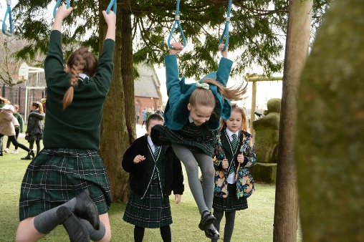
Physical Education has always had a high profile in the school and it lays the foundations of a lifelong interest in physical activity with positive lifelong repercussions. It fosters transferable skills, such as team work and fair play; cultivates respect; and builds body and social awareness. It provides a general understanding of the ‘rules of the game’ which children can readily make use of in other subjects or life situations.
Through the provision of high-quality PE and extra-curricular sporting activities, the school aims to develop children who:

- are committed to PE and sport and make them a central part of their lives – both in and out of school;
- know and understand what they are trying to achieve and how to go about doing it;
- understand that PE and sport are an important part of a healthy, active lifestyle;
- have the confidence to get involved in PE and sport;
- have the skills and control that they need to take part in PE and sport;
- willingly take part in a range of competitive, creative and challenge-type activities, both as individuals and as part of a team or group;
- co-operate and compete fairly, understanding their own and others’ roles;
- think about what they are doing and make appropriate decisions for themselves;
- show a desire to improve and achieve in relation to their own abilities, characterised by a focus on their personal best;
- have the stamina, suppleness and strength to keep going;
- enjoy PE, school and community sport.
Through the programme of work the children have the opportunity:
- to develop physically;
- to develop the necessary physical skills and capabilities for participation in a range of indoor and outdoor physical activities;
- to acquire knowledge and understanding of the principles and concepts involved in the performance of physical activities;
- to develop the ability to plan, organise, compose and express ideas in sequences of action in physical activities;
- to develop personal and social qualities; concepts of fair play; a sporting spirit; respect for rules; an understanding of the capabilities of themselves and others;
- to develop the capacity to maintain interest and to persevere to achieve success;
- to develop an awareness that physical competence and performance can be improved through practice, control and dexterity, as well as creative thinking and commitment;
- to develop and foster self-confidence and self-esteem through the acquisition of physical competence;
- to develop an understanding of the importance of regular physical activity in maintaining a healthy lifestyle;
- to develop the capacity to evaluate physical performances;
- to learn how to stay safe in physical activities.
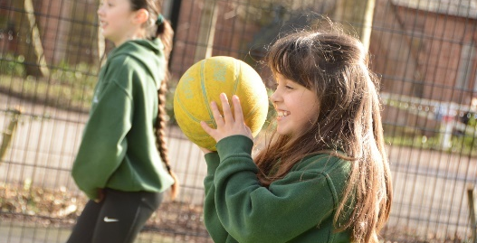
The programme of work is planned by the PE Subject Leader. It provides opportunities for pupils to be creative, competitive and to face different challenges as individuals and in groups and teams. The areas of physical education in which the children are involved are:
- Games;
- Gymnastic activities;
- Dance;
- Athletic activities;
- Outdoor and adventurous activities (such as orienteering);
- Swimming.

An average of two hours per week is devoted to PE in formal lessons throughout the Key Stage and all children are expected to participate in every session. There are other opportunities for children to be active for example, at play time and lunch time through the OPAL programme (Outdoor Play and Learning), and when the children are involved in day and residential visits. Children are encouraged to engage in at least five hours a week of PE and sport (including the two hours of high-quality PE in curriculum time).
The teachers are committed to physical education: the staff are involved in teaching the National Curriculum and engage in extra-curricular sporting activities. The school may choose to employ qualified sports coaches to enrich the teaching and learning already taking place.
As well as formal lessons, between 16-18 hours are devoted to extra-curricular activities. There is a good range including, but not limited to, the following: football, cricket, netball, tennis, table tennis, rounders, cross-country running and athletics. The children compete against other schools in the area in all of the above, as well as swimming.
The school shares the small field adjacent to the Halton Borough Car Park with St. Bede’s Infant School. The staff make use of Victoria Park, the Tennis Academy, Widnes Cricket Club and the Halton Table Tennis Centre too.
Towards the end of every academic year there is a Sports Day (morning or afternoon). It is not a traditional event; the aim is maximum participation by all pupils for the maximum amount of time. There is a competitive aspect in that all children have a score card. There is a prize for the two highest scores in each class and the children try to beat their score from the previous year.
The children in Year 6 are offered the opportunity to participate in an outdoor and adventurous residential opportunity, which further allows them to ‘push beyond their limits’ and try activities such as abseiling, climbing, archery, paddle-boarding, rifle-shooting, axe-throwing and assault courses.
The children in the school are encouraged to be involved and fulfil their potential. They display skills, dedication and exemplary sporting behaviour. They enjoy a great deal of success. Details of achievements are published in the school’s newsletters, website and social media.
The school attained Activemark in June, 2000, which is recognition for promoting the benefits of physical activity. The school was among the first to achieve this innovative award and then procured Activemark Gold in March, 2003. Unfortunately, this award is no longer available. However, the school does hold AfPE (Association for Physical Education) Quality Mark for Physical Education and Sport, having received this prestigious award in 2016 for the first time. In July, 2022, the school was recognised with the Sainsbury’s School Games Platinum Award for commitment to, and development of, competition, school sport and physical education. The school continues to hold both awards.

Safety in PE and Sport
Advice from ‘Safe Practice in Physical Education and School Sport’ (detailed below) is followed.

Personal Effects
The wearing of non-essential personal effects (including earrings and other body piercings) by pupils can pose a difficult management problem in physical education, since such items need to be removed for safety reasons before active participation takes place.
The following principles are applied:
- All personal effects are removed.
- If they cannot be removed, the adult in charge takes action to make the situation safe.
- If the situation cannot be made safe, the individual pupil does not actively participate.
Putting tape over ear studs is used to make the situation safe. However, the adult in charge must be confident that this strategy will be effective.
When medical bracelets have to be worn, they should be covered with sweat bands secured by adhesive tapes.
Long hair must be tied back to prevent it obscuring pupils’ vision or becoming entangled in apparatus during physical activity.

PE/Sports Premium
Since September. 2013 the school has received £9,255 per year as a PE/Sports Premium. In 2017/2018 it rose to approximately £19,000; the same is due to be allocated for the financial year 2025-26.
Over the years, the funding has been used for gymnastics, judo, cricket, table tennis, rugby, Quidditch, Drumba, coaching, purchasing equipment, the services of a PE Consultant, a ‘specialist’ from the Halton Sports Development Team and staff training. There is an itemisation of the use of the funding, the amount spent and the impact available in school.

Healthy School Standard
The Healthy School Award (formerly known as the National Healthy Schools Scheme) was proposed in the Green Paper ‘Our Healthier Nation’ in 1998. In this paper, the Government identified the school as a setting to improve children’s health and educational achievement, with the support of other agencies.
Halton LA introduced the Halton Healthy Schools’ Programme and full accreditation was achieved by the school in December, 2004. The school has been judged to be maintaining the standards of the Healthy Schools’ Programme and is involved in many projects, for example: Healthitude and Fit4Life.

OUTDOOR PLAY AND LEARNING (OPAL)
St. Bede’s strongly believes that: “Play is freely chosen, personally directed, intrinsically motivated behaviour that actively engages the child. Play can be fun or serious. Through play children explore social, material and imaginary worlds and their relationship with them, elaborating all the while a flexible range of responses to the challenges they encounter. By playing, children learn and develop as individuals, and as members of the community.” (Children’s Play Council 2001).
We recognise that play is an essential part of a happy and healthy childhood. We aim to provide high quality, enjoyable play experiences for all children across school. We do this by providing carefully considered outdoor spaces, play structures and resources that offer a rich choice of accessible play experiences for every child. We refer to our school’s mission and Play Policy in all decisions that affect our children's play. We are committed to providing the strategic and operational leadership needed to provide and maintain quality play provision for all of our children.
We seek to attain the highest standard for all our children, in all aspects of school life. With children spending up to 20% or 1.4 years of their time in school at play, it is imperative that this time needs to be coherent and well thought out. The current climate and ever-changing society, for example, heavier traffic, busier lifestyles, fewer areas for play and awareness of risk have led children to have less time, space and permission for play in the wider public realm. This makes their play opportunities at school even more vital.
In 2018, OPAL won the Best Active Schools’ Programme in Europe Award and has been cited in two parliamentary reports as delivering outstanding practice. OPAL is working closely with Sport England to promote more active childhoods, which is one of the many reasons we are improving our playtime, as well as to improve opportunities for socialisation, cooperation, coordination, resilience, creativity, imagination and enjoyment for all pupils.
In conjunction with Outdoor Play and Learning (OPAL) CIC, we started our OPAL journey in Spring 2023 and have been accredited as an OPAL platinum school.

ARTS AND HUMANITIES
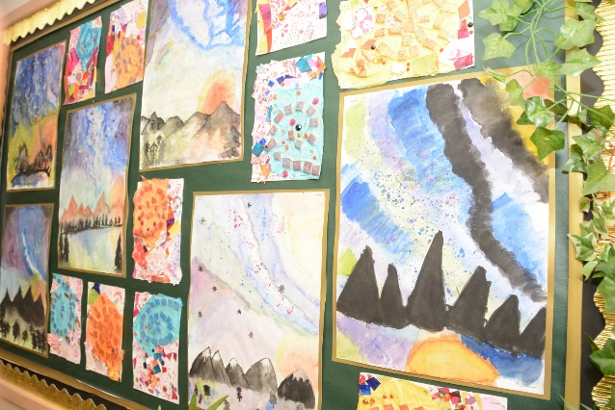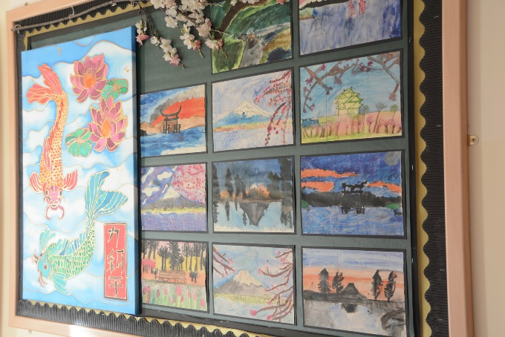

The arts are a source of inspiration and fulfilment. They provide contexts in which children learn to express their thoughts and emotions, use their imaginations, experiment and develop creativity. This area of learning makes a contribution to children’s personal, social and emotional development and to their growth as confident individuals.
The aims of art education in St. Bede’s are as follows:
- to cater for individual needs within the arts curriculum by providing challenging, stimulating learning opportunities for all children, whatever their background or ability;
- to co-ordinate the arts curriculum across the school ensuring diverse and multifarious activities which broaden children’s understanding of the arts;
- to promote spiritual, social and cultural development by incorporating music, art, dance and drama into the curriculum and encouraging children to express opinions, feelings and make judgements through the experiences;
- to enable all staff to identify, develop and use resources available for the delivery of quality arts education within the school;
- to utilise the arts provision available within the wider community;
- to employ resources effectively so that all children receive a broad and balanced arts curriculum;
- to foster a sense of appreciation for and fulfilment in the arts through enjoyable experiences irrespective of ability.
The arts subjects are integrated into the curriculum which is taught through cross-curricular topics:
- The children are taught how creative ideas can be developed in response to different stimuli and imaginative thinking;
- They learn how and why people from different times and cultures have used the arts to express their ideas and communicate meaning;
- Through practical activities and performances they learn the importance of self-discipline, control and practice as ways of improving techniques;
- The children are taught that different art forms evoke moods, thoughts and ideas.

The arts curriculum provides a wealth of opportunities for the children to use their literacy and ICT skills. It enhances the personal, emotional and social development of the children as it allows them to express themselves in many different ways. Above all, it provides diverse opportunities for the children to enjoy their learning.
Children encounter aspects of the arts and humanities curriculum as part of the programmes of study for art, music, English, history, geography and modern foreign languages.
The many different art forms within each of these areas are often brought together through different forms of creative expression:
- Drama and music combine in our school plays;
- Music and dance combine for school concerts, plays and class assemblies;
- Music, dance, drama and visual artistry combine within class assemblies;
- Traditional music merges with the contemporary during school and class assemblies;
- Printing, craft and textile work combine to produce large scale display work;
- Visual arts make use of multimedia and computer technology, including photography.

The children at St. Bede’s gain a breadth of experience across all areas of the arts curriculum.
Music
Music plays a vital role in the life of the school and in religious celebrations. Children have the opportunity to learn to play string, brass and wind instruments and keyboard. They share their skills in assemblies and concerts.
Dance
The children are involved in dance as part of the PE curriculum.
Drama
Children participate in educational drama sessions and performance drama. Every year, the school production is a huge success and approximately a third of the school take part.
Theatre companies perform in school and the children engage in drama workshops. Visits to the theatre are arranged annually: every child in every year group is given the opportunity to watch live theatre every year.
Visual arts
Freelance artists make a valuable contribution to the school. Children are encouraged to experiment with textile, sculpture and media, and develop their own creative impulses.
Visits are made to exhibitions and art galleries.
Since 2016, Year 5 pupils have entered the Dot-Art Schools competition. In 2024 – 25, a St. Bede’s Junior School pupil won the competition.
Authors and poets
Authors and poets are invited to work in school. Stories and poems take on a special life and relevance when the children meet the person who actually created them. There is no better way to learn about the craft of writing than through the fun and enjoyment of doing it under the guidance of someone who writes for a living.

INFORMATION TECHNOLOGY AND COMPUTING
Information technology (IT) prepares pupils to participate in a rapidly changing world in which work and other activities are revolutionised by access to varied and developing technology. Pupils use IT to find, explore, analyse, exchange and present information. They learn how to access ideas and experiences from a wide range of people, communities and cultures. Increased capability in the use of IT promotes initiative and independent learning, with pupils being able to make informed judgements about when and where to use IT to best effect, and to consider its implications for home and work both now and in the future.

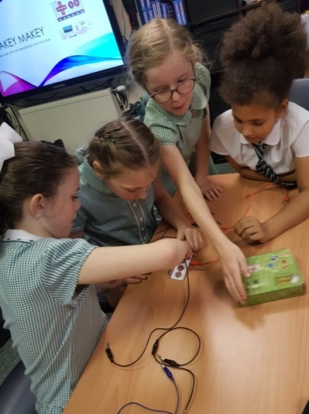
The school is well resourced; it has laptops and a whole class set of iPads. Every classroom has an interactive smartboard.

In March 2006, the school achieved Naacemark which recognised success in developing and implementing a strategic approach to IT. It acknowledged the use of IT to enhance teaching and learning and the opportunities provided for the school community to develop IT capability. IT Mark was a new quality mark available from April, 2006, and it was attained in May, 2006. It is a national benchmark standard awarded to schools that demonstrate high achievement and impact on learner outcomes in IT. The school was successfully reassessed for the award in April, 2009, December, 2012, March, 2016, March, 2019 and most recently in Spring, 2024.

Parents/carers are requested to become familiar with the school’s E-Safety Policy.

NATIONAL CURRICULUM TESTS
At the end of Key Stage Two the children are assessed in English and mathematics.
All the children receive a teacher assessment level and a test level. The expected scaled score at the end of Key Stage 2 is 100. The higher standard is awarded to pupils who attained `110 or more; the highest score is 120. Pupils take a National Curriculum test in Reading, English Grammar, Punctuation and Spelling and Mathematics, including arithmetic and reasoning. Teacher assessment grades are reported for Writing and Science.

COMPLAINTS ABOUT CURRICULUM
In the first instance, any parents / carers wishing to make a complaint about the content of the curriculum should make an appointment to discuss the matter with the Headteacher. If the parent / carer remains dissatisfied, then the Governing Body Curriculum / Standards Committee will hear the grievance and will consult the LA.
The school prides itself on having very clear aims for the curriculum to ensure there is both depth and breadth. All subjects are delivered well and teacher subject knowledge is excellent; thus pupil outcomes are also excellent throughout the curriculum.

ADMISSION POLICY AND ARRANGEMENTS FOR 2026 - 27

ETHOS STATEMENT
The Catholic Faith and the Teachings of the Catholic Church have an essential role in school life and influence every aspect of the curriculum. The Governing Body requests that all parents/carers applying for a place in our school respects this ethos and its importance to the school community. This does not affect the rights of parents/carers who are not of the Faith of this school to apply for and be considered for a place.
St. Bede’s is a Roman Catholic Junior School under the trusteeship of the Archdiocese of Liverpool. It is maintained by Halton Local Authority. As a Voluntary Aided School, the Governing Body is the Admissions Authority and is responsible for taking decisions on applications for admissions. The Local Authority undertakes the co-ordination of admissions arrangements. For the school year commencing September 2021, the Governing Body, under the instruction of the Archdiocese of Liverpool, set its admissions number at seventy-five pupils.
St Bede’s Catholic Infant School and St. Bede’s Junior School are two separate schools. Although the majority of the children who have attended the Infant School often wish to move to the Junior School, there is no automatic transfer. Attendance at St Bede’s Catholic Infant School does not guarantee your child a place at St Bede’s Catholic Junior School. The Admission Policy for St Bede’s Catholic Junior School is strictly followed.
Parents/carers of children in Year 2 in St Bede’s Catholic Infant School must apply for a place for Year 3 to St Bede’s Catholic Junior School by completing an Infant to Junior Transfer Form and do so during the primary application period (closing date 15th January 2025). This is available online from www.halton.gov.uk/schooladmissions , following the “Junior Schools” link, or by filling in the form that will be sent to the parents/carers of pupils in Year 2 at St Bede’s Catholic Infant School, by the Local Authority Admissions Team.
The form must be returned to the Local Authority by the closing date. Any applications received after this closing date will only be considered if there are still places available after all the ones received on time have been accepted or declined, according to the admissions criteria.
ADMISSIONS CRITERIA
The Governing Body makes admissions to the school. All preferences listed on the Local Authority Preference Form are considered on an equal basis with the following set of admissions criteria, forming a priority order where there are more applications for admissions than the school has places available.
- Looked after children and previously looked after children. This includes children who appear to have been in state care outside of England and ceased to be in state care as a result of being adopted.
- Baptised Catholic children who have a sibling in St Bede’s Catholic Infant or St Bede’s Catholic Junior School at the time of admission.
- Baptised Catholic children resident in the parish of St Wilfrid, the parts of the parish formerly referred to as St Bede and St Raphael.
- Other baptised Catholic children.
- Other children who have a sibling in St Bede’s Catholic Infant or St Bede’s Catholic Junior School at the time of admission.

- Children from other Christian denominations. Proof of Baptism in the form of a Baptismal Certificate or confirmation in writing that the applicant is a member of their Faith community from an appropriate Minister of Religion is required.
- Children of other faiths. An appropriate Faith Leader would need to confirm in writing that the applicant is a member of their faith group.
- Other children.

ADMISSIONS ARRANGEMENTS
- All applicants will be considered at the same time and after the closing date for admissions which is 15th January.
- A Looked After Child is a child who is (a) in the care of a Local Authority, or (b) being provided with accommodation by a Local Authority in the exercise of their Social Care functions (under section 22(1) of the Children Act 1989. A previously Looked After Child is one who immediately moved on from that status after becoming subject to an adoption, residence or special guardianship order.
- Baptised Catholic means within the policies and practices relating to school admissions; any child who, before the date of application is a baptised Catholic or who, having been baptised into another Christian denomination whose baptisms are recognised by the Catholic Church, has subsequently been formally received in to the Catholic Church;
For a child to be considered as a Catholic, evidence of a Catholic Baptism or reception into the Church will be required.
A Baptised Catholic can also be defined as one who has been baptised by the Rites of Baptism of one of the various Churches in communion with the See of Rome (Cf. Catechism of the Catholic Church 1203). Written evidence of this baptism can be obtained by recourse to the Baptismal Registers of the church in which the baptism took place.
Or
A person who has been baptised in a separate ecclesial community and subsequently received into full communion with the Catholic Church by the Rite of Reception of Baptised Christians into the Full Communion of the Catholic Church. Written evidence of their reception into full communion with the Catholic Church can be obtained by recourse to the Register of Receptions, or in some cases a sub-section of the Baptismal registers of the Church in which the Rite of Reception took place.
The Governing Body will require written evidence in the form of a Certificate of Reception before applications for school places can be considered for categories of “Baptised Catholics”. A Certificate of Reception is to include: full name, date of birth, date of reception and parent(s) name(s). The certificate must also show that it is copied from the records kept by the place of reception.
Those who would have difficulty obtaining written evidence of baptism for a good reason, may still be considered as baptised Catholics but only after they have been referred to their parish priest, who after consulting with the Vicar General, will decide how the question of baptism is to be resolved and how written evidence is to be produced in accordance with the law of the Church.
- If in any category there are more applications than places available, priority will be given based on distance from home to school. Distance will be measured in a straight line from the front door of the child’s permanent residence (including the community entrance to flats) to the main entrance of the school. The address to be used in measuring distance for the purpose of allocating school places will be the child’s permanent address on the closing date of 15th January, 2025. Distance is measured using the Local Authority’s computerised measuring system, with those living nearer to the school having priority. In the event of distances being the same for two or more applicants where this distance would be last place/s to be allocated, a random lottery will be carried out in a public place. All the names will be entered into a receptacle and the required number of names will be drawn out.
- If you are separated and your child spends time at each parent’s address, the address we use for admission to school is that of the main carer. We use the address of the parent who gets the Child Benefit for this.
- Sibling is defined in these arrangements as children who live as brother or sister in the same house, including natural brothers or sisters, adopted siblings, stepbrothers or sisters, foster brothers and sisters or the child of a parent’s/carer’s partner where the child for whom the school place is sought is living in the same family unit at the same address as that sibling.
- A waiting list for children who have not been offered a place will be kept and will be ranked according to the Admission Criteria. The waiting list does not consider the date the application was received, or the length of time a child's name has been on the waiting list. This means that a child's position on the list may change if another applicant is refused a place and their child has higher priority in the admissions criteria. The waiting list will be retained until at least the end of December of the relevant year of the admissions process.For ‘In Year’ applications received outside the normal admissions round and if places are available then children qualifying under the published criteria will be admitted. Direct application to the school can now be made under this heading. If there are places available but more applicants than places then the published oversubscription criteria will be applied.
- For ‘In Year’ applications received outside the normal admissions round, if places are available, they will be offered to those who apply. Direct application to the school can now be made under this heading. If there are places available but more applicants than places, then the published oversubscription criteria for the relevant year group will be applied. A waiting list for those who have not been offered a place will be kept until the end of the relevant academic term.
- If an application for admission has been turned down by the Governing Body, parents can appeal to an Independent Appeals Panel. Parents must be allowed at least twenty school days from the date of notification that their application was unsuccessful to submit that appeal. Parents must give reasons for appealing in writing and the decision of the Appeals Panel is binding on the Governors.
- The Governing Body reserve the right to withdraw the offer of a school place where false evidence is received in relation to the application, e.g. baptism, sibling connections or place of residence.
- If the Governing Body has refused an application for admission, parents/carers can appeal to an Independent Appeals Panel. Parents/carers must be allowed at least twenty school days from the date of notification that their application was unsuccessful to submit that appeal. Parents/carers must give reasons for appealing in writing and the decision of the Appeals Panel is binding on the Governors.
- When all preferences have been considered, the Child Place Planning and Provision Team will notify parents/carers of their child’s allocated Halton LA community, voluntary controlled or voluntary aided school.

SCHOOL ORGANISATION
The children are taught in single age classes, with the exception of Class 3 and Class 8, which are mixed age.

HOMEWORK
At St. Bede’s, we focus on the formation of the whole person, not just on intellectual development. Thus, we believe that social interaction is valuable and a child needs opportunities to foster individual interests/skills and participate in different activities.
Rationale
Parents are the first educators of their child and they continue to have a vital role during the time that the child is at School. The teaching staff at St. Bede's believe that a child's learning is enhanced if parents and teachers work in partnership. Classwork is enriched and collaboration is established. However, it is acknowledged that parents’ commitment to homework is essential if it is to be effective and a child needs to enjoy their childhood and requires time to explore interests and investigate the joy and challenge of relating to other groups outside the School community - cubs, brownies, orchestras, swimming clubs, etc.
The demands of Key Stage Three will come soon enough and there is no intention to burden a child in Key Stage Two by replicating practices in high schools.
Purposes
- to enable parents / carers, teachers and support staff to work together for the benefit of the child;
- to allow parents / carers to be involved in their child’s learning;
- to consolidate and reinforce knowledge, skills and understanding, particularly in literacy and numeracy;
- to extend the work being developed in the classroom;
- to inform parents / carers of the work being undertaken in school;
- to encourage the child and parents / carers to TALK about the learning;
- to foster communication between the home and school;
- to promote the transfer of skills from one situation to another (for example, the multiplication facts learnt in the morning, help with the measuring of the area of the living room in the evening!);
- to nurture the confidence and self-discipline needed for children to become independent;
- to prepare Year 6 pupils for requirements, regarding homework, in Key Stage Three.
Guidelines
Children are expected to complete homework.
1. Children are encouraged to read every evening for a minimum of fifteen minutes. Parents/carers and pupils are asked to write a reading comment in the pupil’s diary each day.
2. Appropriate English and mathematics homework are provided by the teacher on a weekly basis. Additional tasks / activities are sent home when a child’s learning will be reinforced or when they are preparing for tests, etc.

The amount of homework is determined by the teacher according to the child’s age and ability. It is not to be onerous for the child, parents / carers, teacher. The DfE recommended time allocation for homework, not including reading, is 1½ hours per week in Years 3 and 4 and 2½ hours per week in Years 5 and 6.
Feedback is given on homework and a record maintained by the teacher.
Children are rewarded for displaying a positive attitude towards homework and returning it completed, on time. Parents / carers are encouraged to help their child with homework tasks, provide a reasonably peaceful, suitable place for homework to be completed and give praise when it is accomplished.
Reading / homework diaries are used to facilitate communication between home and school. Diaries need to be returned to school every day. The children are responsible for completing the diary on a regular basis and parents / carers are requested to read and sign it each week. The class teacher reads the diary at least once per week. Teachers endeavour to sign the diary every week, but this is challenging when pupils ‘forget’ their diary.
Parent / carer comments provide the teacher with valuable information. Parents / carers are welcome to make a written comment or call into school between 8·30 - 8·40 a.m. on any school day to discuss any aspect of the homework.

PASTORAL CARE
All staff, both teaching and non-teaching, have a duty of care and ensure the good health and safety of each pupil during school hours. The school employs a full-time Pastoral Leader (Mrs. L. Harrington) who is responsible for the well-being and social and emotional development in our pupils. The Pastoral Leader assists the school’s staff team in providing/ signposting to services, training and skills development opportunities to local families by using local information. Through one to one and small group work, she is able to assist pupils who need help to overcome barriers to learning inside and outside of the school. This provision ensures an environment for teaching and learning that empowers both staff and pupils to achieve their highest potential.

BEHAVIOUR FOR LEARNING
St. Bede’s Catholic Junior School fosters a truly Christian community which works together to facilitate the growth of the whole person and empowers each individual to experience.
“life in all its fullness” (John 10:10).
Parents /carers play the most important role in teaching about ways of behaving. The attitudes, courtesies and disciplined behaviour that children begin at home is reinforced in school. Positive behaviour is rewarded; inappropriate behaviour is dealt with firmly and fairly. Every opportunity is taken to support self-discipline.
School discipline is regarded as a system of relationships, expectations (practices and procedures), rewards and sanctions designed to promote co-operation, and develop individuals who are responsible and actively living our chosen values in all aspects of everyday life.
The school has a Behaviour for Learning Policy, the purposes of which are:
- to confirm that a well-ordered community, which combines an atmosphere of care, security and respect within defined boundaries of behaviour, lies at the heart of an effective school;
- to establish that the management of behaviour is the responsibility of everyone in the school;
- to acknowledge that the behaviour of each individual has an effect on the behaviour of others;
- to understand that behaviour is a form of communication;
- to assist children in taking personal responsibility for their actions;
- to appreciate that every child is entitled to a classroom where she / he can work unimpeded by the behaviour of others;
- to promote good (acceptable, pleasant, polite, sociable, reasonable) behaviour which reflects the school’s values and expectations;
- to ensure that standards are consistent and that rewards / sanctions are fairly applied;
- to recognise that parents / carers are central to the school community, being natural and irreplaceable agents in the education of their children;
- to accept that the context of some children’s lives is not settled nor secure, and that the school may be a sanctuary;
- to work in positive partnership with parents / carers, governors, the support agencies and the wider community.

Policy Guidelines
Everyone involved in the life of the school is responsible for the management of behaviour. The Home-School Agreement details the responsibilities of pupils, parents / carers and staff.
A broad, differentiated, well-balanced, high quality, enjoyable curriculum is a prerequisite. Staff strive to engage children’s interest in learning and thus avoid disruptive behaviour. Preventative work is considered preferable to remedial action.
Other school contributions towards the successful management of pupil behaviour are evident in the delivery of a well-managed pastoral support system, constructive partnerships with parents / carers and the involvement of pupils in a varied programme of extra-curricular activities.
School discipline is based on the notion that children respond more readily to positive recognition of their good social behaviour rather than bad behaviour being penalised. It is appreciated that most children want to recreate the behaviour that resulted in a reward.

It is the consistency of approach within the classroom that enables children to learn appropriate behaviour and self-discipline. Guidance has been prepared by staff to help with the implementation of the Behaviour for Learning Policy. School expectations have been agreed by parents / carers, pupils, staff and governors. They are limited in number and are memorable to ensure that all members of the school community know them and follow them.
Our school is one which ensure that children are fully aware of the expectations of them, not only in the classroom but within the whole school.
“We are children of God who, respect, love and achieve.”
These key words are to be reiterated when speaking to a child, whether this be to praise or as a reminder of the expectations.
Rewards are given to individuals, groups, classes and house teams; this encourages children to work together in creating a positive classroom atmosphere.
Before children are admitted into the school they are made aware of the school’s expectations regarding behaviour in the ‘About our School’ booklet. The rewards include verbal / written praise, house token, postcards home etc. There is a great emphasis on CELEBRATION, as the school “celebrates life and learning”.
Sanctions are applied to solicit co-operation. It is the consistency and inevitability of the consequence that helps the pupil to choose appropriate behaviour.
The intention is to give children the opportunity to think about the choices that they have in improving their behaviour. The sanctions are in proportion to ‘offences’ and enable pupils to make reparation, where appropriate.

Use Of Force And Restraint
The school’s Policy on Behaviour for Learning is always observed and in almost every instance the application of it is sufficient to deal with the majority of situations. However, there is a Policy on the Use of Restrictive Physical Intervention. Positive handling is used to control or restrain pupils when all other strategies have failed. Staff have undertaken training. The Headteacher has authorised staff to use such force as is reasonable in extreme circumstances to prevent a pupil from doing harm to themselves or other pupils/staff.
Although physical intervention is very unlikely to be used in our school, schools have the legal power to use reasonable force to:
- remove disruptive children from the classroom where they have refused to follow an instruction to do so;
- prevent a pupil behaving in a way that disrupts a school event or a school trip or visit;
- prevent a pupil leaving the classroom where allowing the pupil to leave would risk their safety or lead to behaviour that disrupts the behaviour of others;
- prevent a pupil from attacking a member of staff or another pupil, or to stop a fight in the playground; and
- restrain a pupil at risk of harming themselves through physical outbursts.
All children are treated with dignity and respect. If physical force is necessary, it will be reasonable and proportional to the circumstances. It will be used in a manner which is consistent with the statutory duty upon schools to safeguard and promote the welfare of pupils and staff. Any incident will be recorded; parents/carers informed and it will be investigated by a senior member of staff.
Discipline is positive, fair and firm, based on mutual respect and equality of treatment of all pupils. The children are encouraged, praised and rewarded for their contribution to all aspects of school life. Parents / carers are invited to discuss unacceptable social behaviour, infringement of recognised school and classroom expectations, etc., with the class teacher / Headteacher.

Support Services
The causes of inappropriate behaviour can be complex. Often the support of a range of agencies is required to move the situation forward in a positive manner. When parents / carers seek support, it is targeted on the needs of the individual child. There is consultation to determine the most applicable referral route, for example, Psychology Service, Educational Welfare Service/Attendance and Behaviour Team, Social Care, Primary Child and Adolescent Mental Health Team, etc. Through access to these services parents / carers can procure support and come to an understanding of their rights and responsibilities concerning the education system.

Our Success
Our success is tested not by the absence of problems but by the way that we (staff, parents/ carers and children) deal with them.
Everyone in the school community is aware of the:
- Behaviour for Learning Policy;
- Anti-Bullying Policy;
- Early intervention (including identification of underlying causes of inappropriate behaviour) and staged approach;
- Involvement of parents / carers;
- Consistent application of policies;
- Opportunities for training regarding behaviour for learning;
- Periodic review of the policies relating to behaviour for learning which include consultation with parents / carers and pupils;
- Commitment to equality of opportunity.
Behaviour/discipline is regarded as a matter which lies at the heart of the school and its effectiveness. Thus, governors, staff, parents / carers and pupils work together on holistic and consistent approaches to managing behaviour.
If parents / carers have any concerns regarding behaviour/discipline, they are advised to make arrangements to discuss them with the Headteacher.

PREVENTION OF BULLYING
In our school context, with the co-operative ethos, bullying is less likely to emerge, but prevention is better than cure and nowhere is free of risk. Bullying can have a devastating effect on victims; it can lead to absenteeism, under-achievement, and, in the worst cases, to depression and suicide. For the silent majority who witness bullying or who know that it is happening, the weight can be traumatic leading to feelings of worry, fear and guilt. Thus, to develop positive self-images and self-worth, bullying must be prevented in school.

Some technologies, for example, mobile phones and the internet can be used negatively. Cyberbullying is the use of Information Technology (IT) to deliberately upset someone else. It can take place at any time and can intrude into spaces (including the home) that have previously been regarded as safe or personal. The whole community has a part to play in ensuring cyber safety. Parents/carers are urged to limit their child’s engagement on social media, including the use of WhatsApp groups and Instagram, as these platforms are not always used appropriately and place younger children at risk.

Bullying is regarded as deviant behaviour, but because of the serious consequences there is a separate Anti-Bullying Policy. This is available for parents / carers in school and details a definition; recognition of bullies / victims and bullying behaviour; immediate response of staff to bullying; preventative tactics; and procedures for staff when investigating bullying behaviour. There is key advice for parents / carers and children related to cyber safety. However, tackling cyberbullying will be an ongoing process as technology continues to develop. Full guidance is produced by the DfE and Childnet
(www.teachernet.gov.uk/publications and www.digizen.org).

CHILD PROTECTION
“Because of their day-to-day contact with individual children during school terms, teachers and other school staff are particularly well placed to observe outward signs of abuse, changes in behaviour or failure to develop”.
(Working Together - Under the Children Act).

Where it appears to a member of staff that a child may have been abused, the school is required, as part of Child Protection procedures, to report the concerns to Halton Social Care.

SAFEGUARDING
The Children Act places a duty on key persons and bodies to make arrangements to ensure that in discharging their functions, they have regard to the need to safeguard and promote the welfare of children.
As members of Halton’s Safeguarding Children’s Board, all partner agencies have agreed to ensure that the duty to safeguard and promote the welfare of children is carried out in such a way as to improve outcomes for children and young people in Halton.
Safeguarding includes:
- Keeping children and young people safe from maltreatment, neglect, violence and sexual exploitation. This includes child abuse, domestic violence, sexual abuse;
- Keeping children and young people safe from accidental injury and death. This includes safety in the home, school, workplace, on the streets, on public and private transport, fire safety, environmental safety;
- Keeping children and young people safe from bullying and discrimination. This includes anti-bullying strategies, diversity policies and actions, anti-racism / homophobic strategies, equal opportunity policies and actions;
- Keeping children safe from crime and anti-social behaviour in and out of school. This includes personal safety, positive activities, citizenship, volunteering;
- Ensuring children and young people have security, stability and are cared for. This includes support to children at home and looked after children, assessment and planning for children’s needs.

The Safeguarding Officer in St. Bede’s Catholic Junior School is Faith Housley. She is supported by the Designated Safeguarding Lead, Mrs. G. Geoghegan (Assistant Headteacher) and the Deputy Designated Safeguarding Lead, Mrs. L. Harrington (Pastoral Leader).

EXTRA CURRICULAR ACTIVITIES
The school subscribes to the view that:

“The basic curriculum as prescribed by law… is not intended to be the whole curriculum. The whole curriculum of a school goes far beyond the formal timetable. It involves a range of policies and practices to promote the personal and social development of pupils”. National Curriculum Council
The children have the opportunity to participate in a wide range of extra-curricular activities during their four years at the school, for example: computing club, art, craft, crocheting, knitting, sewing, drama, baking/cookery, science, design and technology, film club, choir, guitar, keyboard, orchestra, dance, netball, cricket, gymnastics, cross-country, athletics, football, rounders, rugby and table tennis.

CHILDREN’S UNIVERSITY
From September, 2013, the school became a validated Children’s University learning destination which encourages its children to access learning beyond the normal school day and to gain recognition for their commitment to enhancing their own learning. Children collect credits for each hour that they spend attending the after-school clubs.
In the summer term, the children in Year 6 receive the Children’s University ‘National Award’ once they have reached Bronze (thirty hours), Silver (sixty five hours) and Gold (one hundred hours). By Year 6, many children will have surpassed these milestones and achieve Bronze, Silver or Gold diplomas for even greater commitment to extra-curricular activity. Children and families are invited to attend a graduation ceremony in one of the local universities. The children are robed in cap and gowns and then presented with their national certificate. The graduation is a fantastic way to celebrate the commitment and hard work that the children have displayed throughout the year.

ARRANGEMENTS FOR VISITING THE SCHOOL
Parents / carers wishing to visit the school in connection with the possible admission of their child are invited to do so by telephoning the school to make an appointment. Parents / carers are welcome to call into school between 8·30 - 8·40a.m. on any school day to speak with the class teachers and Headteacher. Parents / carers can visit the school after 3·30p.m. to speak with the class teacher or Headteacher. This has to be by appointment, because of staff meetings and staff commitment to extra-curricular activities.
There is an opportunity provided each term for parents / carers to consult with the class teacher about their child’s progress.

UNIFORM

- Bottle-green ‘V’ neck jumper / cardigan
- White shirt
- Grey trousers (NOT skinny jean style)
- Tartan skirt, kilt or pinafore
- Tie - bottle-green and silver striped
- Grey / white socks, grey / bottle-green tights
- Black shoes (NOT boots nor trainers)
OPTIONAL
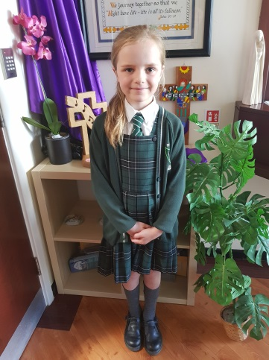
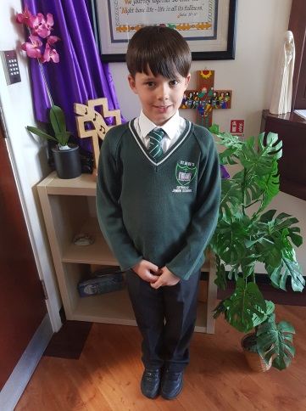
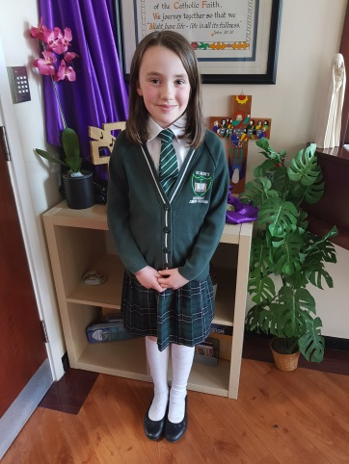
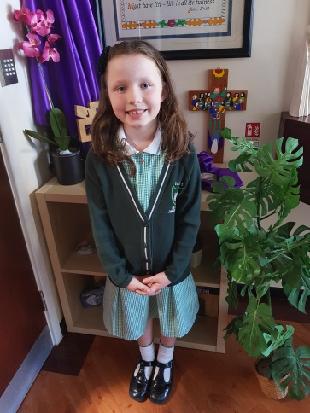
- In summer, a green / white gingham dress, short grey trousers, short-sleeved blouse / shirt, or a polo shirt embroidered with the school badge
PE UNIFORM
NOTE: Children are expected to wear the School PE Kit on PE Days – this is a PE uniform. Children should not wear other sports clothes, included branded items and/or other colours such as grey /navy.
- Green and black T-shirt
- Black shorts
- Black pumps / trainers

OPTIONAL
- School black and green tracksuit (only available from our suppliers)
- Trainers (for outside PE and Sport)
A green hoodie embroidered with the school badge (and optional initials) can be worn at playtimes and during outdoor PE.
NB: This is not a replacement for the school jumper/cardigan.

One small stud in each ear may be worn but any other jewellery is not to be worn. This is entirely in the interest of the pupil’s own safety. Please refer to Safety in PE and Sport, p.20. Watches and other equipment such as calculators, etc., are the child’s own responsibility.

SUPPLIERS
Our school uniform and PE kit can be purchased at:
- Boydells Sports (0151 424 3257)
- Touchline (01925 413777)

WORKING DAY
The morning session begins at 8.50 a.m. and ends at 12.15 p.m. The afternoon session begins at 1.15p.m. and finishes at 3.30p.m. No responsibility can be accepted for children before 8.40a.m. or after 3.30p.m., unless they are taking part in a school activity with a member of staff. Pupils should not be unsupervised on the playground before 8.40 a.m.
A typical day in the life of a Year 3 pupil:

8·50 – 9·00 a.m. - Morning Prayer
Registration

9.00 – 9.30a.m. - Religious Education
9.30 – 10.45a.m. - English / Mathematics lesson
10.45 – 11.00a.m. - Break time
11.00 – 12.20p.m. - Mathematics / English lesson
12.20 – 1.15p.m. - Lunch time
1.15 – 2.15p.m. - Foundation subject lesson (e.g. Spanish or Music)
2.15 – 3.15p.m. - Foundation subject lesson (e.g. PE or PSHE)
3.15 – 3.30p.m. - End of day Prayer
3.30 – 4.15p.m. - Extra-curricular club, for example, Science or Art Club.

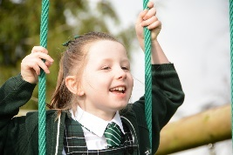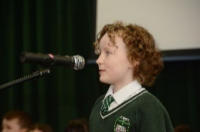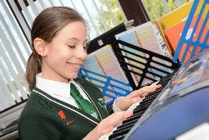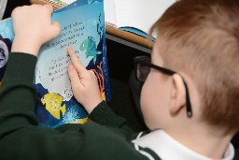

VILLAGE CARE CLUB LTD

The Village Care Club Ltd operates on our school site. It is independent from the school. It offers a Breakfast Club (7.45a.m. until the start of school) and an After-School Club until 5.30p.m. There is a cost for each session. Any enquires should be made to:
Miss B. Allen - 07905 25290 (Manager)
ATTENDANCE
When the child is absent, a verbal message / telephone call is essential on the first day of absence, preferably before 8.30a.m.
If a satisfactory explanation is not received by the school, then the absence is unauthorised. The Office, or Mrs. Harrington, will contact you by telephone to ascertain the safety and wellbeing of a child if we do not hear from you.

Leave of absence
Parents/carers are encouraged to read the following document regarding School Attendance:
Working together to improve school attendance (applies from 19 August 2024) (publishing.service.gov.uk).

Regarding Exceptional circumstances: All schools can grant a leave of absence for other exceptional circumstances at their discretion. In the case of schools maintained by local authorities and special schools not maintained by local authorities, it must be requested in advance by a parent who the pupil normally lives with. Schools are then expected to consider each application individually taking into account the specific facts and circumstances and relevant background context behind the request. If a leave of absence is granted, it is for the school to determine the length of the time the pupil can be away from school.
NOTE: Generally, the DfE does not consider a need or desire for a holiday or other absence for the purpose of leisure and recreation to be an exceptional circumstance.
If a parent/carer believes that he/she has exceptional circumstances, there is a form available in the Office for completion. Every form will be scrutinised by the Headteacher and/or Educational Welfare Officer before it is returned by the School Business Manager.
Please visit the school website, for the Attendance Policy.

PARENTS / CARERS IN PARTNERSHIP
A positive and productive partnership between the home and school is promoted and all parents / carers are invited to sign the Home - School Agreement.

Many parents / carers assist the teachers in classroom activities, for example, art and science sessions, reading groups and the organisation of the library. They accompany the children on educational visits, support at sport fixtures and help with homework, etc. In addition to being partners in the education process, parents / carers are one of our most valuable resources. If anyone has particular skills that he/she is willing to use/offer in school, please contact the Headteacher. The school welcomes and appreciates the contribution made by parents / carers.

ARCHDIOCESAN SCHOOLS BUILDING FUND
The Archdiocese requests £10 per year per family for the Archdiocesan Schools Building Fund. The money finances new buildings and large repair works on schools in the Archdiocese of Liverpool.
The donation is required from every family. Parents / carers are welcome to make a direct subscription of £10 per year.

CHARGES AND REMISSION POLICY

Parents / carers are invited to forward voluntary subscriptions towards the cost of the purchase of music tuition delivered by peripatetic music teachers.

When educational outings / residential visits are being organised parents / carers are requested to make a voluntary contribution. Failure to contribute will not involve a child being treated differently from any other child in the school. However, the trips rely on voluntary contributions and may be cancelled if they cannot be funded.

CHILDREN’S PROSPECTUS

There is a children’s version of this prospectus which is given to each individual during his / her induction session.

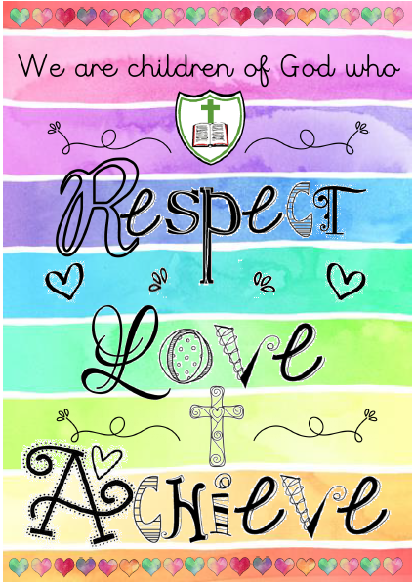
ST. BEDE’S CATHOLIC JUNIOR SCHOOL


Email: head.stbedesjunior@haltonlearning.net
Website: www.stbedesjuniorschool.co.uk
Appleton Village
Widnes
Cheshire
WA8 6EL
Tel: 0151 424 3386
Fax: 0151 424 1886

