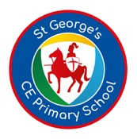
Year 5 Curriculum Newsletter- Summer Term 2

Welcome to the Summer Term! We are really excited for the term ahead and are looking forward to all the wonderful learning experiences the children will have. We hope that this current newsletter will support your understanding about what your child will be doing this half term and enable you to discuss their learning with them.
General Class Information
- We celebrate ‘Reading for Pleasure’ in Year 5. Children are exposed to a diverse range of high –interest books to develop a culture that will enable them to become avid and independent readers. In addition to texts covered in the curriculum, every child will choose a book (or two) to read at home and we encourage our children to share their experiences with one another and their families.
- Year 5 will have PE once a week. Our PE day is on MONDAY. Your child’s PE kit should consist of white T-shirt, black shorts/joggers, school jumper and trainers or pumps. We would like our children to look smart at all times.
- Daily Mile - our children are extremely enthusiastic and continuously strive to beat their personal best. All of Year 5 can run a mile and some of our children are now running two miles in fifteen minutes!




LEARNING MEANS THE WORLD- Full of Beans
“Full of Beans” is a thematic unit, with a key focus on geography. The children begin by learning about different types of beans, how and where beans are grown and their nutritional value. They will then go on to look at beans as a source of energy, before moving on to learn about energy sources generally, both renewable and non-renewable. A business enterprise element will enable to the children to create and sell their own smoothies.
Here is the key knowledge, skills and understanding the children will acquire by the end of the unit:

English- Writing
This half-term the children will be covering:
Titanic – Non-fiction news report
The malfeasance - Poetry
Teaching sessions are split into: Find the Shape lessons, Experience Days, Sentence Stacking Days and Independent Writing days. At the beginning of a unit children learn how to read non-fiction model and are helped to understand it as a visual, jigsaw style shape. Then lessons concentrate on teaching of writing with a sharp focus on the craft and construction of sentences. Experience Days are immersive teaching to stimulate ideas and can take many forms. Independent Writing days give children real freedom to develop their content around a theme independently.

English-Reading
During guided reading lessons, the children read a variety of texts both fiction and non-fiction within their groups. We discuss the book in detail and the children develop strategies to improve fluency and understanding when reading. Alongside reading strategies the children are assessed on their comprehension and inference skills. This half term, we have a focus on vocabulary so it would help if you could ask children what certain words in their reading books mean so they have a better understanding of the text. It is vital that you read at home with your child so that they can practise their reading skills on a daily basis.

Maths
We use White Rose Maths to plan and deliver the teaching of Maths. This half term, the children will be learning about decimals, negative numbers, converting units and volume. Here are the small steps of learning:
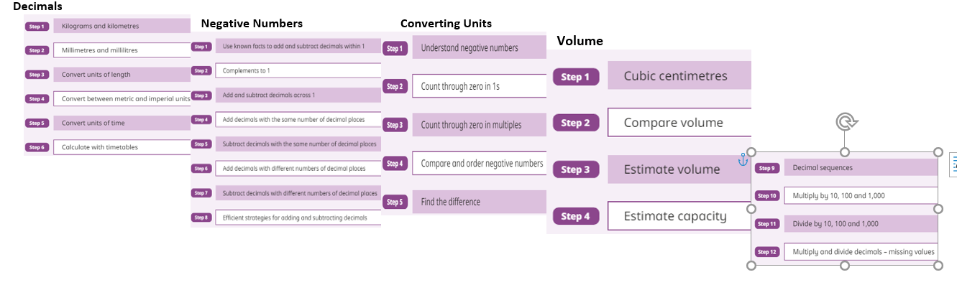
RE
Our topic for the Summer Term is What does it mean to be a Muslim in Britain today?
This unit enables pupils to learn in depth from different religious and spiritual ways of life about being a follower of the Muslim religion. Pupils explore the five pillars of Islam and the importance of these to Muslim believers. Pupils will gain a greater understanding of Islam and what we can learn from its beliefs, values and ideas. This investigation provides an opportunity to learn about the Qur’an and other forms of guidance and visit a Mosque. Accurate vocabulary: teach pupils to remember and use Islamic terminology correctly, for example prophet, Allah, 5 Pillars, minaret, dome, mosque, muezzin, mihrab, wudu, revelation. Also use the vocabulary of spirituality: ‘a sense of the presence of God’, ‘experiences of awe and wonder’.

Our whole school Christian Value this half term is RESPECT.
‘Whatever you wish that others would do to you, do also to them, (Matthew 7.12)
During our Collective Worship assemblies, the children will be reflecting on the themes of using our talents to serve, receiving as well as giving and living for others.

