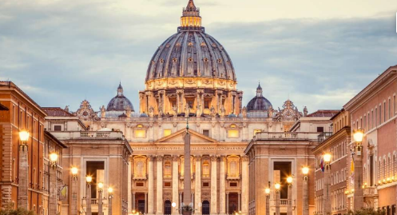
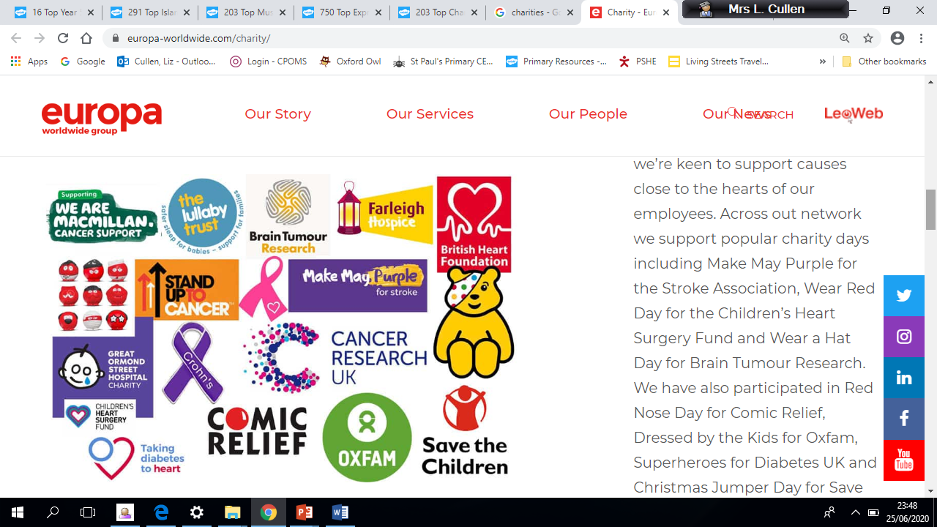
Is it better to express your religion inarts and architecture or in charity and generosity?
Key Question:
This investigation enables pupils to learn in depth from two different religions about why their holy buildings and works of art matter to them as expressions of devotion to God and worship, and about how they practice generosity and charity. Muslim and Christian examples are sometimes criticised by non religious people: this critique is examined too. Of course, the rather polarising title can receive the response ‘both matter’, as the final lesson will show, but the controversy is good for the pupils’ learning.
Questions:
3.7 How can people express the spiritual through the arts?
Religions and worldviews:
Christians, Muslims and non‐religious, e.g. Humanists

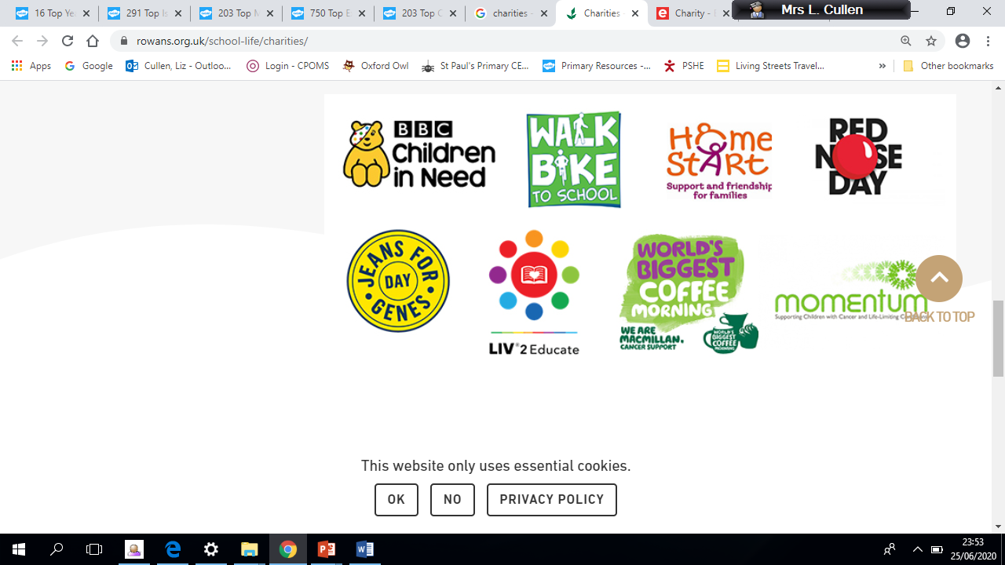
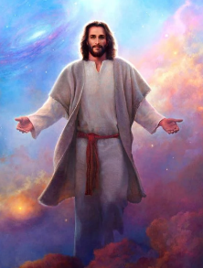

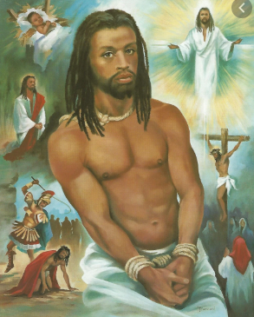
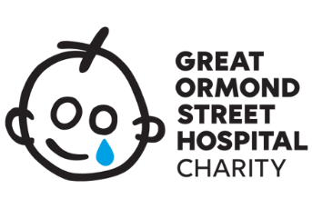

Emerging | Expected | Exceeding
Respond with ideas of their own to the title question (B2).  Find out about religious teachings,charities and ways of expressing    generosity (C3) | Describe and make connections between examples of religious creativity (buildings and art) (A1).  Show understanding of the value of sacred buildings and art (B3).  Suggest reasons why some believers see generosity and charity as more important than buildings and art (B2).  Apply ideas about values and from scriptures to the title question (C2). | 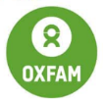  Outline how and why some Humanists criticise spending on religious buildings or art (A3).  Examine the title question from different perspectives, including their own (C1).
