Questions:
F2 Which people are special and why? UU2.2 What would Jesus do? Can we live by the values of Jesus in the twenty‐first century? 3.3 What is so radical about Jesus?
Religions and worldviews:
Christians

Why is Jesus inspiring to some people?
Key Question:
This investigation enables pupils to learn in depth from Christianity, exploring different reasons why Jesus is considered an inspiring figure by Christians – and by many other people too.









Christianity

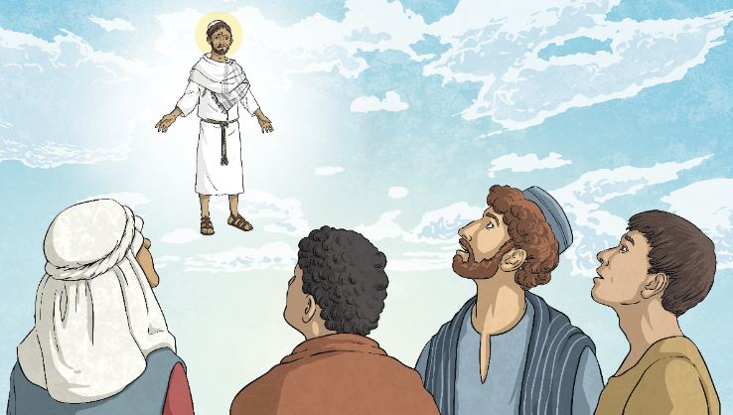

Emerging | Expected | Exceeding
Ask questions raised by the stories and life of Jesus and followers today and give examples of how Christiansare inspired by Jesus (B1).  Suggest some ideas about good ways to treat others, arising from their learning (C3). | Make connections between some of Jesus’ teachings and the way Christians live today (A1).  Describe how Christians celebrate Holy Week and Easter Sunday (A1).  Identify the most important parts of Easter for Christians andsay why they are important (B1).  Give simple definitions of some key Christian terms (e.g. gospel, incarnation, salvation) and illustrate them with events from Holy Week and Easter (A2). | Make connections between the Easter story of Jesusand the wider ‘big story’ of the Bible (creation, the Fall, incarnation, salvation – see unit L2.2), rreflecting on why this inspires Christians (A1).  Present their own ideas about the most important attitudes and values to have ttoday, making links with Christian values (C2).

