Questions:
F3: Which places are special and why? 1.7: What makes some places sacred? L2.5: Why do people pray? 3.6: Should religious buildings be sold to feed the starving?
Religions and worldviews:
Christians, Hindus and Jewish people
If God is everywhere, why go to a place of worship?
Key Question:
This investigation enables pupils to learn in depth from different religious and spiritual ways of life about worship, drawing out more detail, history and diversity through focussing on places of worship. Pupils learn about the various purposes of a place of worship as well as how believers see these places. Pupils think about the idea of God’s presence on earth and in believers’ lives. Opportunities to debate are given, including of the key question, to offer pupils a chance to reflect for themselves on the value and purpose of worship in religion.


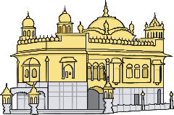

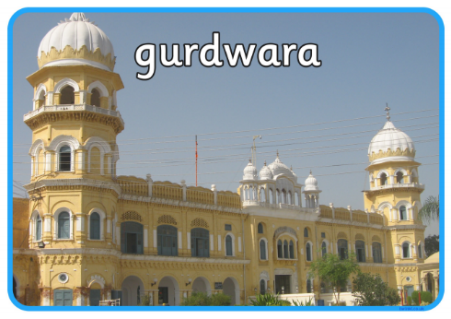
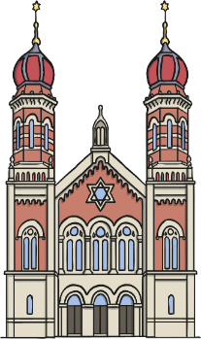

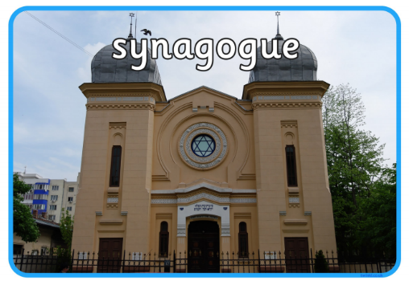
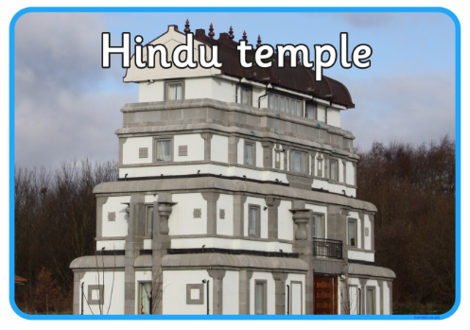
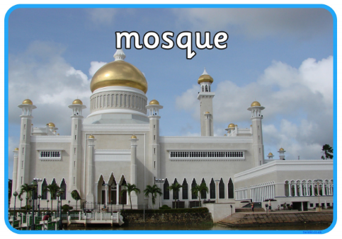
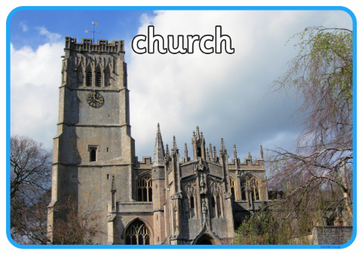
Emerging | Expected | Exceeding
Recall and name some key features of places of worship studied (A1).  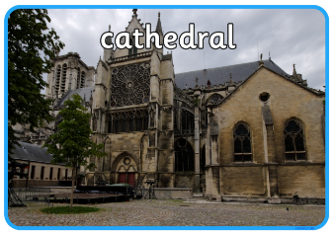  Find out about what believers say about their places of worship (C2). | Make connections between how believers feel about places of worship in different traditions (A3).  Select and describe the most important functions of a place of worship for the community (B3).  Give examples of how places of worship support believers in difficult times, explaining why this matters to believers (B2).  Present ideas about the importance of people in a place of worship, rather than the place itself (C1). | Outline how and why places of worship fulfil special functions in the lives of believers (A3).  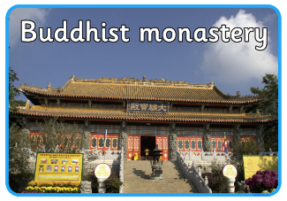  Comment thoughtfully on the value and purpose of places of worship in religious communities (B1).

