Questions:
1.8 How should we care for others and the world, and why does it matter? 3.11 What difference does it make to believe in…?

Religions and worldviews:
Christians, Muslims and Hindus
What difference does it make to believe in Ahimsa (harmlessness), Grace (the generosity of God), and Ummah (community)?
Key Question:
This investigation enables pupils to learn in depth from different religious and spiritual ways of life through exploring three important ideas from three different religions in ways that relate to commitment.

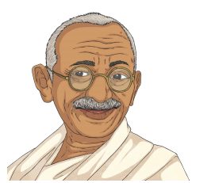
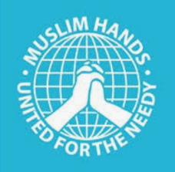







Christianity

Hinduism
Islam


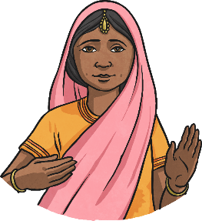
Emerging | Expected | Exceeding
Describe what Ahimsa, Grace or Ummah mean to religious people (A1).  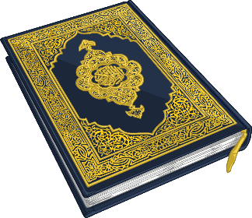  Respond sensitively to examples of religious practice with ideas of their own (B2). |   Make connections between beliefs and behaviour in different religions (A1).  Make connections between belief in ahimsa, grace and Ummah, teachings and sources of wisdom in the three religions (A1).  Outline the challenges of being a Hindu, Christian or Muslim in Britain today (B2).  Consider similarities and differences between beliefs and behaviour in different faiths (B3). | Explain similarities in ways in which key beliefs make a difference to life in two or three religions (A1).  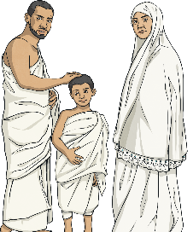  Consider and evaluate the significance of the three key ideas studied, in relation to their own ideas (B3).

