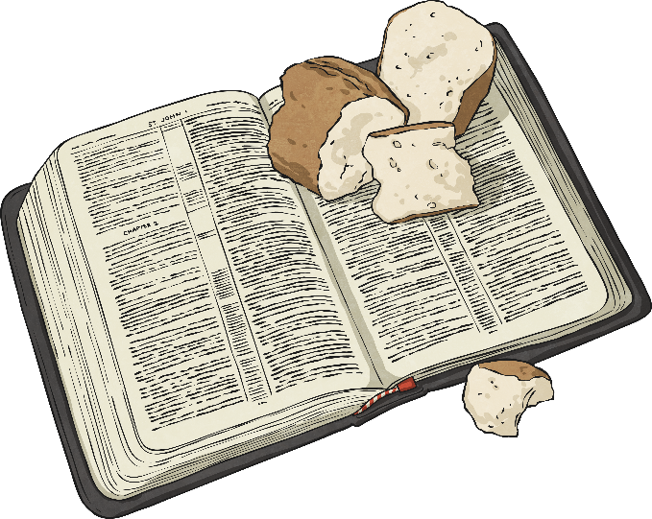
Questions:
F1 Which stories are special and why? 1.4 What can we learn from sacred books? 3.2 Does living biblically mean obeying the whole Bible
Religions and worldviews:
Christians
Why is the Bible important for Christians today?
Key Question:
This investigation enables pupils to learn in depth from different religious and spiritual ways of life about Christian scriptures – the Bible – exploring questions about what the Bible says and how the bible is used and valued in Christian communities today





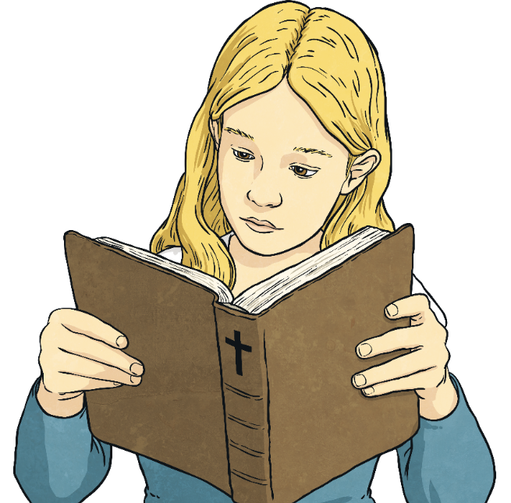
“The Bible is the best selling book in the world.”

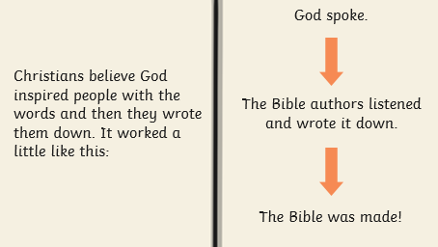
Emerging | Expected | Exceeding
Recall and name some Bible stories that inspire Christians (A2).  Identify at least two ways Christians use the Bible in everyday life (B1). | Make connections between stories in the Bible and what Christians believe about creation, the Fall and salvation (A2).  Give examples of how and suggest reasons why Christians use the Bible today (B1).  Describe some ways Christians say God is like, with examples from the Bible, using different forms of expression (A1).  Discuss their own and others’ ideas about why humans do bad things and how people try to put things right (C3). |   Explain how the bible uses different kinds of stories to tell a big story (A2).  Suggest why Christians believe that God needs to rescue/ save human beings (B2).

