
Questions:
1.8 How should we care for others and the world, and why does it matter? UU2.7 What matters most to Christians and Humanists? 3.10 Does religion help people to be good?
Religions and worldviews:
Christians, Jewish people, non-religious people eg humanists
What can we learn from religions about deciding what is right and wrong?
Key Question:
This investigation enables pupils to think about guidance that people follow to help them live their lives. It starts off by looking into the Golden Rule and how it is seen in Christianity, Humanism and Judaism. Pupils then look at guidance for living from all three of these worldviews, examining how Christians, Humanists and Jewish people might decide what is ‘right’. The unit moves on to look at teachings about temptation in Christianity and Judaism, helping pupils to think about what religious stories show about temptation. Finally, pupils investigate the life of a religious figure, looking at how teachings from religion may affect the actions of a believer.


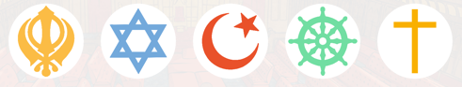


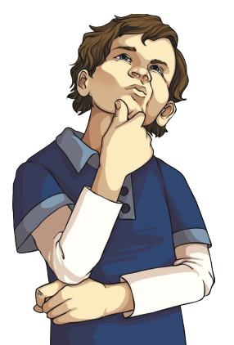

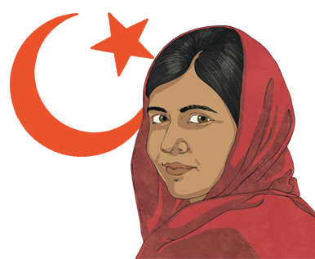
right
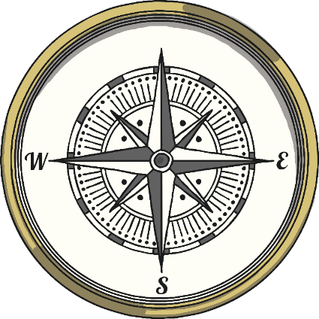
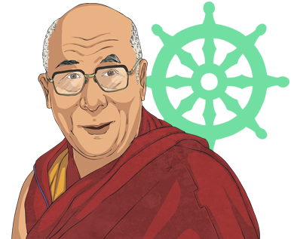
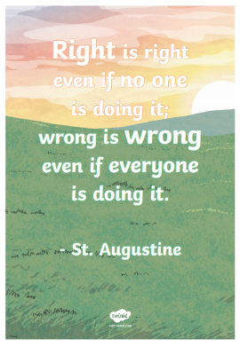
Emerging | Expected | Exceeding
  Recall and talk about some rules for living in religious traditions (B2). Find out at least two teachings from religions about how to live a good life (C3). | Give examples of rules for living from religions and suggest ways in which they might help believers with difficult decisions (B1).  Make connections between stories of temptation and why people can find it difficult to be good (A2).  Give examples of ways in which some inspirational people have been guided by their religion (B1).  Discuss their own and others’ ideas about how people decide right and wrong (C3) | 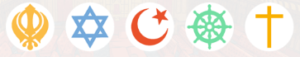  Explain some similarities and differences between the codes for living used by Christians and the followers of at least one other religion ornon‐religious belief system (B3) Express ideas about right and wrong, good and bad for themselves, including ideas about love, forgiveness, honesty, kindness and generosity (C3).
wrong

