Why do some people believe God exists?
Key Question:

This investigation enables pupils to learn in depth from different religious and non-religious groups about belief in God. Pupils enquire into the key question- raising questions about the nature and existence of God focussing on Christian ideas about God. Pupils will consider why people do or don’t believe in God and the impact that might have on the way they live their everyday life. This investigation provides an opportunity to meet Christians, agnostics and atheists and ask questions about why they do or don’t believe in God.
Questions:
1.1-3 Who is Christian/ Muslim / Jewish and what do they believe? L2.1 What do different people believe about God? 3.1 Do we need to prove God’s existence
Religions and worldviews:
Christians, non-religious e.g. Humanist

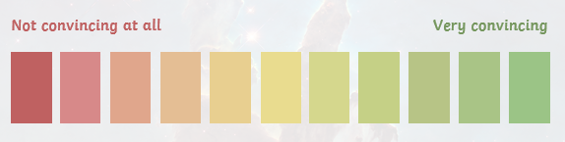



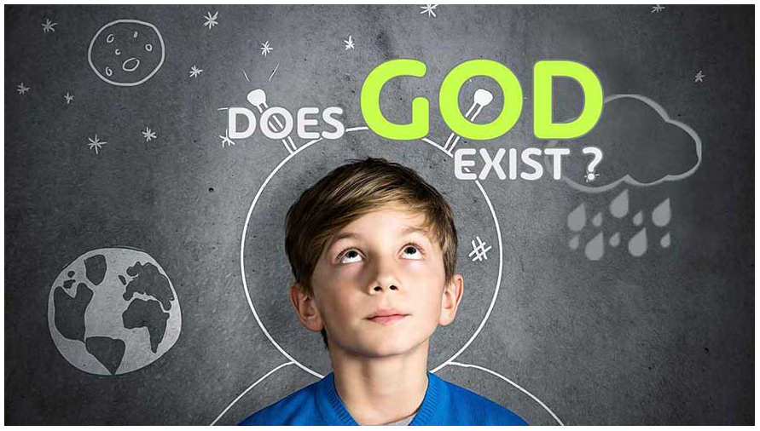

C
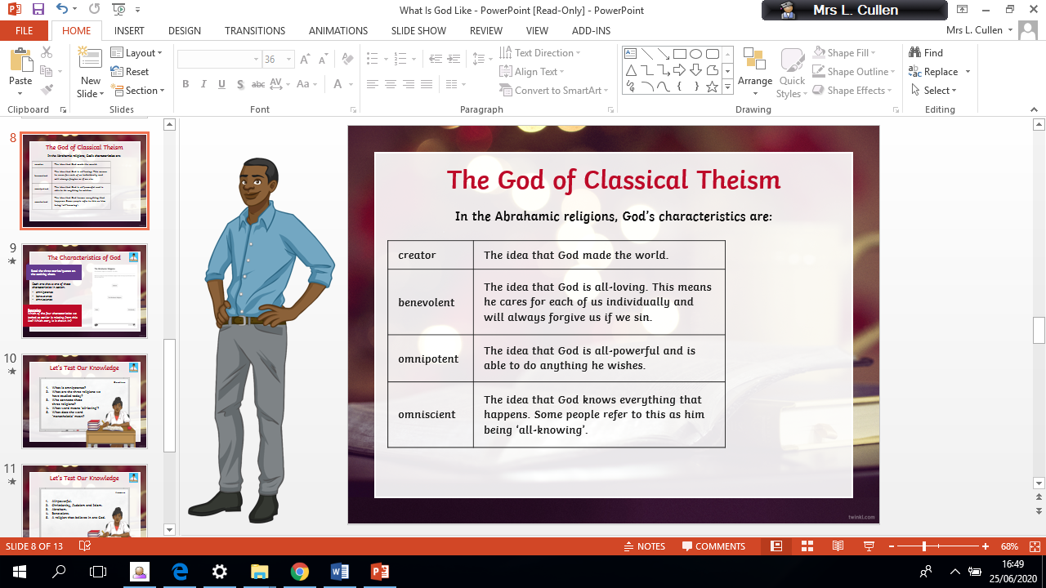




Emerging | Expected | Exceeding
  Define the terms theist, atheist and agnostic and give examples of statements that reflect these beliefs (B1). Give two reasons why a Christian believes in God and one why an atheist does not (A3). | Outline clearly a Christian understanding of what God is like, using examples and evidence (A2).  Give examples of ways in which believing in God is valuable in the lives of Christians, and ways in which it can be challenging (B2).  Express thoughtful ideas about the impact of believing or not believing in God on someone’s life (B1). • Present different views on why people believe in God or not, including their own ideas (C1). |   Explain how Christians sometimes disagree about what God is like, giving examples of how  they interpret texts differently (B3).  Enquire into what some atheists, agnostics and theists say about God, expressing their own ideas and arguments, using evidence and examples (C1)

