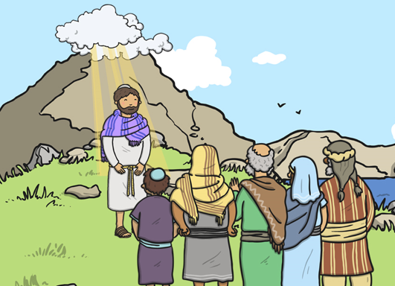
Questions:
1.1-3 Who is Christian / Muslim / Jewish and what do they believe? U2.1 Why do some people believe God exists? 3.2 Do we need to prove God’s existence?
Religions and worldviews:
Christians, Hindus or Muslims
What do different people believe about God?
Key Question:
This investigation enables pupils to learn in depth from different religious and spiritual ways of life regarding diverse beliefs about God




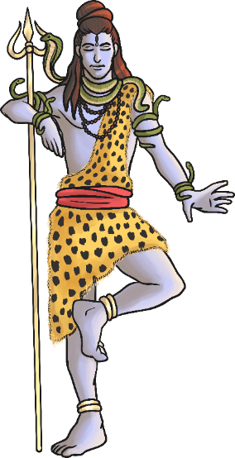
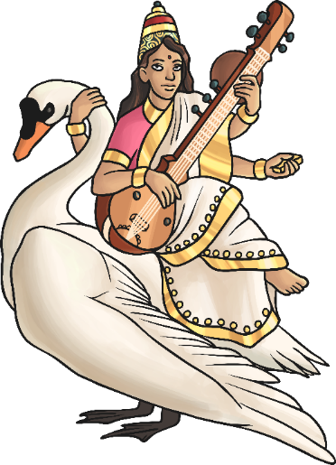
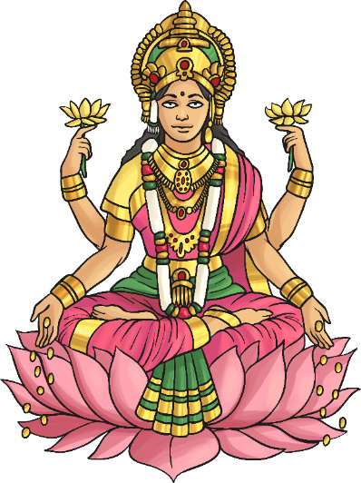
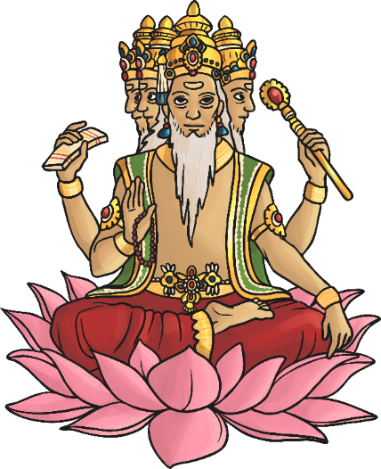
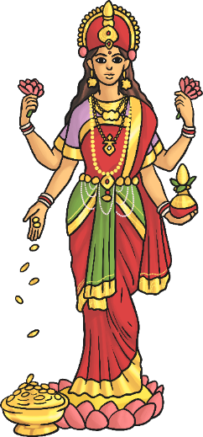
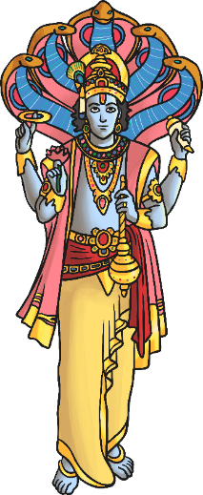

Emerging | Expected | Exceeding
Identify beliefs about God that are held by Christians, Hindus and/or Muslims (B1).        Retell and suggest the meanings of stories from sacred texts about people who encountered God (A1). | Describe some of the ways in which Christians Hindus and/or Muslims describe God (A1).  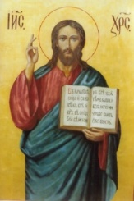  Ask questions and suggest some of their own responses to ideas about God (C1). Suggest why having a faith or belief in something can be hard (B2).  Identify how and say why it makes a difference in  people’s lives to believe in God (B1). | Identify some similarities and differences between ideas about what God is like in different religions (B3).  Discuss and present their own ideas about why there are many ideas about God and express their own understanding of God through words, symbols and the arts (C1).

