
Questions:
FS: Which times are special and why? 1.6 How and why do we celebrate special and sacred times?
Religions and worldviews:
Christians, Hindus and/or Jewish people

Why do some people think that life is like a journey and what significant experiences mark this?
Key Question:
This investigation enables pupils to learn in depth from different religious and spiritual ways of life relating to milestones on the journey of life. Through exploring baptism, Bar and Bat Mitzvah or Hindu Samskaras and marriage pupils explore how and why people chose to mark significant moments in life.






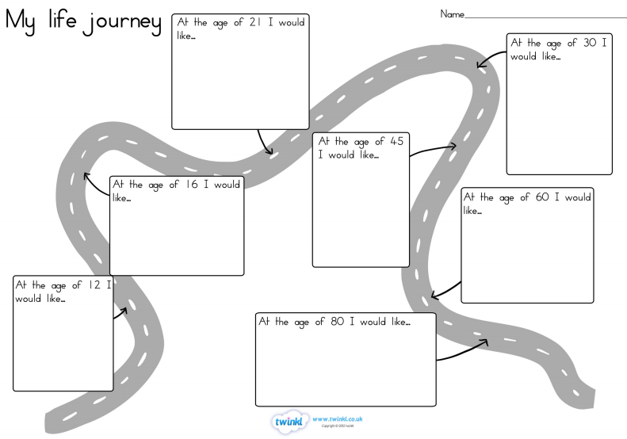

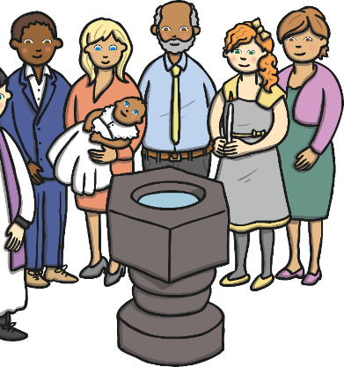





Emerging | Expected | Exceeding
Recall and name some of the ways religions mark milestones of commitment (including marriage) (A1).    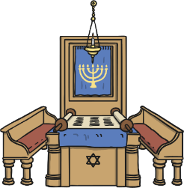  Identify at least two promises made by believers at these ceremonies and say why they are important (B1). | Suggest why some people see life as a journey and identify some of the key milestones on this journey (A2).  Describe what happens in Christian, Jewish, and/or Hindu ceremonies of commitment and say what these rituals mean (A3).  Suggest reasons why marking the milestones of life are important to Christians, Hindus and/or Jewish people (B2).  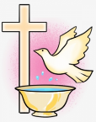  Link up some questions and answers about how believers show commitment with their own ideas about community, belonging and belief (C1). | Explain similarities and differences between ceremonies of commitment (B3).    Discuss and present their own ideas about the value and challenge of religious commitment in Britain today (C2).

