
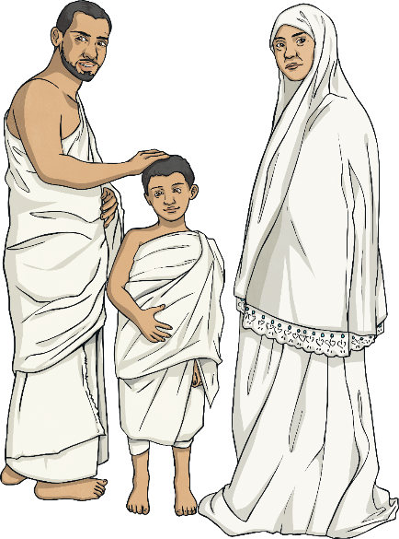
What does it mean to be a Muslim in Britain today?
Key Question:
This unit enables pupils to learn in depth from different religious and spiritual ways of life about being a follower of the Muslim religion. Pupils explore the five pillars of Islam and the importance of these to Muslim believers. Pupils will gain a greater understanding of Islam and what we can learn from its beliefs, values and ideas. This investigation provides an opportunity to learn about the Qur’an and other forms of guidance and visit a Mosque.

Questions:
F5: Where do we belong? 1.7 What does it mean to belong to a faith community? L2.7 What does it mean to be a Christian in Britain today? L2.8 What does it mean to be a Hindu in Britain today? 3.8 What is good and what is challenging about being a teenage Buddhist, Sikh or Muslim in Britain today?

Religions and worldviews:
Muslims





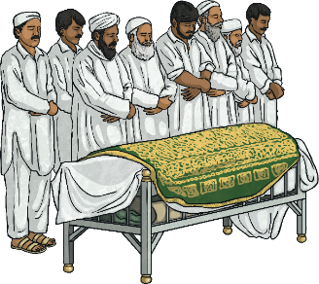
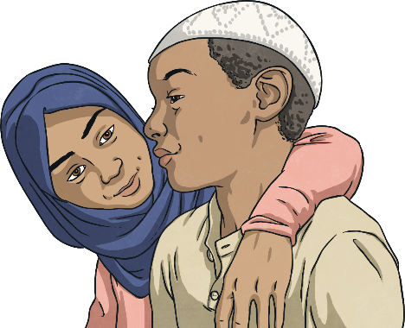
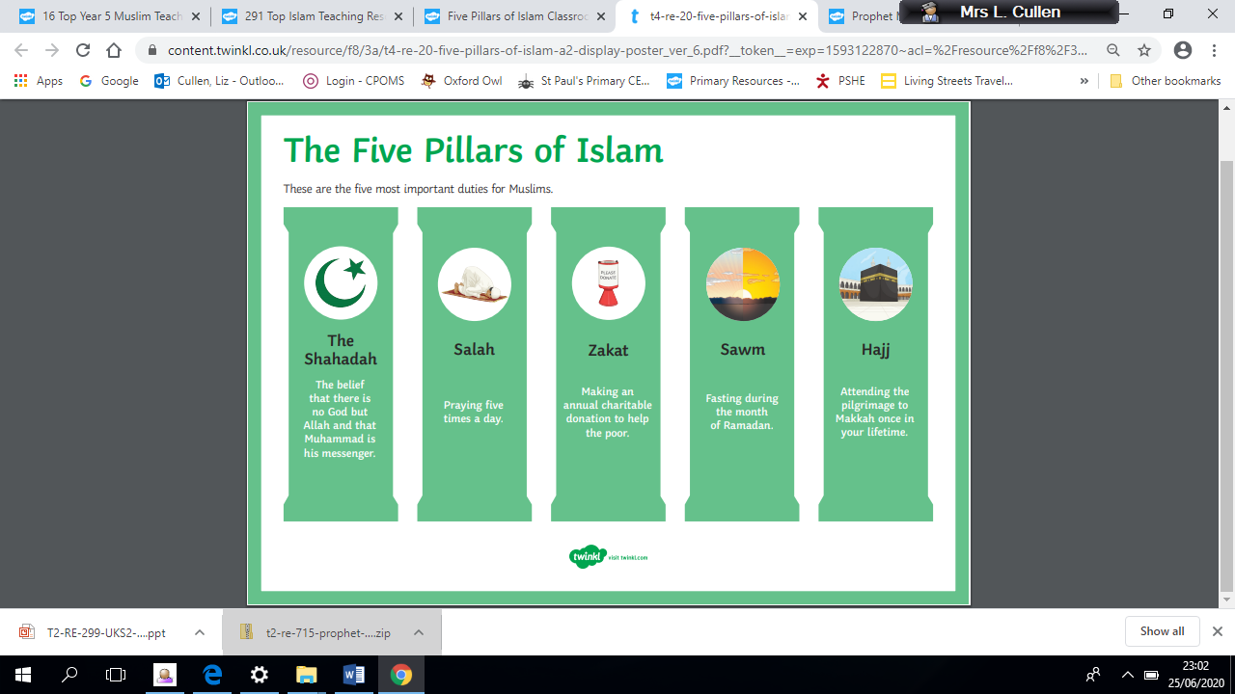
Emerging | Expected | Exceeding
Describe the Five Pillars of Islam and give examples of how these affect the everyday lives of Muslims (A1).    Identify three reasons why the Holy Qur’an is important to Muslims, and how it makes a difference to how they live (B1) | Make connections between Muslim practice of the Five Pillars and their beliefs about God and the Prophet Muhammad (A2).  Describe and reflect on the significance of the Holy Qur’an to Muslims (B1).  Describe the forms of guidance a Muslim uses and compare them to forms of guidance experienced by the pupils (A2). Make connections between the key functions of the mosque and the beliefs of Muslims (A1). | Comment thoughtfully on the value and purpose of religious practices and rituals in a Muslim’s daily life (B1).  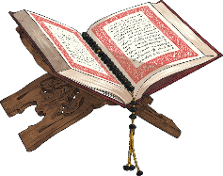  Answer the title key question from different perspectives, including their own (C1).
