



Why are festivals important to religious communities?
Key Question:
This investigation enables pupils to learn in depth from different religious and spiritual ways of life as shown through festival and celebration. We have chosen to focus on Easter, Divali in Hinduism, Pesach in Judaism and Eid ul Fitr in Islam. Schools are free to choose to study other festivals as shown in the syllabus however the learning exemplified in this unit focuses on these 4 festivals. There are links to literacy, art and philosophy for children within this unit. This unit enables pupils to begin to understand how celebration reminds believers of key beliefs and gives time to focus on beliefs and commitments and celebrating as a believing community. The focus is on the key elements of festival-shared values, story, belief and hopes and commitments. This unit may be studied as a whole unit or maybe split and studied as a series of festival focussed learning days around the times of the festival being studied.

Questions:
F4 Which times are special and why? 1.6 How and why do we celebrate special and sacred times? U2.5 Is it better to express your beliefs in arts and architecture or in charity and generosity? 3.7 How can people express the spiritual through the arts?
Religions and worldviews:
Christians plus Hindus and/or Jewish people and/or Muslims

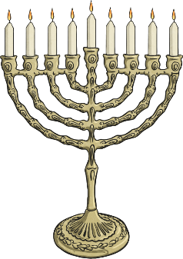

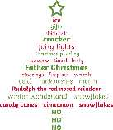

Emerging | Expected | Exceeding
Recognise and identify some differences between religious festivals and other types of celebrations (B2).      Retell some stories behind festivals (e.g. Christmas, Divali, Pesach) (A2). | Make connections between stories, symbols and beliefs with what happens in at least two festivals (A2).  Ask questions and give ideas about what matters most to believers in festivals (e.g. Easter, Eid) (B2).    Identify similarities and differences in the way festivals are celebrated within and between religions (A3).  Explore and suggest ideas about what is worth celebrating and remembering in religious communities and in their own lives (C1). | Discuss and present their own responses about the role of festivals in the life of Britain today, showing their understanding of the values and beliefs at the heart of each festival studied, using a variety of media (C2).  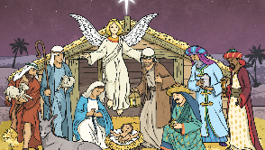  Suggest how and why religious festivals are valuable to many people (B2).

