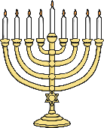
Questions: Key Question:
F4 Which times are special and why?
LL2.5 Why are festivals important to religious communities?
U2.5 Is it better to express your beliefs in arts and architecture or in charity and generosity?
3.7 How can people express the spiritual through the arts?
Religions and worldviews:
Christians, Jewish people and/or Muslims
How & why do we celebrate special and sacredtimes?
Key Question:
This investigation enables pupils to learn in depth from different religious and spiritual ways of life about Easter and Pesach (Passover) and/or Eid ul‐ Fitr.
Through art, drama and music the significance of these celebrations to believers is explored focussing on story, symbol and particular celebrations
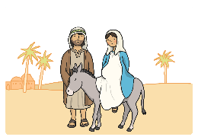

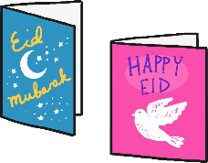

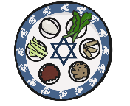

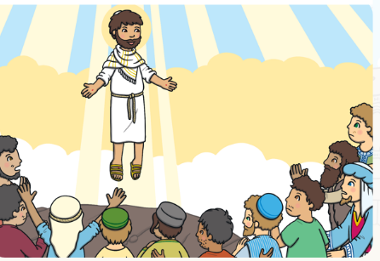
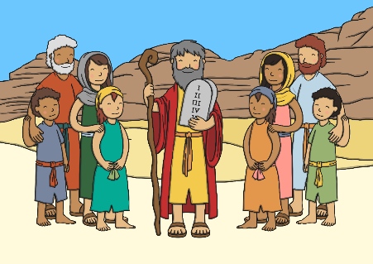
Emerging | Expected | Exceeding
Identify a special time they  celebrate and explain simply  what celebration means (A1).  Talk about ways in which Jesus was a special person who  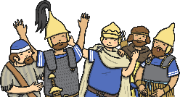  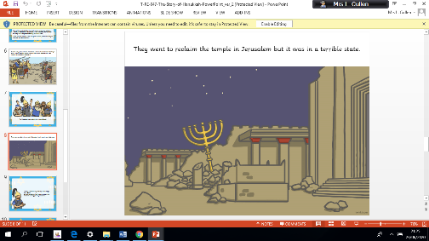  Christians believe is the Son of God (A2). | 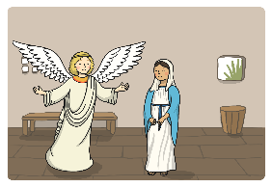  Identify some ways Christians celebrate Christmas/ Easter/ Harvest/ Pentecost and some ways a festival is celebrated in another religion (A1)  Retell stories connected with Christmas/ Easter/Harvest/Pentecost and a festival  in another religion and say why these are important to believers (A2).  Ask questions and suggest answers about stories to do with Christian festivals  and a story from a festival in another religion (B1).  Collect examples of what people do, give, sing, remember or think about at the  religious celebrations studied, and say why they matter to believers (C1). | Suggest meanings for some symbols and actions used in  religious celebrations, including Easter/Christmas, Chanukah and/or Eid‐ul Fitr (A3).    Identify some similarities and  differences between the celebrations  studied (B3).
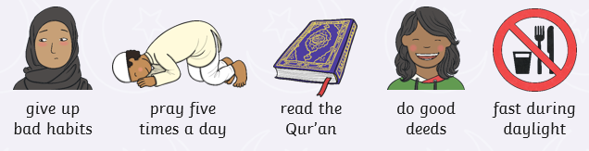
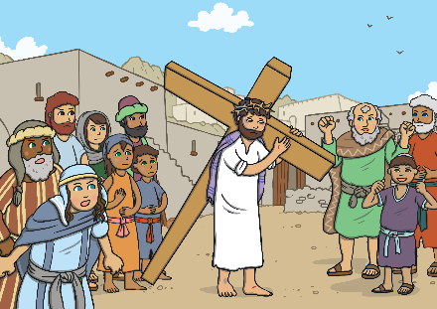

Ramadan

