What can we learn from sacred books?
Key Question:
This investigation enables pupils to find out about sacred books from more than one religion. It clearly builds upon work from unit F1 (Which stories are special and why?). Pupils begin by recapping their work on special books and thinking about what makes a book ‘holy’. They then move onto looking at stories and teachings in holy books and finding out what these mean for believers. Pupils learn how different holy books are treated and that some stories appear in more than one book. You may choose to study the Bible and the Torah or the Bible and the Qur’an rather than looking at all 3 sacred books.

Questions:
F1 Which stories are special and why? L2.2 Why is the Bible so important for Christians today? 3.2 Does living biblically mean obeying the whole bible?
Religions and worldviews:
Christians, Muslims, Jewish people

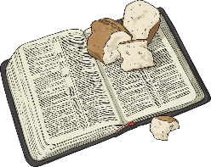

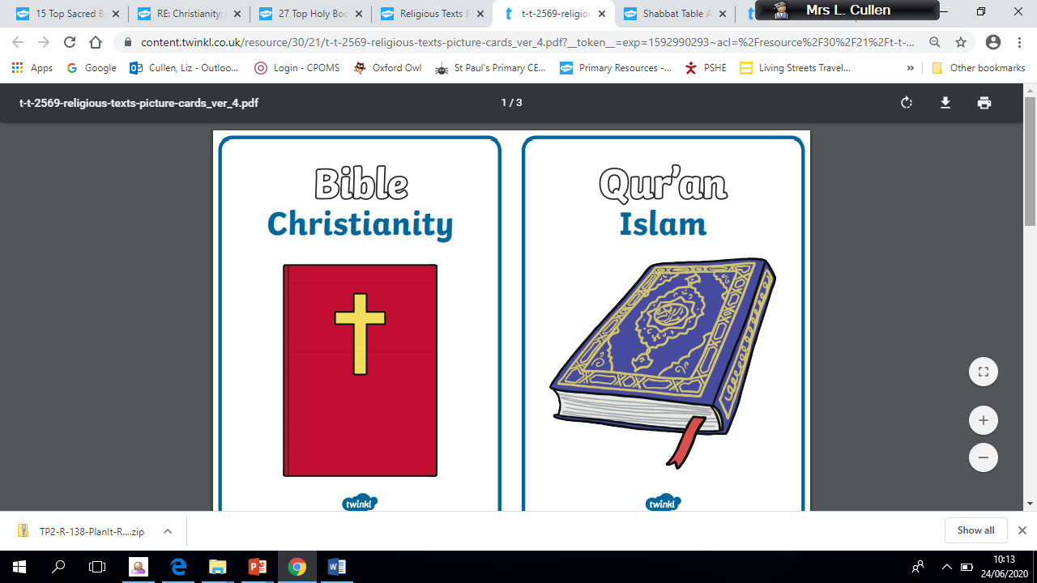

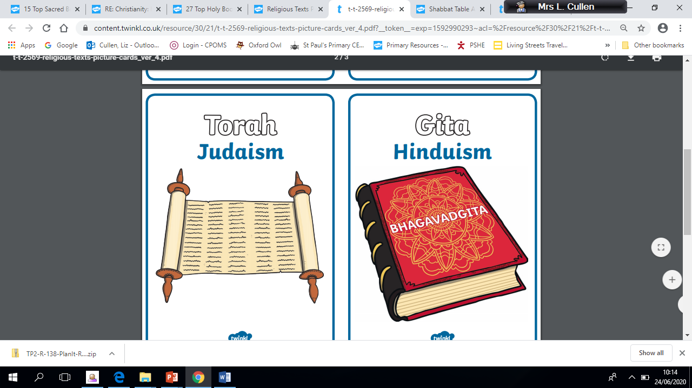
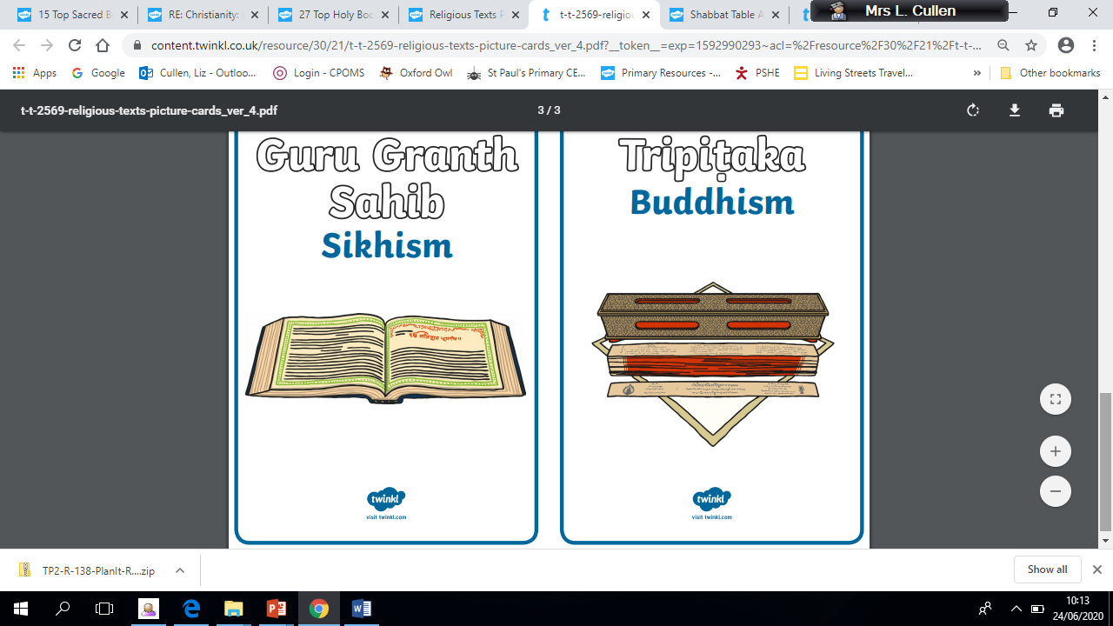
Emerging | Expected | Exceeding
  Talk about some of the stories that are used in religion and why people still read them (A2). Recognise some ways in which Christians, Muslims and Jewish people treat their sacred books (B3). | Recognise that sacred text contain stories which are special to many people and should be treated with respect (B3).  Re-tell stories from the Christian Bible and stories from another faith; suggest the meaning of these stories (A2).  Ask and suggest answers to questions arising from stories Jesus told and from another religion (C1).  Talk about issues of good and bad, right and wrong arising from the stories (C3). | Suggest their own ideas about stories from sacred texts and give reasons for their significance (C1). Make links between the messages within sacred texts and the way people live (A2)

