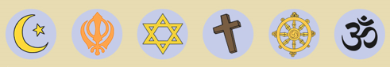
Questions:
F5: Where do we belong? 1.7 What does it mean to belong to a faith community? L2.7 What does it mean to be a Christian in Britain today? U2.6 What does it meant to be a Muslim in Britain today? 3.8 What is good and what is challenging about being a teenage Buddhist, Sikh or Muslim in Britain today?
Religions and worldviews: Christians, Muslims and Jews
What does it mean to belong to a faith community?
Key Question: This investigation enables pupils to think about belonging. They will learn about how religious people show they belong to their faith community. They will learn about ways babies are welcomed in religions and the promises made at weddings. They will think about their own network of belonging and how we all belong to someone

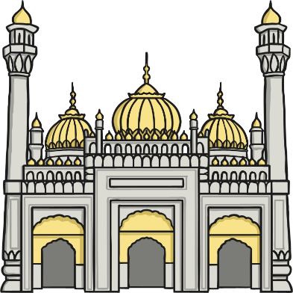
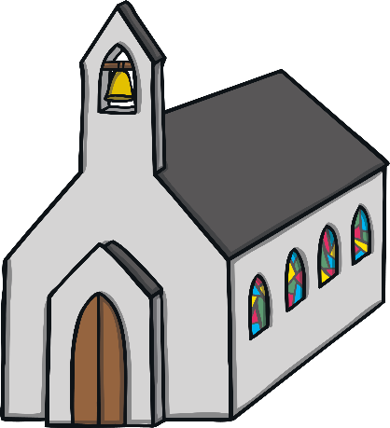





Emerging | Expected | Exceeding
Talk about what is special and of value about belonging to a group that is important to them (B2).  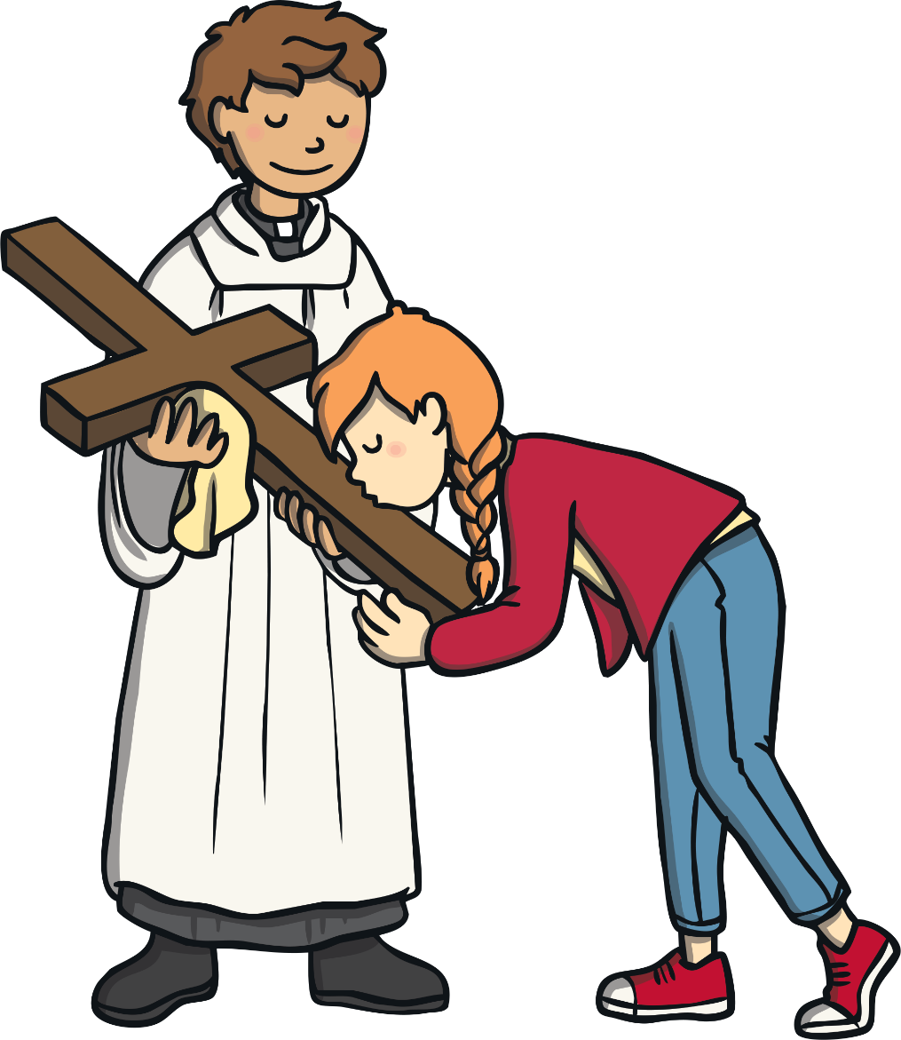  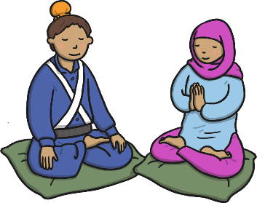  Show an awareness that some people belong to different religions (B1). | Recognise and name some symbols of belonging from their own experience, for Christians and at least one other religion, suggesting what these might mean and why they matter to believers (A3).  Give an account of what happens at a traditional Christian infant baptism /dedication and suggest what the actions and symbols mean (A1).  Identify two ways people show they belong to each other when they get married (A1).  Respond to examples of co-operation between different people (C2) | Give examples of ways in which believers express their identity and belonging within faith communities, responding sensitively to differences (B2).      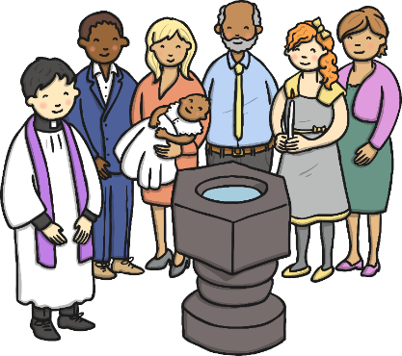  Identify some similarities and differences between the ceremonies studied (B3).

