
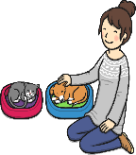

How should we care for others and the world, and why does it matter?

Key Question:
This investigation enables pupils to learn in depth from different religious and spiritual ways of life about caring for other people and for the world. Through studying bible stories, the lives of believers such as Dr Barnado, Mother Teresa or a local believer, the Jewish practice of Tzedekah and Sukkot celebrations pupils learn about how beliefs turn into actions for many religious and non-religious people. The unit encourages creativity through the use of art and music.
Do you have any pets?
Questions: Key Question:
F6. What is special about our world?
L2.9 What can we learn from religions about deciding what is right and wrong?
U2.7 What matters most to Christians and Humanists?
U2.8 What difference does it make to believe in…?
3.10 Does religion help people to be good?
3.11 What difference does it make to believe in…?
3.12 Is religion a power for peace or a cause of conflict in the world today?
Religions and worldviews: Christians and Jewish people


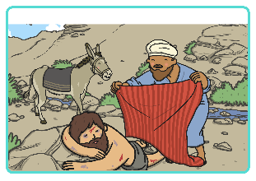
The Good Samaritan



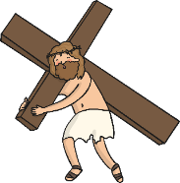
Emerging | Expected | Exceeding
Talk about how religions teach  that people are valuable, givingsimple examples (B1).  Recognise that some people  believe God created the world  and so we should look after it  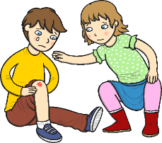  (A2) | Retell Bible stories and stories from another faith about caring for others and the world (A2).  Identify ways that some people make a response to God by caring  for others and the world (B1).  Talk about issues of good and bad, right and wrong arising from  the stories (C3).  Talk about some texts from different religions that promote the ‘Golden Rule’, and think about what would happen if people followed this idea more (C2)  Use creative ways to express their own ideas about the creation  story and what it says about what God is like (C1). | Give examples of ways in which believers put theirbeliefs about others and the world into action,  making links with religious stories (B1).  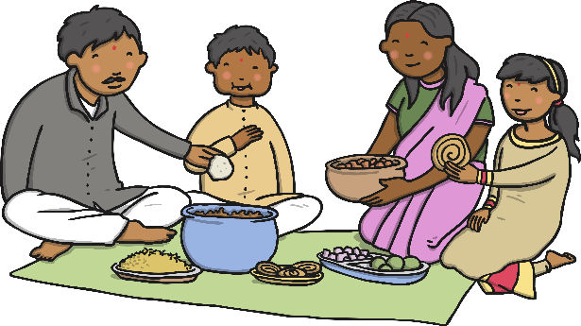  Answer the title question thoughtfully, in the lightof their learning in this unit (C1).

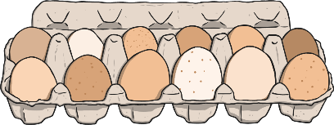
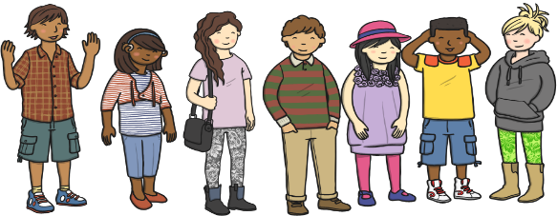


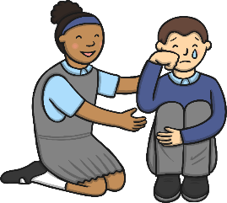
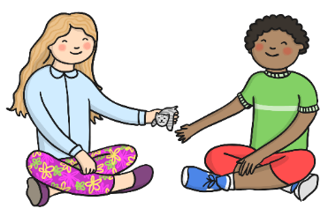
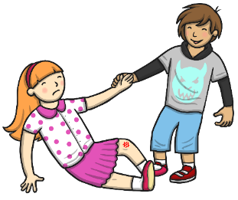
No matter what the eggs look like on the outside, they are all the same on the inside, just like people

