
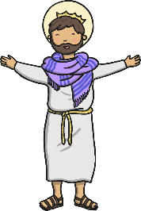
Questions:
1.2 Who is a Muslim and what do they believe?
1.3 Who is Jewish and what do they believe?
L2.1 What do different people believe about God?
U2.1 Why do some people believe God exists?
3.1 Do we need to prove God’s existence?
Religions and worldviews: Christians
Who is a Christian and what do they believe?
Key Question: This unit enables pupils to begin to understand what Christians believe about God and about Jesus as the Son of God. This unit looks at stories about Jesus and stories that Jesus told. The planning gives opportunity for good links with the English curriculum. Teaching in this unit will help children to understand that Christians see God as Father and Creator and Jesus as the Son of God and an inspiration to Christian people. This unit also allow pupils to study prayer and in particular the Lord’s prayer.
Our Father, who art in heaven,
Hallowed be thy Name.
Thy Kingdom come.
Thy will be done,
On Earth as it is in heaven.
Give us this day our daily bread.
And forgive us our trespasses,
As we forgive them that trespass
against us.
And lead us not into temptation,
But deliver us from evil.
For thine is the kingdom,
The power, and the glory,
For ever and ever.
Amen.

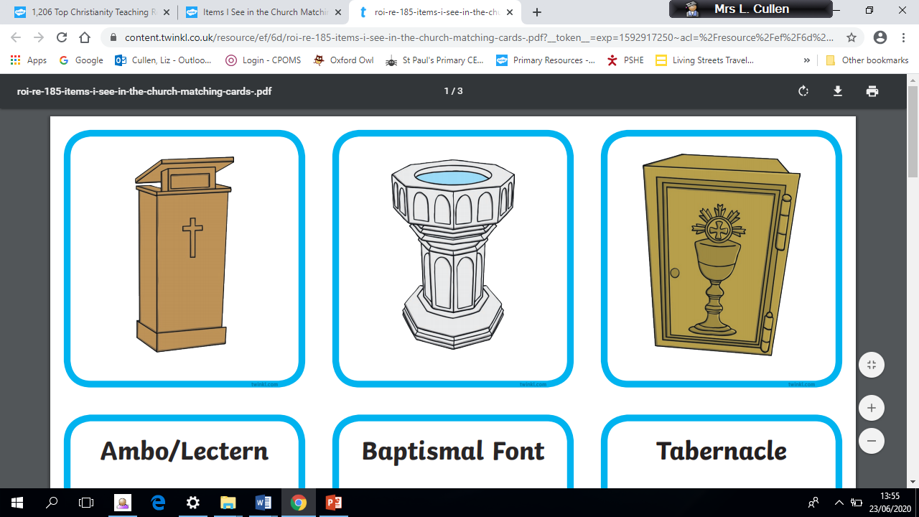

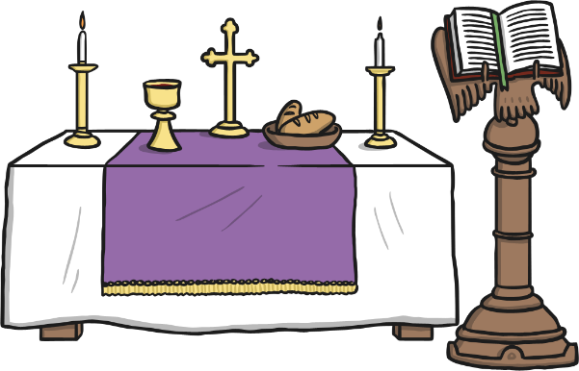
Emerging | Expected | Exceeding
Talk about the fact that Christians believe in God and follow the example of Jesus (A1).    Recognise some Christian symbols and images used to express ideas about God (A3) | Talk about some simple ideas about Christian beliefs about God and Jesus (A1).  Re-tell a story that shows what Christians might think about God, in words, drama and pictures, suggesting what it means (A2).  Talk about issues of good and bad, right and wrong arising from the stories (C3).  Ask some questions about believing in God and offer some ideas of their own (C1). |   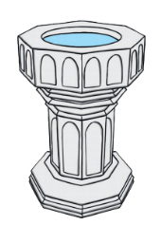    Make links between what Jesus taught and what Christians believe and do (A2).

