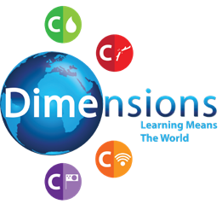
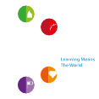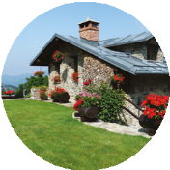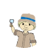
No Place Like Home
Curriculum Newsletter
My House
All about pupils’ own houses Learn about diuerent rooms
All Kinds of Houses and Homes
Explorers
C
No Place Like Home
Looking After Things
C
C

C
C
Diuerent Kinds of Houses
Names and features of diuerent types of houses Create 3D models

Pets’ Homes
Learn the diuerent names for pets’ homes Know why they are suitable

Wild Animals’ Homes
Identify wild animals and their homes
How we can help look after animal habitats
Unusual Homes
Find out about unusual homes e.g. lighthouse, castle Imagine and describe their dream house
Tents, Caves and Dens
Learn about tents, caves and dens
Share experiences and read stories relating to these places


No Place Like Home © Dimensions Curriculum Ltd.

