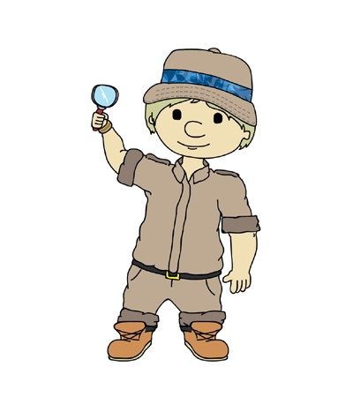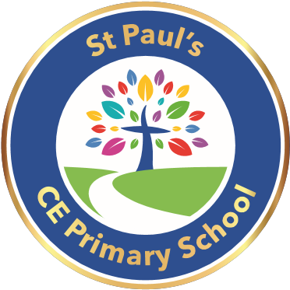
EXPLORERS THEME CYCLE 1 2024-2025
 | EXPLORERS 1 / NURSERY | EXPLORERS 2 / RECEPTION
Theme 1  07.09.24 - 21.10.24 |   ‘Happy to Be Me’ | Happy to be Me
Additional Units 31.10.24- 18.11.24 | Come and join the Celebration | ‘ Come and Join the Celebration
Additional Units 21.11.24- 09.12.24 | The Spirit Of Christmas | ‘The Spirit of Christmas’
Christmas Theme Week  12.12.24 - 20.12.24 |  | ‘Christmas Theme’
Theme 2  04.01.25 -10.02.25 |   ‘Let’s Play!’ Toys and Games | Lets Play
Theme 3  13.02.25 - 31.03.25 |   ‘Under the Sea’ Stories of Friendship | Under the Sea  Asia
Additional Units 17.04.25- 05.05.25 | Jurassic Park | Jurassic Park
Additional Units 08.05.25- 26.05.25 | ‘Food, Glorious Food’ | Food Glorious food
Theme 4  05.06.25- 19.07.25 |   ‘What on Earth | ‘What on Earth…?’ Looking After Things
© Dimensions Curriculum Ltd.

