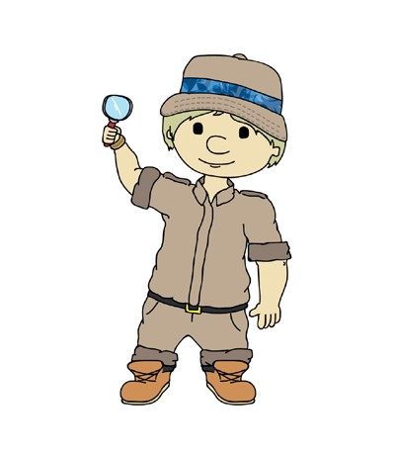
EXPLORERS THEME CYCLE 2 2025-2026
 | EXPLORERS 1 / NURSERY | EXPLORERS 2 / RECEPTION
Theme 1  07.09.25 - 21.10.25 |   Tell us a story | Tell us a story
Additional Units 31.10.25 - 18.11.25 | Come and join the Celebration | ‘ Come and Join the Celebration
Additional Units 21.11.25- 09.12.25 | The Spirit Of Christmas | ‘The Spirit of Christmas’
Christmas Theme Week  12.12.25 - 20.12.25 |  | ‘Christmas Theme’
Theme 2  04.01.26-10.02.26 |   Help is at hand | Help is at hand
Theme 3  13.02.26 - 31.03.26 |   ‘Come fly with me Asia | Come Fly with Me Asia  Asia
Additional Units 17.04.26 - 05.05.26 | Animal Crackers | Animal Crackers
Additional Units 08.05.26 - 26.05.26 | ‘Food, Glorious Food’ | Food Glorious food
Theme 4  05.06.23 - 19.07.26 |   No Place Like Home | No Place Like Home
© Dimensions Curriculum Ltd.

