
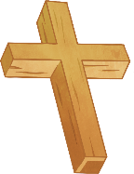
What matters most to Christians and to Humanists?
Key Question:
This investigation enables pupils to learn in depth from Christianity and from Humanism, a non-religious way of life. If it is pupils’ first encounter with Humanism, then teaching will need to secure their understanding of what a nonreligious way of life means, both similar to and different from Christianity.

Questions:
1.8 How should we care for others and the world, and why does it matter? L2.9 What can we learn from religions about deciding right and wrong? 3.10 Does religion help people to be good

Religions and worldviews:
Christians and Humanists

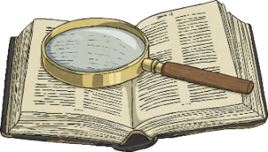


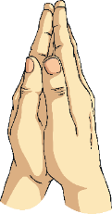


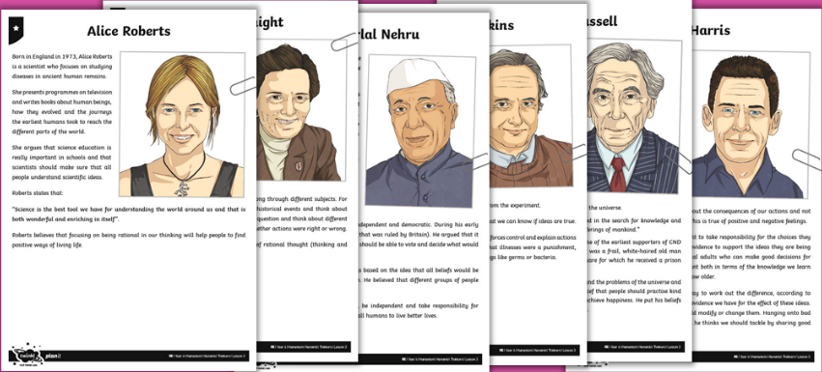
Humanist Thinkers
“The naturalist worldview is a good way to feel grounded and feel part of something. It's based on observable facts in the human and in the biological history of the planet.” - Greg Graffin Bad Religion
Emerging | Expected | Exceeding
Identify the values found in stories and texts (A2).    Suggest ideas about why humans can be both good and bad, making links with Christian and Humanist ideas (B3). | Describe what Christians mean about humans being made in the image of God and being ‘fallen’, giving examples (A2).  Describe some Christian and Humanist values simply (B3).  Express their own ideas about some big moral concepts, such as fairness or honesty comparing them with the ideas of others they have studied (C3).  Suggest reasons why it might be helpful to follow a moral code and why it might be difficult, offering different points of view (B2). | Give examples of similarities and differences between Christian and Humanist values (B3).  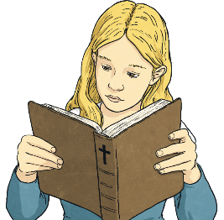  Apply ideas about what really matters in life for themselves, including ideas about fairness, freedom, truth, peace, in the light of their learning (C2).

