
Questions:
F2 Which people are special and why? L2.3 Why is Jesus inspiring to some people? 3.3 What is so radical about Jesus?

Religions and worldviews:
Christians
What would Jesus do? Can we live by the values of Jesus in the twenty-first century?
Key Question:
This investigation enables pupils to learn in depth from Christianity, considering in a detailed way some teachings of Jesus and the ways they are applied today. Pupils will consider examples of what Jesus said, and how Christians today respond to the challenges of his teachings.




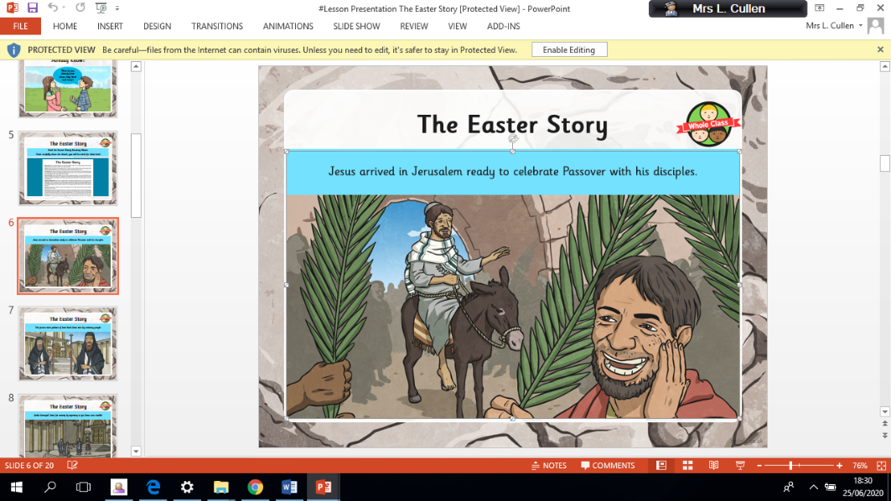

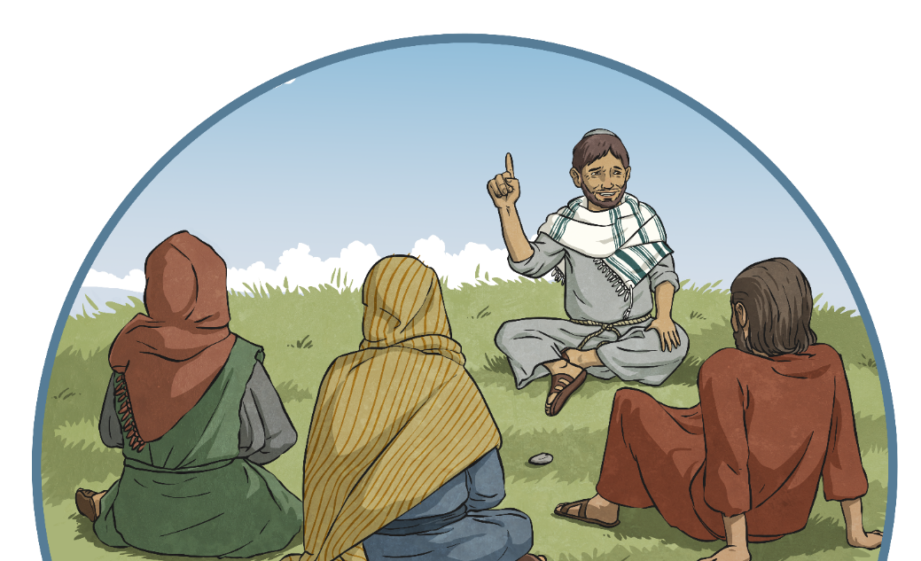

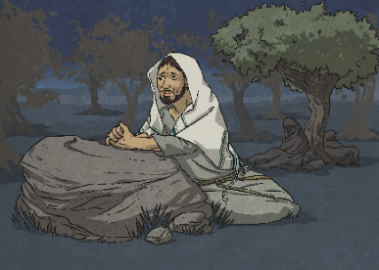
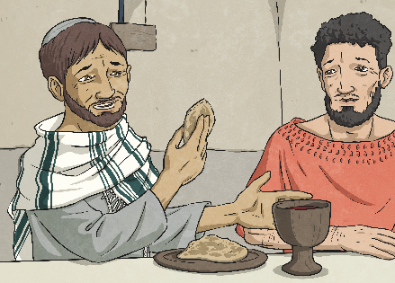

Emerging | Expected | Exceeding
Make connections between some of Jesus’ teachings and the way Christians live today (A1).    Discuss their own ideas about the importance of values to live by, comparing them to Christian ideas (C3). | Outline Jesus’ teaching on how his followers should live (A2).  Offer interpretations of two of Jesus’ parables and say what they might teach Christians about how to live (B3).  Explain the impact Jesus’ example and teachings might have on Christians today (B1).  Express their own understanding of what Jesus would do in relation to a moral dilemma from the world today (C3). | Explain the links between Jesus’ death on the cross and Christian belief in love and forgiveness, giving reasons why Christians want to follow Jesus (A2).  Investigate and explain the challenges of following Jesus’ teaching about love, forgiveness justice and/or generosity, expressing their own ideas (C3).

