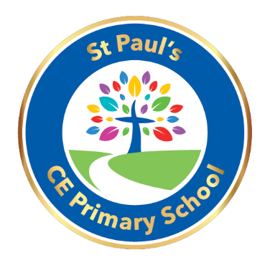

Dear Parents,

Hello and welcome back after the Christmas break. This half term we have got lots of exciting things planned for the children.
PE remains every Friday and children should have their PE kits in school every day. Your child’s PE kit should consist of a pair of black joggers or leggings, a white t-shirt and a pair of trainers.
Children have worked incredibly hard during our Phonics sessions and are enjoying reading books from the Oxford Reading Tree scheme alongside this. Please read with your child as often as possible and sign their diaries so that we can keep a record. We will listen to children read at least twice a week in school and every child will take part in a Guided Reading session with their peers.
We will be concentrating on our sentence structure during Writing sessions and working on improving our spellings and handwriting. Children will be writing some of their own stories as well as non-fiction pieces based on our topics. Please continue to practise the Year 1 and 2 spellings at home whenever you get a chance.
Children will begin the half term working with money in our Maths lessons where they will be able to identify coins and their values. We will be focusing on adding different coins together and making the same amount in 2 different ways. Children will then develop their Multiplication and Division skills and become more confident with word problems.
We will be starting our new Dimensions topic of Land Ahoy where we will be carrying out a range of interactive activities and fun lessons. This topic is based on Geography and Science and will take the children on a journey around the continents and oceans whilst exploring speed and sound at the same time.
I am looking forward to an exciting half term.

Thank you
Miss. Abbot

