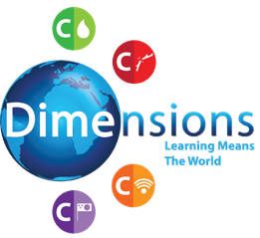
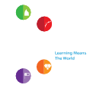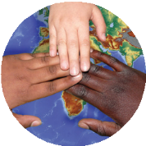
Help is at Hand
Curriculum Newsletter
Help at Home
Who helps us at home / How pupils can help at home Specific roles
Who Helps Us / Who Needs Our Help
Explorers
C
Help is at Hand
Sharing and Caring
C
C

C
C
Help at School
Who helps us at school / How pupils can help at school Specific roles

Police, Fire, Ambulance!
People who help in emergency situations Who to call for help in diuerent situations

Doctors and Nurses
The role of doctors and nurses and the ways in which they help us Ways we can keep our bodies fit and healthy
Other Helpers
Who else helps us in the wider community

Helping Others
Diuerent ways we can help other people
How we can help older people in our community

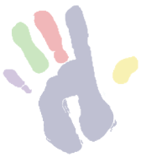
Help is at Hand © Dimensions Curriculum Ltd.

